REPUBLIC OF TÜRKİYE
T.C MINISTRY OF TRANSPORT AND INFRASTURUCTURE

ISTANBUL NORTH RAIL CROSSING PROJECT (INRAIL)

RAILWAY SAFETY PLAN

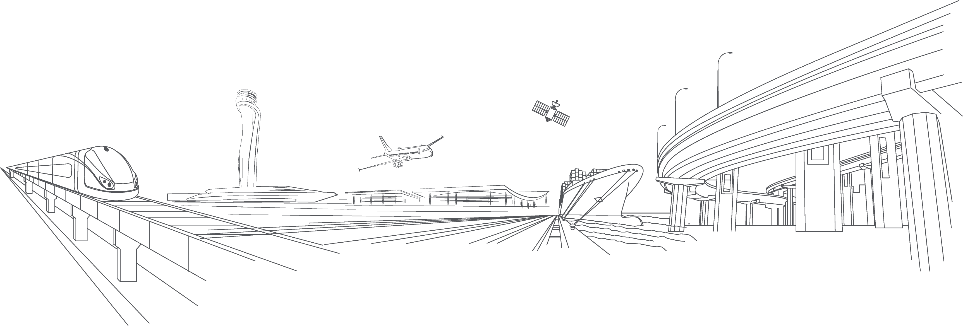

General Directorate of Infrastructure Investments
(AYGM)
March 2026

Introduction
This document sets out the general requirements for safety management and the safety targets for the overall The Istanbul North Rail Crossing Project (Herein referred to as INRAIL” or “the Project”). It specifically identifies the activities and requirements of the Contractor(s) and Subcontractors employed by AYGM to deliver the Project. However, it should be appreciated that for each contract package specific requirements relating to said contract may be specified and that these contract-specific requirements take precedence over the general requirements in this Railway Safety Plan.

Scope
This document defines the railway safety plan for the Project. In terms of safety it relates to railway safety only (i.e. the risks arising from the operation and maintenance of the completed railway). It does not include health and safety during construction. Health and safety management of the Project will be the responsibility of the Contractor(s) and its subcontractors.

In many cases, this document refers to the requirements and responsibilities of the Contractor(s). It is implicit that these requirements will be cascaded down to their subcontractors and sub-subcontractors as appropriate.

This document shall be reviewed after major system updates or changes to project organization
and after every phase of the Project lifecycle by the Contractor(s).

Project Description
The Istanbul North Rail Crossing Project (“INRAIL” or “the Project”) is a flagship investment of the Government of Türkiye (GoT) to provide an alternative, overland railway infrastructure link across the Bosphorus Strait that bypasses the Istanbul Metropolitan Area. Currently, the only cross-Bosphorus railway link is the Marmaray immersed tube tunnel, which was primarily designed for passenger services and faces significant freight capacity and maintenance constraints. Freight trains can only use the Marmaray tunnel during limited night-time windows, creating a major bottleneck for the several national and intercontinental rail corridors that traverse Istanbul. This bottleneck increases logistics costs, reduces the competitiveness of rail in Türkiye’s logistics system, and reduces the attractiveness of Türkiye as a transit hub for time- and cost-sensitive international/intercontinental Eurasian cargo. This results in higher greenhouse gas (GHG) emissions, greater congestion in Istanbul’s Metropolitan Area, and missed opportunities for truck-to-rail modal shift.

To address these challenges, the Project will construct a 127 km greenfield railway line as a high-capacity overland alternative across Bosphorus. The line will be double-tracked, electrified, fully signalized, and mixed-used, designed to carry passengers and freight.

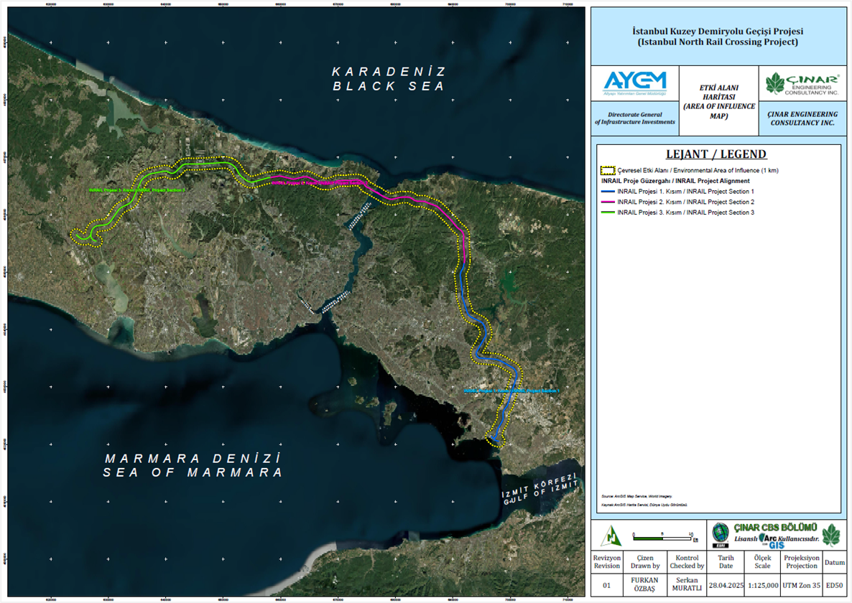
Figure 1: Project Location
The proposed railway line will start at the Çayırova station on the Asian side of the Istanbul Metropolitan Area and end at the Çatalca station on the European side. The line will cross the Bosphorus Strait using the existing track space allocated for this purpose on the Yavuz Sultan Selim Bridge (“YSS Bridge”, or “Third Bridge”), at the Bosphorus’ northern end. The line will be connected to the Turkish national high-speed rail network, with the intended ability of moving passenger trains at a top design speed of 160 km per hour. Freight trains will move at speeds of 80-120 km per hour. Between Çayırova and Çatalca, the line will connect Istanbul Airport (IST) on the European side and Sabiha Gökçen International Airport (SAW) on the Asian side to the urban and inter-city railway network, thus facilitating (i) domestic and international air and rail passenger connectivity, and (ii) urban mobility within the Istanbul Metropolitan Area.

The two airports will be the only stations along the target line. These stations will serve passenger flows and support multimodal logistics, including rail freight-to-air freight transfers. The line’s current alignment is almost entirely within the right-of-way of the existing North Marmara motorway, thereby minimizing the need for land acquisition. Its technical design, which is intense in tunnels (~50% of length) and viaducts (~17% of length), minimizes environmental and social impacts and improves safety.
INRAIL comprises 3 components, as follows:
Component 1: Design, Infrastructure, and Superstructure Construction Works.
The technical work under this component will include the following:
- Preparation of detailed engineering designs for all construction and installation works within the scope of the Project, which are expected to be conducted under a design-build implementation approach (FIDIC Yellow Book 2017 and amendment of 2022), aiming at improving infrastructure quality outcomes and accelerating physical progress by integrating these interdependent functions under the same provider.
- Construction of 122.3 km of double-track main line and about 4.7 km of single-track connection lines, resulting in a total of nearly 127 km of electrified and fully signalized high-speed railway with a maximum design speed of 160 km/hr. This includes 5 twin-tube tunnel boring machine (TBM) tunnels totaling 36.2 km, 22 double-track New Austrian Tunneling (NATM) tunnels totaling 23.3 km, 17 cut-and-cover tunnels totaling 3.7 km, and 2 viaducts and 40 bridges totaling 22.1 km. The infrastructure and superstructure will adhere to Türkiye’s recently updated national standards for structural integrity, which explicitly address climate-related hazards such as flooding, wind, and extreme temperatures.
- Full electrification of the project line, installing an overhead catenary system to be supported by three traction transformer centers (154/25 kV) positioned along the route two near the termini and one centrally. Energy will be sourced from nearby 154 kV lines operated by Türkiye Electricity Transmission Inc., with all transformers conforming to national and international standards.
- Installation of European Rail Traffic Management System (ERTMS)/European Train Control System (ETCS) Level 1 & 2 signaling and telecommunication systems along the project line. All signaling and telecommunications systems will be compatible with train speeds up to 250 km/h, while also supporting safe and efficient operation of lower-speed trains. Integration with existing systems will be achieved through necessary connections, interfaces, and software for electrification, signaling, communication (including continuity with the Centralized Traffic Control (CTC) center), Supervisory Control and Data Acquisition (SCADA), and related facilities.
- Construction of dedicated structural reservations designed to incorporate potential freight connections with cargo terminals at IST.
- Construction of a new underground railway station for the project line at SAW, with siding tracks to be incorporated in separate parallel tunnels to segregate freight and passenger trains to improve safety and operational performance.
- The adaptation of and connection with the existing railway station at IST, incorporating siding tracks with structural separation for freight and passenger trains to improve safety and operational performance.
Component 2: Design Supervision and Construction Supervision
Component 2 comprises the provision of consulting services to supervise all design and construction/installation work under Component 1, in accordance with FIDIC regulations, across all Project contracts.
Component 3: Project Implementation and Oversight Support
This component will enhance project implementation by mobilizing a Project Management Consultant (PMC) to provide direct implementation support to AYGM, and by engaging an independent Project Implementation Oversight Consultant (PIOC) to support both AYGM and Project Financiers (see below).
INRAIL has an estimated total cost of US$8.1 billion (including VAT, project management and supervision, and contingencies). Financing will be provided by a consortium of International Financial Institutions (IFIs) (henceforth referred to interchangeably as “the Financiers”), with expected contributions as follows:
- World Bank (IBRD), designated as Lead Financier: US$2.0 billion.
- Asian Development Bank (ADB): US$1.5 billion.
- Asian Infrastructure Investment Bank (AIIB): US$1.5 billion.
- Islamic Development Bank (IsDB): US$0.75 billion.
- OPEC Fund: US$0.5 billion; and
- European Bank for Reconstruction and Development (EBRD): US$0.5 billion.
The remaining US$1.522 billion will be provided by the GoT, primarily to cover land acquisition and applicable taxes.
The Project will be implemented by Türkiye’s Ministry of Transport and Infrastructure (MoTI), through its Directorate-General of Infrastructure Investments (AYGM). A dedicated Project Implementation Unit (PIU) within AYGM’s Department of Railway Construction will have direct responsibility for managing the Project’s implementation.
AYGM (the “Employer” or the “Client”) will implement the Project in accordance with the Yellow FIDIC Book (FIDIC Conditions of Contract for Plant and Design-Build), engaging:
- Civil Works Contractor(s) (henceforth referred to interchangeably as “Contractor” or “Contractors” – the Project is expected to engage more than one contractor) responsible for designing and building the Project.
- Construction Supervision Consultant/Engineer (henceforth “CSC” or “the Engineer”) to administer the design-build civil works contract(s) and act as the Employer’s representative on site, per FIDIC regulations, with the following duties: (a) administering the design-build contract(s) and ensuring full supervision and monitoring of the Contractor’s performance, with timely completion, adherence to budget, and compliance with the Employer’s Requirements, approved design, and contract terms; (b) safeguarding construction quality and overseeing site safety throughout the works; (c) managing all contractual matters between the Employer and the Contractor; and (d) facilitating the successful handover of the completed works as an operable and maintainable system.
- Project Management Consultant (PMC) provide support to the Employer on the daily tasks of implementing and managing the Project, including complying with all Financiers’ requirements and related financing agreements, as well as with national laws and obligations. The definition of the PMC’s duties will be elaborated in this ToR. The provider of these PMC services will be referred to within this ToR as “the Consultant.”
- Project Implementation Oversight Consultant (PIOC): the PIOC will provide independent project implementation oversight, including technical support and quality assurance, throughout the project lifecycle to help meet AYGM and Financiers’ requirements. The PIOC will provide structured, periodic—and in some cases real time or near real time—oversight and quality assurance of key aspects of project implementation, including but not limited to design, construction, fiduciary performance, environmental and social performance, and risk management. The PIOC support is intended to ensure the timely, fit-for-purpose, and on-budget delivery of a flagship project of national and international importance.
Upon completion, AYGM will transfer the Project-financed infrastructure to TCDD, which will operate and maintain the completed railway asset over its economic life.
The Project will be implemented according to the World Bank’s Environmental and Social Framework (ESF). Additional requirements may be considered to meet policies of other Financiers and shall be communicated to the consultant and added to the scope of the relevant task. Project implementation will be guided by the following Environmental and Social (E&S) instruments: Environmental and Social Impact Assessment (ESIA), Environmental and Social Management Plan (ESMP) and sub-management plans, Stakeholder Engagement Plan (SEP), Labor Management Procedure (LMP), and a Resettlement Framework (RF) to inform the preparation of a Resettlement Plan (RP) during implementation. These instruments have been prepared, publicly consulted, and disclosed by AYGM, and will be updated, re-consulted, and re-disclosed when detailed engineering designs are undertaken during Project implementation.

3.1 overvıew of the Project
Metropolitan City İstanbul has only one single track railway line which runs from east side (Gebze) to west side (Halkalı) of the city. Existing MARMARAY Project has three lines between Gebze- Haydarpaşa and between Kazlı Çeşme- Halkalı, this project has two lines between Haydarpaşa and Kazlıçeşme including Bosphorus crossing. This two-lines are used mostly with metro lines. Freight trains and intercity passenger trains can pass through Bosphorus when the existing metro train traffic allows, which will be within a restricted time gap.
In the year 2013 Ministry of Transport and Infrastructure decided to construct a third bridge for crossing Bosphorus, with Yavuz Sultan Selim Bridge. This bridge was planned, as to have; 2x4 lanes of highway and two railway lines which can be used by freight trains and passenger trains.
Istanbul Northern Railway will connect all the national and international railway lines coming from east side of Istanbul to, national and international railways of European Side.
A short description of Project line is as follows: It starts, from the east side of Istanbul (Gebze- Çayırova), passing close to existing Sabiha Gokcen Airport, then passing Bosphorus with Yavuz Sultan Selim Bridge and passing through the constructed railway station within İstanbul Airport and afterwards, connected to two track railway line (which is under construction and has the same geometric and technical standards with our railway under consideration) with a triangular connection(wye connection) near Çatalca.
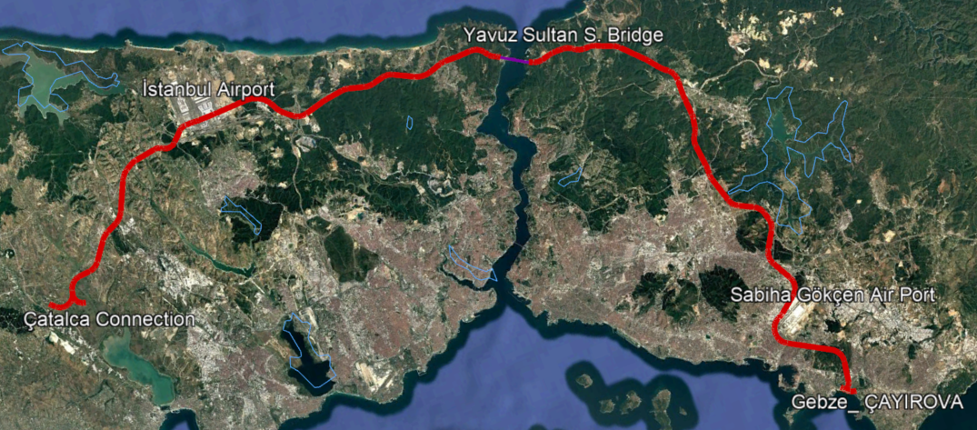
Figure 2: Project Map
The operational philosophy of the INRAIL project is based on mixed-use operation of passenger and freight trains on a high-capacity, double-track electrified corridor, designed to ensure reliability, capacity resilience and efficient segregation of traffic flows. Passenger operations focus on high-frequency intercity and airport-oriented services, with predictable and regular timetables aimed at improving accessibility, travel time reliability and network connectivity, particularly between Istanbul’s two airports and major national corridors. Freight operations are oriented towards medium- and long-distance flows, prioritizing cost efficiency, modal shift from road and maritime transport, and uninterrupted international transit. The operational concept is designed to relieve capacity constraints on existing Bosphorus crossings, support Türkiye’s role as a strategic logistics hub, and ensure long-term operational flexibility with sufficient capacity reserves for future demand growth.
A short summary of the Project discipline-wise; alignment design, standards, criteria and route description; geological and geotechnical, standards-rules to be used in design and assessment; planned structures along the railway, typical sections, standards to be used in the design; E-M systems and standards to be used for the final design are given on the followings.

3.2 ALIGNMENT EVALUATION
This section presents the INRAIL Project, implemented by the General Directorate of Infrastructure Investments under the Ministry of Transport and Infrastructure. The project has been planned to address Istanbul’s growing passenger and freight transportation needs, ensure integration with the existing railway and metro lines, and increase capacity for both urban and intercity transportation.
The Marmaray Line, which represents the most critical east–west railway connection in Istanbul, is currently operating at high capacity due to heavy passenger demand. With the anticipated increase in passenger volumes in the coming years, along with the wider adoption of railways for freight transportation, the Marmaray Line is expected to face capacity limitations.
Metropolitan City İstanbul has only one single track railway line which runs from east side (Gebze) to west side (Halkalı) of the city. Existing MARMARAY Project has three rail lines between Gebze- Haydarpaşa and between Kazlı Çeşme- Halkalı. This project has two lines between Haydarpaşa and Kazlıçeşme (approximately 14 Km.) including Bosphorus crossing. These two lines are used mostly with metro lines. Freight trains and intercity passenger trains can pass this 14 Km line, through Bosphorus when the existing metro train traffic allows, which will be within a restricted time gap.
Therefore, the development of an alternative and complementary route to Marmaray, capable of supporting both passenger and freight traffic, has become a strategic necessity.
In this context, a new railway line has been planned, starting from Çayırova Marmaray Station and extending through Sabiha Gökçen Airport, the North Marmara Motorway, Yavuz Sultan Selim Bridge, and Istanbul Airport, reaching Çatalca. The alignment of the route has been determined by considering technical requirements, recommendations of international financial institutions, environmental sensitivities, existing settlements, and the current transportation network.
Accordingly, the proposed alignment has an approximate length of 127 km.
For the line design, the present “Design Criteria” have been developed based on existing railway practices and the standards prepared by international institutions concerning high-speed rail systems.

HORIZONTAL ALIGNMENT DESIGN CRITERIA

General Information
The horizontal alignment consists of tangent sections, circular curves, and transition curves (clothoids-spirals) that provide the connection between tangents and curves.
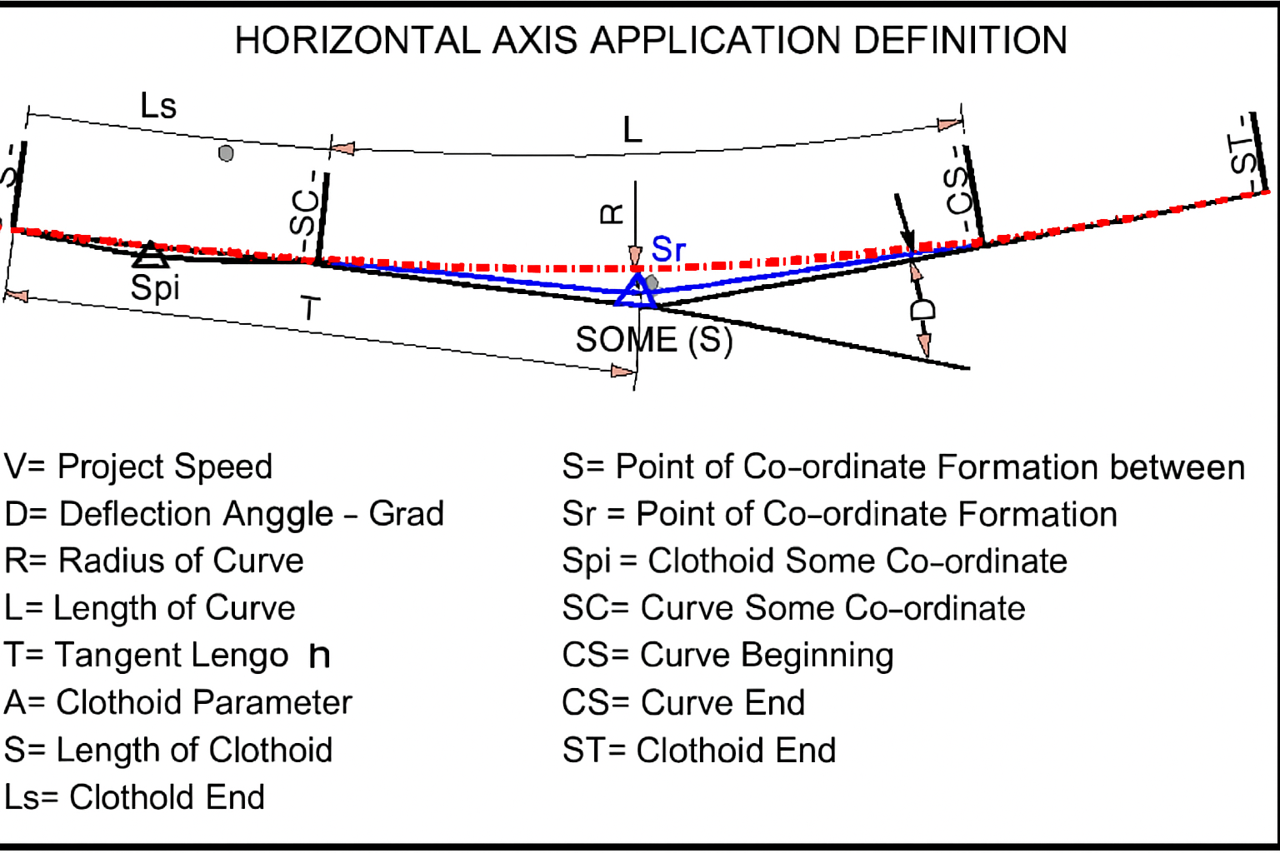
Figure 3: Horizontal Geometry

Design Speed
In order to carry out the geometric design of the horizontal alignment elements, the design speed must first be determined.
The design speed depends on the service capability of the railway to be constructed, the characteristic features of the rolling stock to be operated, and local constraints.
Based on the information outlined above, and taking into account the existing topography and railway conditions, the proposed design speed (Vmax) for the line under design is as follows:

Kilometer | Design Speed, Vd (km/sa)
0+000.00 ~ 126+000.00 (approx.) | 160

RAILS AND TURNOUTS

Rails
The selection of rail section depends on traffic loads. Increases in axle loads and train speeds have led to higher stresses in rails. Rail sections on standard gauge lines are determined by the International Union of Railways (UIC).

For standard gauge lines:
UIC 50 (weight: 50.18 kg/m) is used for light traffic loads,
UIC 60 (weight: 60.34 kg/m) is used for medium and heavy traffic loads.
Within the scope of this project, the rail type to be used along both main lines and secondary lines is UIC 60.

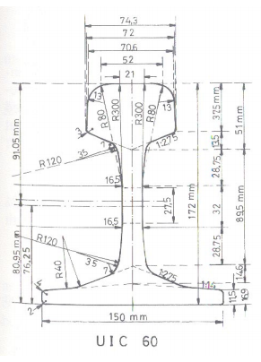
Figure 4: UIC 60
Rails used in turnouts shall differ from plain line rails in geometry, manufacturing process and material performance requirements. While the stock rails and closure rails may be based on standard rail profiles (UIC 60), they shall be specially machined and bent to comply with the turnout geometry and operational tolerances.

Switch rails shall be manufactured from rolled rail sections that are subsequently machined to a reduced and tapered head profile, allowing smooth wheel transfer between the stock rail and the diverging route. The switch rail profile shall ensure continuous wheel support and minimize impact loads at the toe of the switch. Crossings (frogs) shall be designed to withstand high dynamic loads and concentrated wheel impacts. They shall be manufactured either as monoblock cast components made of high-manganese steel or as fabricated crossings using specially heat-treated rail steel, in accordance with applicable UIC and EN standards. The crossing geometry shall ensure safe wheel guidance and limit wear under both passenger and freight traffic.

Check rails shall be provided in the crossing area to control wheelset guidance and flange clearance. Check rails shall be manufactured from rail sections or dedicated profiles and installed with adjustable fastening systems to ensure precise gauge control. All turnout rails and components shall be factory-assembled where practicable and delivered as complete turnout systems. Manufacturing, tolerances, material properties, and acceptance criteria shall comply with relevant UIC leaflets and EN standards applicable to railway turnouts.

Guard rails shall be installed at locations where additional wheel guidance and derailment risk mitigation are required. These locations shall include, but not be limited to, turnouts, crossings (frog areas), sharp curves, bridges, viaducts, and tunnel sections where structural clearances are limited. The primary function of guard rails is to control the lateral position of the wheelsets by restricting flange movement, thereby ensuring correct wheel guidance through critical track sections and preventing wheelsets from reaching vulnerable structural elements in the event of abnormal running conditions.

In turnout and crossing areas, guard rails shall be used to guide wheelsets through the crossing nose, reduce impact forces, and minimize wear on the crossing components. On bridges and viaducts, guard rails shall provide an additional safety measure by limiting derailment consequences and preventing derailed wheelsets from deviating toward structural edges.

Guard rails shall be manufactured from rail sections or dedicated profiles and installed parallel to the running rail with precisely controlled flangeway and check gauge dimensions. Fastening systems shall allow for adjustment and maintenance of the required tolerances. Design, installation, and tolerances of guard rails shall comply with relevant UIC and EN standards applicable to railway track safety components.

The main running tracks shall be constructed as Continuous Welded Rail (CWR) in order to ensure high ride quality, reduced dynamic forces, and improved track stability under mixed high-speed passenger and heavy freight operations. Rail joints on the plain line shall be eliminated except where technically unavoidable, such as at turnouts, expansion devices, or special trackwork interfaces.

The use of CWR is essential to accommodate the combined effects of high operating speeds and heavy axle loads, as it minimizes impact forces, reduces track degradation, and enhances passenger comfort while maintaining structural integrity under freight loading. CWR shall be designed to safely withstand longitudinal forces arising from temperature variations, braking and traction forces, and rail–vehicle interaction.
In turnout areas, CWR shall be applied to the extent permitted by turnout design. Where full continuity cannot be maintained, appropriate rail expansion devices or insulated joints shall be provided to manage thermal movements and prevent the transfer of excessive stresses to turnout components.

Special attention shall be given to CWR installation on bridges, viaducts, and in tunnels, where rail–structure interaction effects are more pronounced. The design shall account for differential movements between track and structure, and measures such as rail fastening systems with defined longitudinal resistance and, where required, rail expansion joints shall be implemented.
All CWR design, installation, stress-free temperature determination, and maintenance procedures shall comply with relevant UIC leaflets and EN standards applicable to mixed passenger and freight railway lines, ensuring long-term safety, reliability, and maintainability.

Rail Fastening System
Along the INRAIL railway, mainly two different rail fastening system will be used; fastening system along the ballasted lines and fastening systems along the ballastless lines. These fastening systems, technical requirements and specs which are to be followed are defined within the technical specs: “technical specification of rail fastening materials for ballast less lines, and “technical specification of rail fastening materials for ballasted lines.

For ballasted track sections designed for mixed operation of high-speed passenger trains and heavy freight trains, a heavy-duty elastic rail fastening system of W21 type or equivalent shall be used as the standard fastening system. The fastening system shall provide increased rail clamping force, enhanced longitudinal and lateral resistance, and controlled elasticity suitable for Continuous Welded Rail (CWR) operation under high dynamic loads. Turnout areas and special trackwork within ballasted sections shall use fastening components compatible with the same performance level.

For slab track sections, a direct fixation elastic rail fastening system specifically designed for ballastless track shall be applied. Such fastening systems shall provide controlled vertical and lateral stiffness, vibration attenuation, and high fatigue resistance suitable for mixed traffic operation. The fastening system shall ensure adequate longitudinal resistance for CWR while allowing limited rail movement to manage thermal effects and rail–structure interaction.
In both ballasted and slab track sections, fastening systems shall be designed to withstand temperature-induced forces, braking and traction loads, and long-term cumulative tonnage. All fastening systems and components shall comply with relevant UIC and EN standards, including the EN 13481 and EN 13146 series, or equivalent, and shall be subject to type testing and approval prior to installation.

The W21 elastic rail fastening system is a heavy-duty fastening solution developed for ballasted track subjected to high axle loads and mixed traffic operation. It is specifically suitable for railway lines with Continuous Welded Rail (CWR) applications.

The system provides a high rail clamping force, ensuring secure rail fixation and enhanced resistance against vertical, lateral, and longitudinal forces generated by heavy freight traffic and high-speed passenger trains. The elastic rail clips are designed to maintain consistent clamping force over long service periods and under repeated dynamic loading, with high fatigue resistance.
The W21 system incorporates high-performance rail pads that provide controlled vertical stiffness and effective vibration damping. This reduces ballast degradation, limits stress concentrations in sleepers, and improves overall track durability under high cumulative tonnage.

The fastening assembly delivers increased longitudinal resistance, allowing the safe accommodation of thermal forces, braking and traction forces associated with CWR without excessive rail movement. At the same time, the system allows limited elastic deformation to distribute stresses and prevent brittle behavior.

The W21 fastening system is fully compatible with concrete sleepers and standard rail profiles used on heavy-duty main lines. It can be integrated with turnout fastening systems of equivalent performance level to ensure continuity of track behavior and maintenance philosophy.

All components of the W21 fastening system shall comply with relevant European and international standards, including the EN 13481 and EN 13146 series, and shall be subject to type testing, fatigue testing, and approval prior to use.

Noise and vibration limits are defined in the regulation published in the official gazette by the Ministry of Environment, Urbanization and Climate Change. This regulation states; the ground vibration level created by railway and road transportation vehicles meets the limit values, and for the noise it states as; the environmental noise level emitted from transportation sources meets the provisions and limit values.

For the vibration measure along the line; technical specification “mass -spring system technical specification”, (Kütle-Yay Sistemi Teknik Şartnamesi) will be given with tender documents.

These documents will be referenced within the tender documents, it will be contractors responsibility to accomplish necessary measures on the railway super structure along the line including passenger stations, tunnels and on the open line).

Turnouts
One of the fundamental characteristics of railways is their unidirectional operation. Directional changes on the railway are provided through turnouts and crossings.

Although turnouts exist in many different forms, they can be classified into two basic categories, with a third category formed by their combination:
- Simple or multiple turnouts: Divide the track into two (sometimes three) and allow vehicles to change direction.
- Diamond crossings: Allow two tracks to intersect without a change in direction.
- Scissors crossovers: Combine the functions of turnouts and crossings.
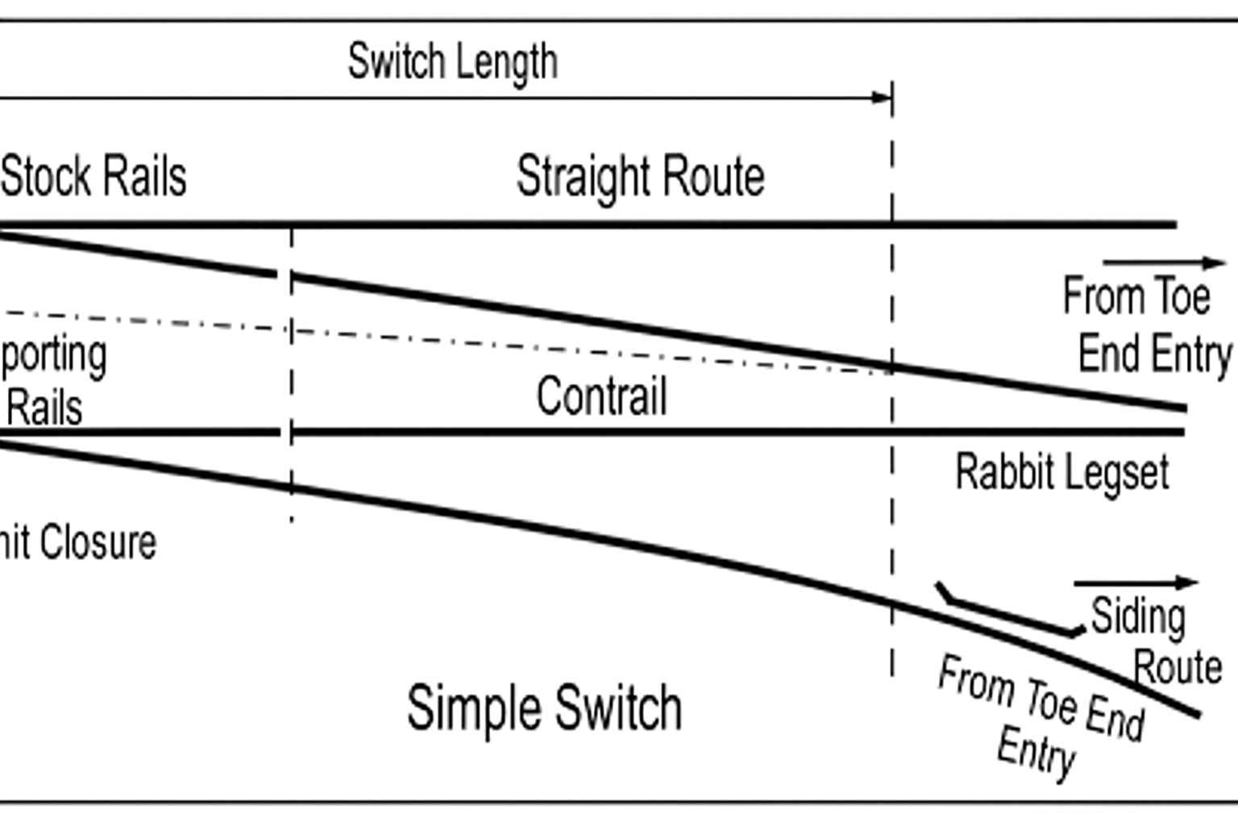
Figure 5: Turnouts and Crossings

In conclusion, the function of turnouts and crossings is to divide a track into two or three or to merge tracks, thereby enabling trains to move from one track to another parallel track and providing flexibility in the direction of movement.
On the main line, S-type turnouts with a ratio of 1/24,5 and a radius of R = 1500 m, typically used by TCDD for speeds between 120–160 km/h, are used.
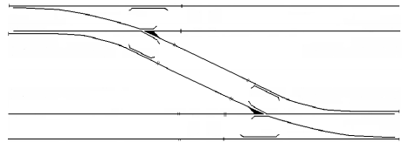
Figure 6: S-type turnouts

Before the entrance of stations at both sides of the stations; turnouts diverging from the main line shall be 1/12 with a radius of R = 500 m. At the beginning (Çayırova) and at the end (Çatalca) of the INRAIL line; connections to existing rails will be wye type (Y) connections are planned with 1/18,5-- R=1200m turnouts are used.

Turnouts are not applied on vertical curves. The straight (through) track of turnouts shall always remain on the main line. On the horizontal alignment, the tangent track length preceding a turnout shall be at least 10 m, and under constrained or required conditions a minimum of 5.0 m. However, if the diverging track and the main line curve are not oriented in the same direction, this length shall not be less than the distance between two bogie centers.

The straight (through) track of a turnout shall always be placed on the main line, while the diverging (curved) track shall be connected to the secondary line. In the design, a total of 24 turnouts of 1/24 R = 1500 m, 6 turnouts of 1/18.5 with R = 1200 m, 10 turnouts of 1/12 with R = 500 m, and 1 turnout of 1/9 with R = 300 m have been applied.

SLEEPERS, BALLAST AND SUBBALLAST

Sleepers
Sleepers are transverse members laid at specific intervals perpendicular to the rails. In accordance with the railway load transfer model, they distribute the forces transmitted from the rails over a wider surface and transfer them to the ballast layer, maintain the track gauge, and keep the track aligned against lateral effects.

On newly constructed lines, the center-to-center spacing of sleepers is applied as 62–63 cm, which is advantageous for automated operations during mechanized maintenance.

In this project design, the sleeper spacing shall be 620 mm. On the main line, B.70 type concrete sleepers, compatible with UIC 60 rail profiles, shall be used. These sleepers are of TCDD type and conform to UIC 713 standards.
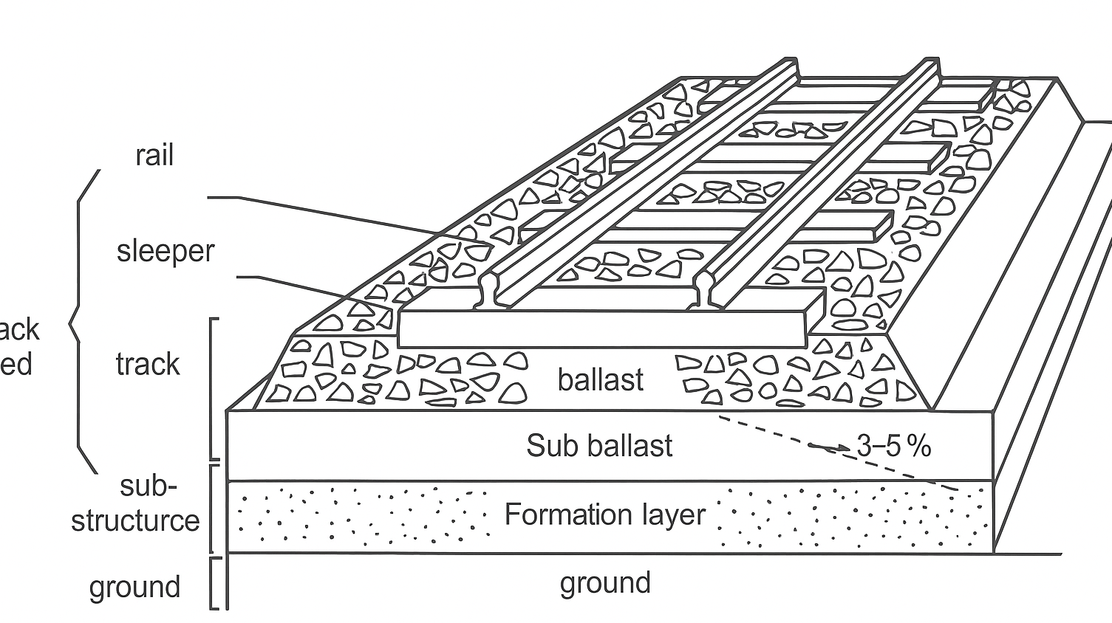
Figure 7: Track with Ballast

Sleepers used in turnout areas shall differ from plain line sleepers in geometry, length, spacing, and structural performance in order to accommodate the specific requirements of switch and crossing layouts. Turnout sleepers shall be special prestressed concrete sleepers, manufactured with variable lengths and arranged at non-uniform spacing in accordance with the turnout geometry. These sleepers shall provide adequate support for switch rails, closure rails, crossings, guard rails, and associated fastening components, ensuring correct rail positioning, gauge control, and load transfer throughout the turnout.

Compared to plain line sleepers, turnout sleepers shall be designed to withstand higher dynamic loads, impact forces at the crossing area, and asymmetric loading conditions inherent to turnout operation.Fastening systems installed on turnout sleepers shall be compatible with the fastening system used in the adjacent plain line track, ensuring continuity of track stiffness, longitudinal resistance, and performance under Continuous Welded Rail (CWR) conditions.

Turnout sleepers shall be factory-manufactured and supplied as part of an integrated turnout system where practicable. Materials, dimensions, tolerances, and structural performance shall comply with relevant UIC leaflets and EN standards applicable to turnout sleepers and concrete railway sleepers.Under-Sleeper Pads (USP) may be applied to ballasted track sections in order to improve track performance, durability, and load distribution. USP are elastic elements attached to the underside of concrete sleepers and function as an additional resilient layer between the sleeper and the ballast.

The primary purpose of USP is to reduce contact stresses between sleepers and ballast by increasing the effective contact area. This leads to more uniform load distribution, reduced ballast degradation, and lower rates of ballast settlement under repeated traffic loading. As a result, track geometry retention is improved and maintenance requirements are reduced.
The use of USP also contributes to controlled track elasticity, particularly in sections subjected to higher dynamic loads or stiffness transitions. By adjusting the vertical stiffness of the track system, USP help to mitigate dynamic forces arising from vehicle–track interaction and to limit the transmission of vibrations to the substructure.

The locations and extent of USP application shall not be predefined at this stage and shall be determined during the construction phase based on detailed technical justification, site-specific conditions, and the results of relevant analyses and reports. Such justification may include track stiffness assessment, ballast performance evaluation, vibration and settlement analyses, and other engineering studies prepared by the Contractor and approved by the Engineer.
All under-sleeper pads shall be designed, selected, and tested in accordance with relevant EN standards, including EN 16730 and applicable provisions of the EN 13146 series, or equivalent, and shall be suitable for long-term operation in ballasted track.

Ballast
Ballast refers to hard and durable stones of 30–60 mm size, crushed with sharp edges and corners. Ballast forms an elastic bed for the track structure by transmitting the loads from the sleepers to the formation without permanent settlements and by dispersing them through intergranular friction.

Properties required for ballast:
- Must be made of sound, veinless stone.
- Should not be permeable and must have very low water absorption.
- Must be resistant to climatic effects such as extreme heat, cold, and precipitation.
- Should be highly angular and multi-faced, and should not bond together.
- Should not contain oversized or undersized particles; must pass through a 60 mm sieve but be retained on a 30 mm sieve.
- Must be homogeneous and free of dust, soil, slag, vegetation, or root fragments.
- Must be resistant to impact.

The type of stone, particle size, particle shape, and gradation (granulometry), as well as the physical and mechanical properties of the stones individually and in layer form, are decisive factors for the ballast to perform the above functions.

Accordingly, for the line to be designed within the scope of this project:
- The material to be used as ballast and sub-ballast shall comply with the TCDD Ballast Technical Specifications, as well as UIC and AREMA standards.
- The ballast layer shall have a minimum thickness of 30 cm beneath the sleepers.
- The use of a sub-base layer shall be determined on the basis of geotechnical investigations. Material selection shall take into account the requirements of UIC, AREMA, AASHTO, and ASTM.

Sub-ballast
The sub-ballast is the transition layer between the upper ballast layer and the underlying soil. It improves drainage, slows down water infiltration, and provides stability. The functions of this layer, formed between the ballast and the subgrade, are as follows:

- To increase the load-bearing capacity of the track by adjusting stiffness and to ensure better distribution of loads transmitted from above to the subgrade,
- To contribute to the improvement of the dynamic performance of the track,
- To act as a filter between the ballast and the subgrade,
- To protect the track against erosion and frost,
- To drain surface water away.

TCDD generally refers directly to UIC and EN standards for high-speed lines and ensures compliance with TSI (Technical Specifications for Interoperability).
In this project, the thickness of the sub-ballast layer has been taken as 30 cm, in accordance with the relevant specifications. Along the Inrail line, on bridges, longer than ballast less infrastructure system will be applied

CLEARANCES
In railway engineering, clearance (gauge) refers to the space left on both sides and above the track to allow locomotives and rolling stock to pass freely. It defines the maximum permissible structure envelope of both powered and towed vehicles, as well as the positioning of obstacles relative to the track, particularly civil engineering works (such as bridges, culverts, cuttings, slopes, and retaining structures).

Clearance dimensions are calculated as static and kinematic envelopes:
- Static clearance: The space occupied by a vehicle when stationary.
- Kinematic clearance: The expanded space required by a vehicle in motion, accounting for sway, displacement, and curve transitions.
- Structure clearance: Defines the minimum infrastructure space that vehicles must pass through.
Various kinematic profiles are defined for rolling stock.
The infrastructure clearance is obtained by enlarging the vehicle clearance by at least the specified safety margins.

Vehicle Clearances
For vehicle characteristics, the specifications defined in the standards for existing TCDD rolling stock and high-speed trains shall be used.

Structure and Load Clearance
The load clearance defines the maximum permissible dimensions of freight loads for safe operation on the tracks, determined in relation to the wagon floor and the maximum width and height allowable above it.

The load clearance is classified into two types:
- Static load clearance: The minimum external limits required when the train is stationary, ensuring adequate clearance space around it.
- Dynamic load clearance: The minimum external limits required when the train is in motion, ensuring adequate clearance space around it. The boundaries enveloping the clearances around the dynamic profile constitute the structure clearance.

The TCDD Structure and Load Clearance is shown in the following figure:

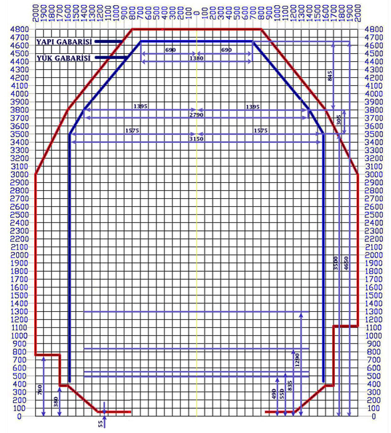
Figure 7: Vehicle Kinematic Clearance + Safety Margin

Table 1: TCDD Kinematic Clearance Table by Vehicle Type
TCDD Kinematic Clearance Table by Vehicle Type
Vehicle Type | Static Width (m) | Static Height (m) | Kinematic Width (m) | Kinematic Height (m) | Gauge Class (EN 15273) | Description
Passenger Coaches (Conventional) | 3.10 – 3.15 | 4.20 – 4.28 | 3.30 – 3.35 | 4.40 – 4.50 | GA / GB | Regional and suburban trains
Freight Wagons (Conventional) | 3.00 – 3.15 | 3.80 – 4.00 | 3.20 – 3.35 | 4.00 – 4.20 | GA | General freight transport
High-Speed Train Sets (YHT) | 3.15 | 4.28 | 3.27 – 3.30 | 4.45 – 4.50 | GB | High-speed trains (160–250 km/h)
Electric Locomotives | 3.15 | 4.30 | 3.30 | 4.50 | GA / GB | Modern electric traction vehicles
Diesel Locomotives | 3.10 | 4.25 | 3.25 | 4.40 | GA | Diesel traction locomotives

Türkiye is a member of UIC, so the international rail lines to be constructed in Türkiye should obey the rules of UIC and European Railway Committee. Structures which are to be constructed along the INRAIL line through which the railway vehicles are to be passed should have minimum inner dimensions suitable for the UIC GC (TCDD) reference profiles, (taking into considerations of; super elevation, catenary system height, construction tolerances). The design envelope for single line TBM tunnel, double line and single line NATM tunnels are given in the project drawings.

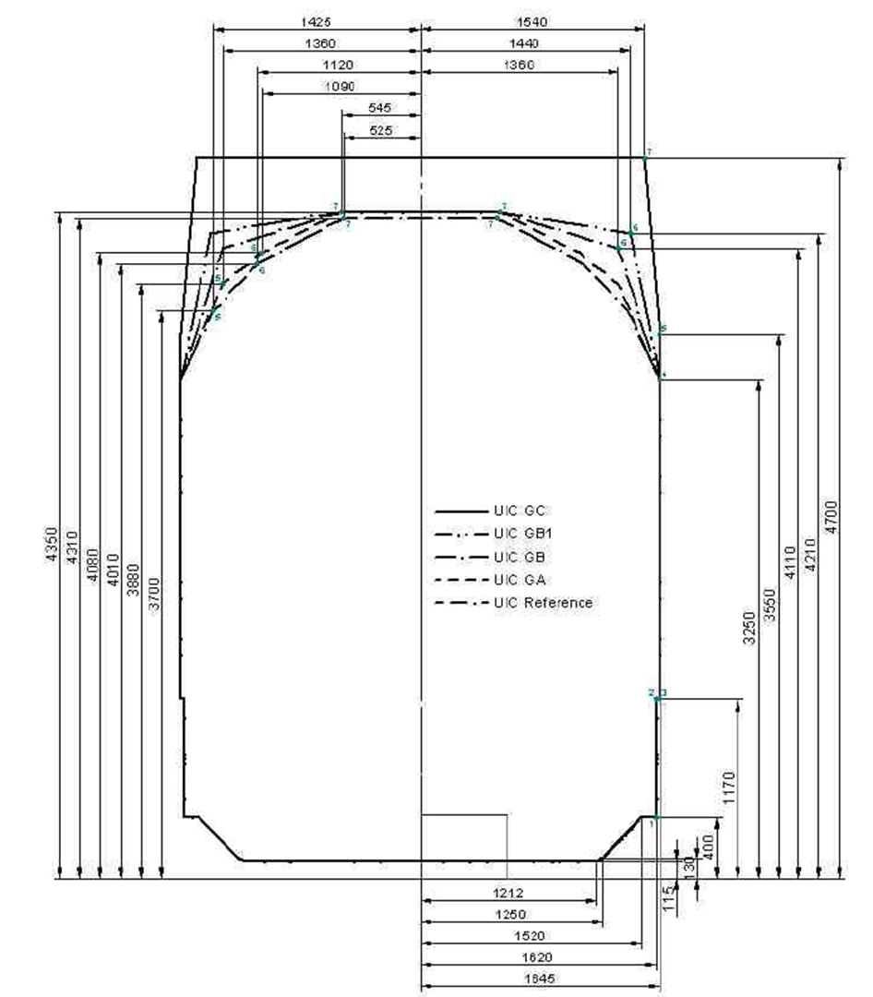
Figure 8. UIC Reference Profiles

ALIGNMENT STUDIES
As mentioned on previous paragraphs; İstanbul Metropolitan City has two parts, which is separated by Bosphorus as east side and west side. These two Anatolian and Europian sides has only one railway connection with The Marmaray Line. Marmaray passes Bosphorus by two rail lines and these lines are mostly used by metro lines. So, it is a necessity to have a rail line; starting from Gebze, passing near Sabiha Gökçen Airport, passing over the existing YSS Bridge, passing through 3rd airport and connecting with the existing railway which is going to Europe.

For the INRAIL alignment, different alternative corridors have been studied with the lead of AYGM. To reduce the land expropriation cost, alignment mostly settled parallel to existing Motorway. Alignment mostly passing out of population areas other than, Gebze- Çayırova- Sabiha Gökçen region. Plan profile of INRAIL is arranged to have minimum disturbance to existing topography and environment. Deep cuts and fills are not preferred, instead; tunnels, bridges are planned. On the alignment drawings; tunnels, bridges, stations are shown. List of structures along the line are given in the document “scope of works”.

All alignment studies are performed by using 1/5000 scale mapping. In line with the criteria described in previous sections, the project departs from Çayırova Marmaray Station and proceeds in the direction of Sabiha Gökçen Airport.

At Çayırova Station, the siding track has been extended, crossing over the existing line by means of a double-track bridge, and “S-type turnouts” have been installed to provide train movements in both directions towards Anatolia.

In order to allow continuation of the line towards Istanbul, a wye connection has been incorporated.
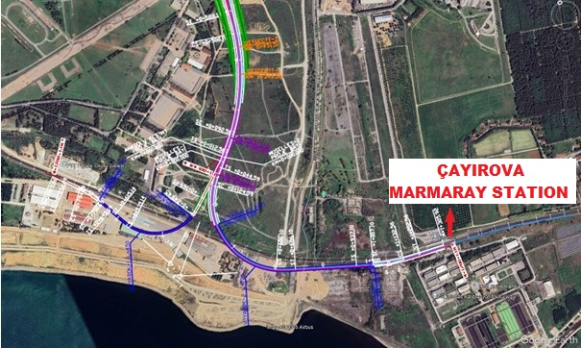
Figure 9 Çayırova Marmaray Station

Following Çayırova Station, Alternative 1 crosses the D-100 Highway using the cut-and-cover method and continues in the direction of Viaport Sabiha Gökçen Station.

In line with the recommendation of the financing institution, the World Bank, Alternative 2 alignment was studied. Alternative 2 proceeds towards Sabiha Gökçen Airport; approximately 1640m after Çayırova Station; two rail lines enter to two single line TBM tunnels. This alignment crosses the D-100 Highway with TBM tunnel.

Alignment reaches to Sabiha Gökcen Station location with these two parallel TBM tunnels (13,275 Km length of one TBM). At Sabiha Gökcen Station region, alignment will be four lines. Two inner lines will be passing through platform type tunnel, and they will be used only for passenger trains. Two outer lines will be used for freight trains; each line will be going through a separate single line TBM tunnel. There will not be any interface of freight trains with passenger trains which use separate tunnels.

Istanbul Northern Railway Station at Sabiha Gökçen Airport, will be planned as to have connection with the super high-speed railway line at concourse level. First level underground floor will be passenger concourse level. This level will be used both by INRAIL passengers and by super high-speed railway line passengers. At this level, they will have separate gates to go down with separate escalator tunnels.
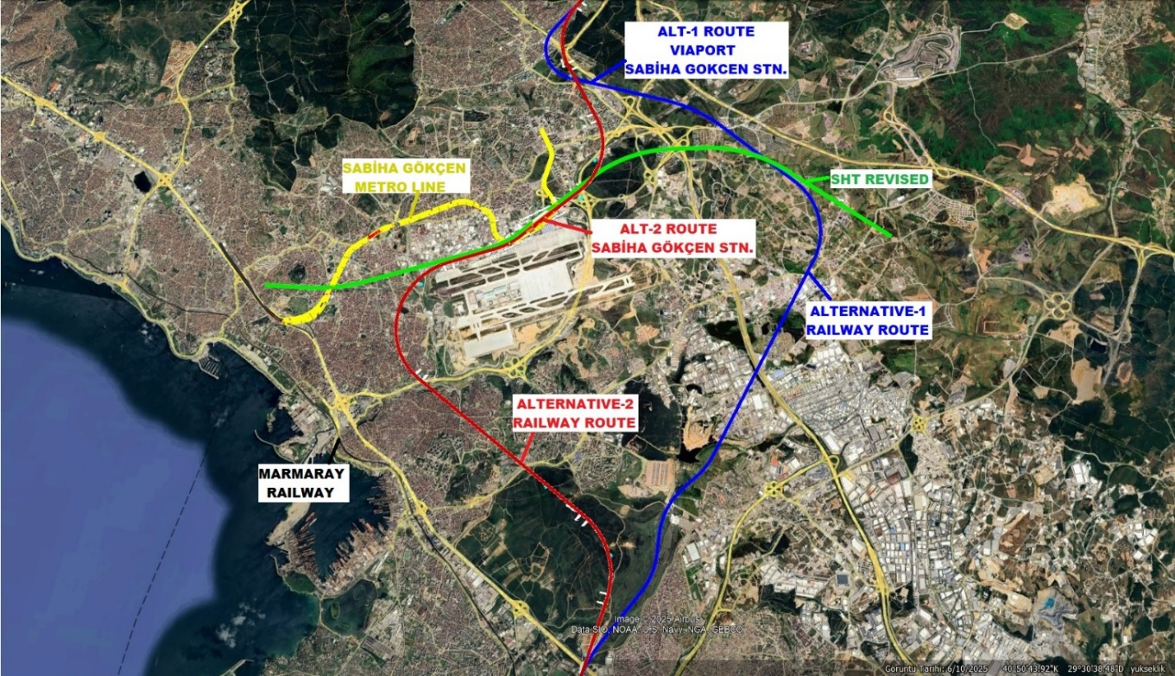
Figure 10 Istanbul Northern Railway Station at Sabiha Gökçen Airport
After Sabiha Gökçen Airport Station, the Alternative 2 alignment, continuing within a TBM tunnel, merges with the Alternative 1 alignment, which proceeds northward after Viaport Sabiha Gökçen Station, joining on the same axis at Km = 21+000.The Alternative 2 alignment crosses the North Marmara Motorway and its connection road via TBM tunnel.

At Km = 26+27000, following Sabiha Gökçen Station, the TBM tunnel—extending approximately L = 11,124.00 m—comes to an end.
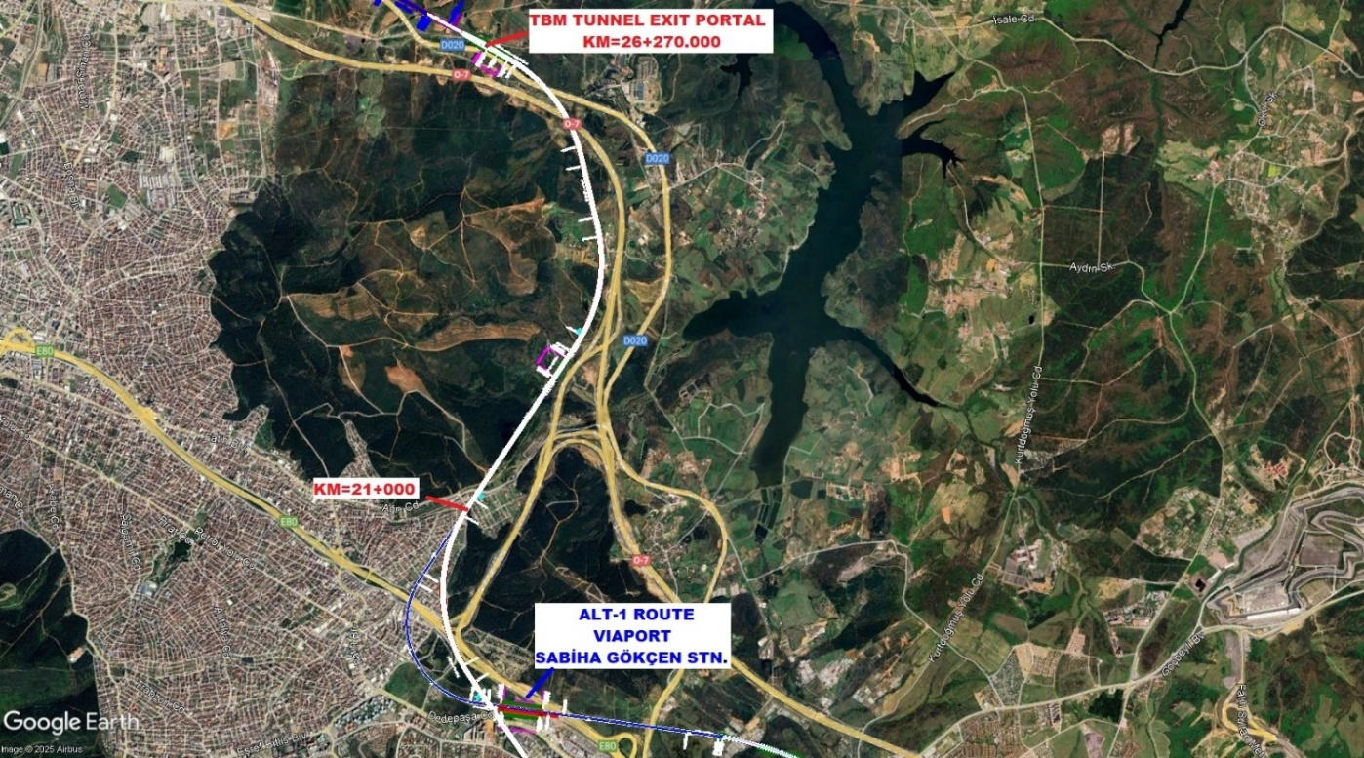
Figure 11 TBM Tunnel from Sabiha Gökçen Airport
From Km = 26+270.000, the alignment continues along the eastern side of the North Marmara Motorway. Passing to the west of the Paşaköy settlement area by means of bridges, cut-and-cover tunnels, and NATM tunnels, the route has been kept as close as possible to the motorway, with efforts made to avoid expropriation in agricultural and forested areas.

On the section where the line crosses to the western side of the North Marmara Motorway through a NATM tunnel, the approximately 10 km stretch up to Km = 36+240 includes 3 bridges, 1 cut-and-cover tunnel, and 4 NATM tunnels.

A tributary flowing towards the Ömerli Dam is crossed by a bridge with a length of L = 310.0 m and a height of h = 44.0 m. In addition, culverts are planned for stream crossings, and suitable areas have been reserved for road crossings.

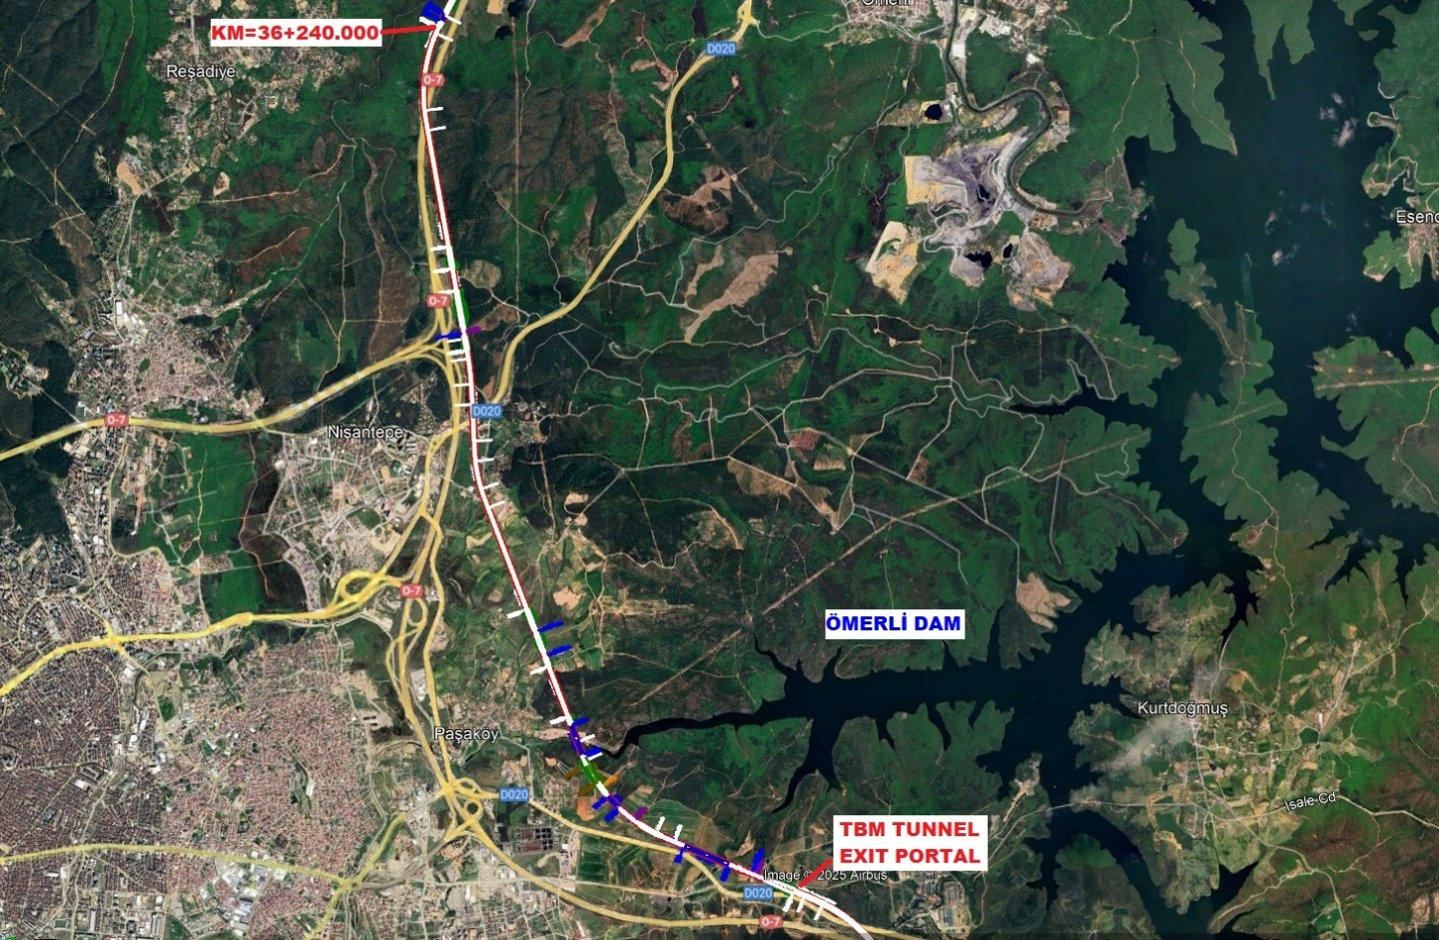
Figure 12 TBM Tunnel Exit Portal Map in Ömerli Dam Area
After crossing to the western side of the North Marmara Motorway via a NATM tunnel, the alignment continues parallel to the motorway through a combination of bridges, viaducts, tunnels, and cut-and-cover sections. Up to the entrance of the Yavuz Sultan Selim Bridge, the line follows the motorway corridor in parallel, thereby minimizing expropriation and the use of forested areas.
At the entrance of the Yavuz Sultan Selim Bridge, the line connects to the bridge via an already completed cut-and-cover structure, thus providing passage to the European side.

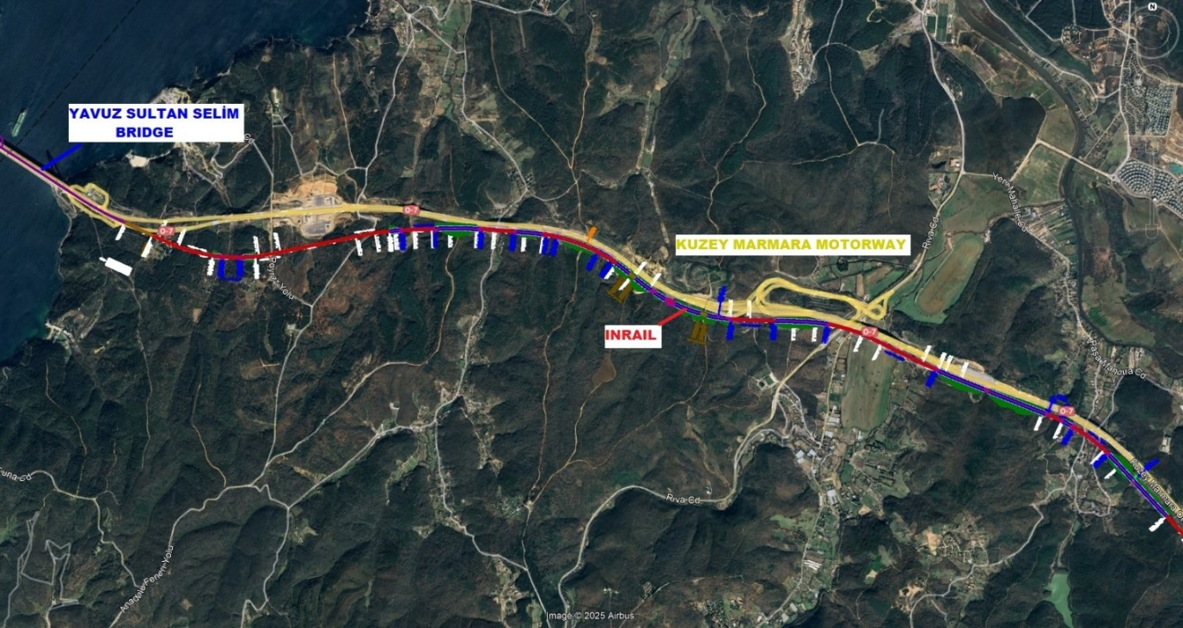
Figure 13 NATM tunnel in North Marmara Motorway
The alignment proceeds along the designated railway corridor on the Yavuz Sultan Selim Bridge and exits through the completed cut-and-cover structure at the bridge’s end, continuing parallel to the motorway via a NATM tunnel.

With, 2x4 lane highways and 2 railway lines, Yavuz Sultan Selim Bridge, has 59m total width and 1408m maximum span length. It is the longest bridge in the world with railway integrated into its design. It was conceived to accommodate both road and rail transportation.

Along the motorway corridor, the alignment continues with viaducts, bridges, and tunnels, minimizing land expropriation. The ecological overpass planned for animal crossings along the North Marmara Motorway has also been extended to the railway alignment, ensuring wildlife passage. In addition, road crossings are designed to be carried out via overpasses and cut-and-cover structures.

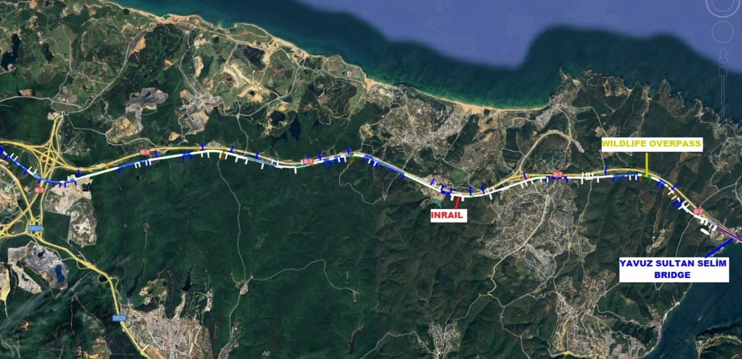
Figure 14 NATM tunnel in North Marmara Motorway
At the entrance and exit of the Istanbul Airport Station, TBM tunnels have been constructed. Within Istanbul Airport Station, passenger and freight transportation are separated by a wall in order to prevent potential hazards arising from fire or freight operations.

In designing the alignment, the Istanbul Airport metro lines have been taken into account, and tail tracks for the cargo terminal have also been planned.

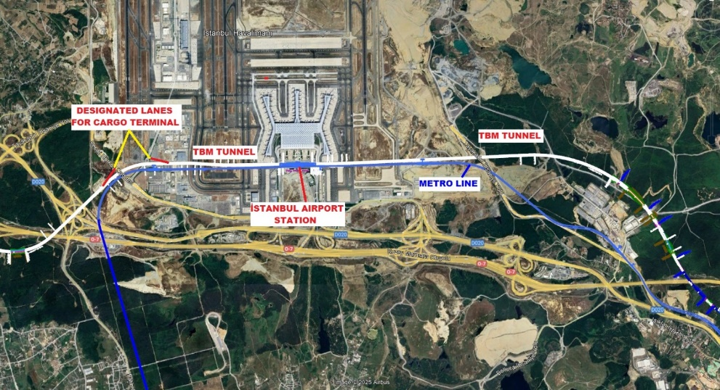
Figure 15 Istanbul Airport Station

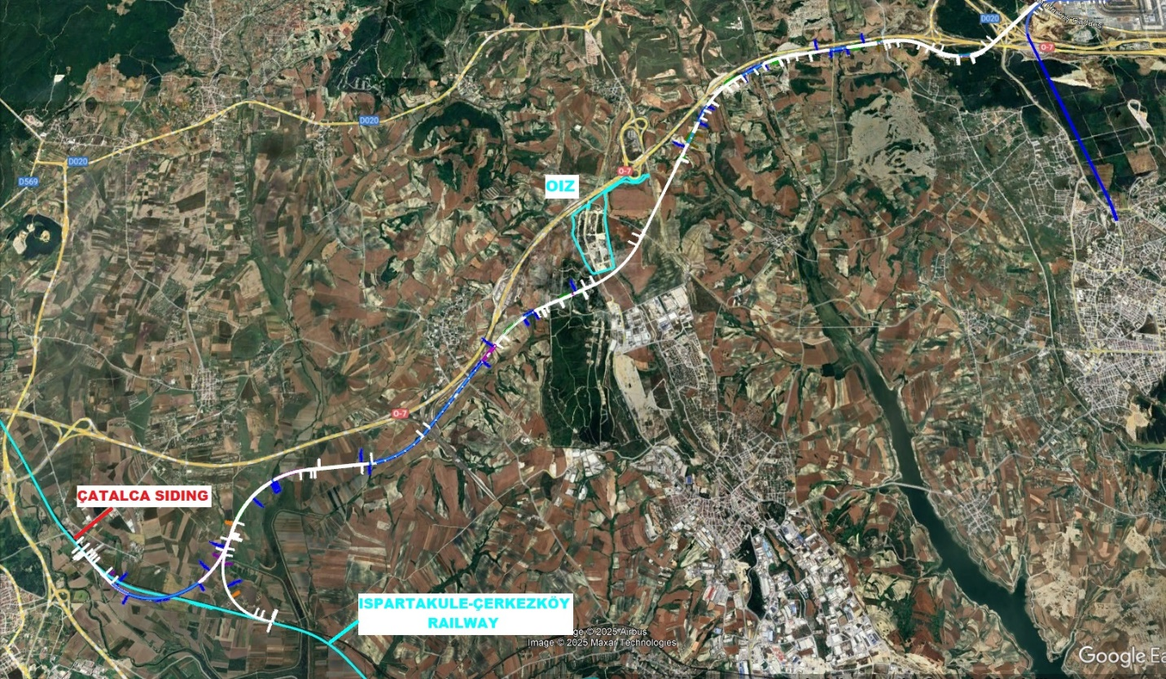
Figure 16 Organized Industrial Zone
After exiting Istanbul Airport, the alignment continues within a TBM tunnel and runs parallel to the motorway for approximately 5.5 km. It then proceeds south of the Organized Industrial Zone through a tunnel, crosses a motorway interchange branch and the under-construction Ispartakule–Çerkezköy Line by means of a bridge, and connects to Çatalca Station.

The alignment has been designed as a double-track route, providing bi-directional operation towards Kapıkule. For the direction towards Istanbul, a wye connection has been planned. Total alignment length of Inrail is 127 Km (excluding sidings at the stations).

The Project is a significant investment that will strengthen Istanbul’s strategic transportation infrastructure and serve as a complementary element to the existing railway network. The proposed alignment has been designed to meet high-capacity demands for both passenger and freight transport, while ensuring integration with existing metro lines, high-speed railway services, and airport connections, thereby providing a holistic approach to the transportation system.

In the alignment planning, engineering criteria, environmental impacts, minimization of expropriation areas, protection of agricultural and forest lands, as well as international standards have all been taken into account. In this way, a solution has been developed that is not only technically feasible but also minimizes environmental and social impacts.

As a result, the implementation of the INRAIL will provide a long-term and sustainable solution to Istanbul’s increasing transportation needs and make a significant contribution to both regional and international transportation.

Platform Level Escape Plan and Door Capacity Assessment for Sabiha Gökçen Station
Passenger amounts for Sabiha Gökçen Station and for New Istanbul Airport Station are not clearly defined. At this stage passenger evacuation for the emergency case from the platform to a fire- safe area can be checked according to NFPA 130 (Standard for Fixed Guideway Transit and Passenger Rail Systems). Accordingly, at each side of the platform floor level, one full train passenger amount will be assumed as waiting. A full train will assumed to be arriving to the platform. There are two platforms at the platform level of Sabiha Gökçen Station (each direction one platform). According to NFPA 130; to have a fire safe passenger station planning, within 4 minutes, totally four full train passenger amount can evacuate from platform to a fire safe area. New passenger high speed trains with 584 passenger capacity are planned to be operated on high-speed train lines of Türkiye.

On the platform floor (B3) of Sabiha Gökçen Metro Station, fire-resistant doors have been installed between the platform and the stairs for use in fire and emergency evacuations. Through these doors, passengers can access safe evacuation routes by passing directly to protected fire halls.
With this arrangement, the stairs and upper floors are protected from the effects of smoke.

Each platform is equipped with 12 fire-rated doors with a net clear width of 2.4 m, resulting in 28.8 m total clear evacuation width per platform. Using an evacuation flow rate of 60 passengers/min/m and a 4-minute evacuation time, the calculated evacuation capacity is: (2 × 2.4 m wide doors × 6 tunnels = 28.8 m clear opening × 60 pass/min × 4 min = 6,912 passengers) > (584x4=2,336 passengers). The design passenger load is significantly lower than the calculated capacity; therefore, the evacuation capacity is sufficient for the defined critical scenario.

Platform Level Escape Plan and Door Capacity Assessment for Istanbul Airport Station
Standards and Acceptance Criteria:
In accordance with NFPA 130, the platform shall be cleared within 4 minutes or less.
Platform Layout:
The station consists of an island platform: Island Platform: 400 m length × 11.50 m width
Platform arrangement:
- Fire escape stairs are provided at both ends of the platform,
- Four escalators are distributed along the platform at regular intervals,
- One fixed stair is provided adjacent to each escalator,
- The net clear width of each fixed stair is 3.0 m.
Accordingly, a total of four fixed stairs are available on the platform.
Design Evacuation Passenger Load (Updated)
- Passengers waiting on the platform: 2x584=1,168 passengers
- Passengers from two trains coming to the platforms: 2 × 584 = 1,168 passengers

Total design evacuation passenger load:
N = 1,168 passengers per platform
Unit Capacity Assumption:
- Under emergency conditions, the evacuation capacity of fixed stairs is taken as 56 passengers/min/m.
- Platform Exit Capacity (Fixed Stairs)
- Total fixed stair width:
4 × 3.0 m = 12.0 m
- Platform exit capacity:
12.0 m × 56 passengers/min/m = 672 passengers/min

Evacuation Capacity within 4 Minutes; 672 passengers/min × 4 min = 2,688 passengers
Compliance Check: 2,688 > 2,336 (=1,168x2)

When the passengers present on the platform and the passengers from two trains berthed at the platform are considered together (total of 1,168 passengers per platform), the available fixed stair capacity is sufficient to evacuate the platform within the 4-minute platform clearance time required by NFPA 130. Therefore, the platform evacuation capacity is adequate for the defined scenario.

GEOLOGICAL, GEOTECHNICAL, CLIMATIC ASSESSMENTS OF THE LINE

Landslide Risks
It is possible to determine the interaction of the alignment with active, inactive and/or shallow-deep landslide potential regions by using Landslide Hazard Map of Turkiye, which is available at https://yerbilimleri.mta.gov.tr/.
A general view of the Project area with active (red), inactive (orange), creep type or shallow (yellow) landslide information is given in the figure below:
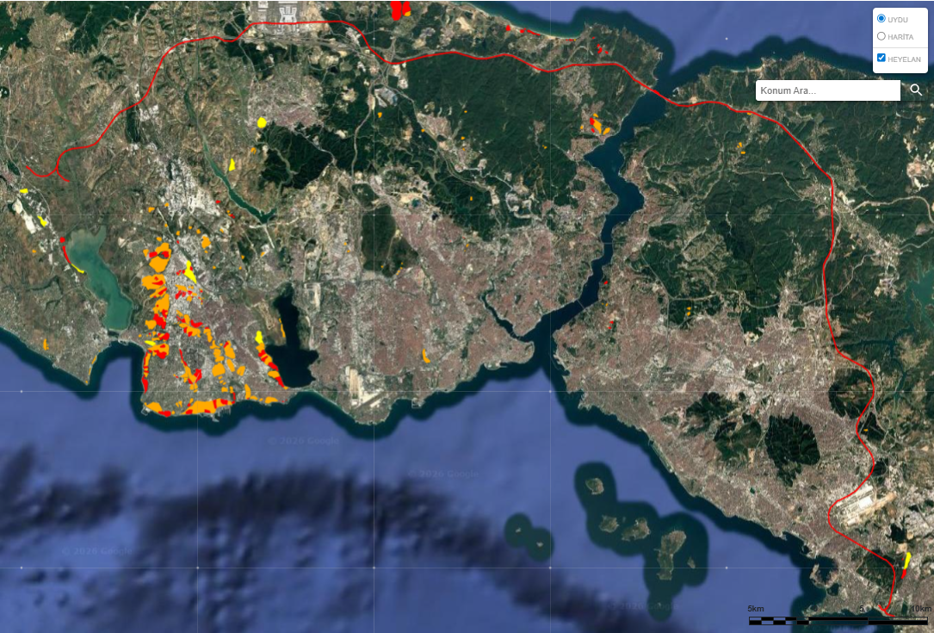
Figure 17 Landslide Hazard Map
According to the desk study conducted, it is determined that the alignment does not have a direct interaction with possible landslide mechanisms. So, it can be concluded that the major risk of landslide can be eliminated by this study. On the other hand, it is mandotary to carry out a site survey during the detailed design phase in order to detect any possible landslides along the route which may not be available in the national inventory.

Site Investigation Works:
Approximately 80% of the alignment is parallel to the Northern Marmara Motorway (O7) which was constructed between 2013-2017. Two sample satellite views for Asian and European side of the Project are presented below, respectively.
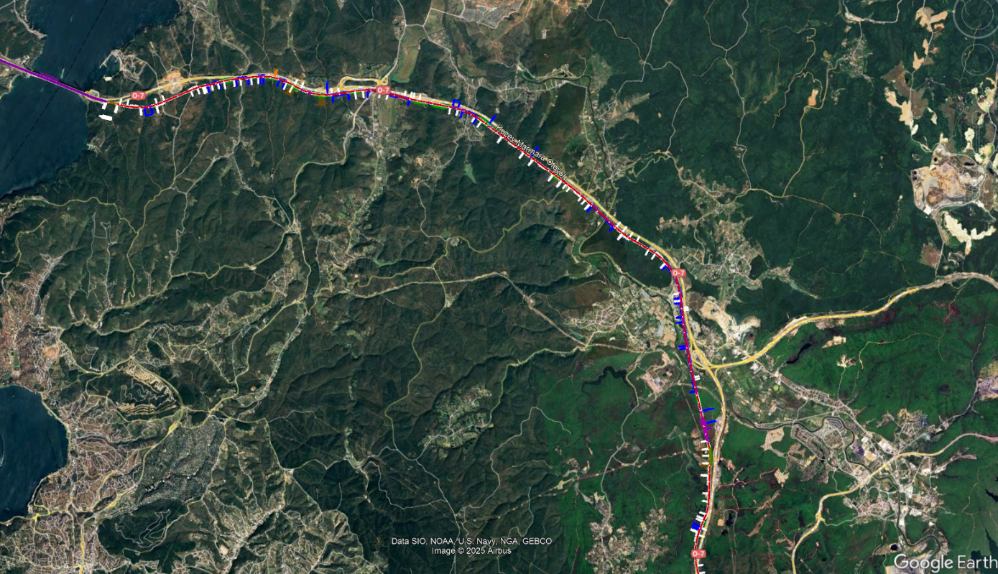
Figure 18 Project alignment and existing motorway (Asian Side)
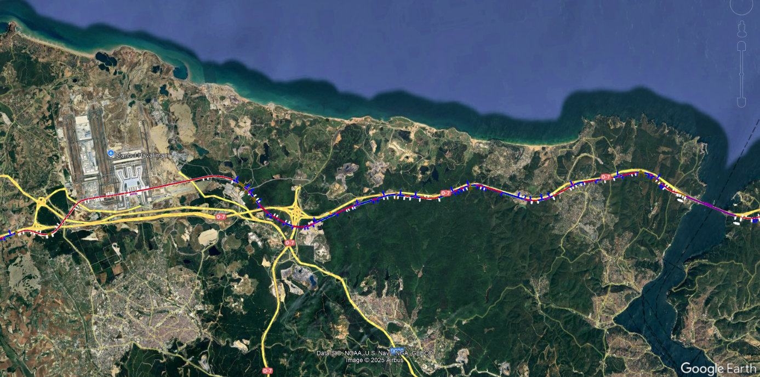
Figure 19 Project alignment and existing motorway (European Side)

The following figure shows a combined view of Asian and European Side with the data of existing boreholes.
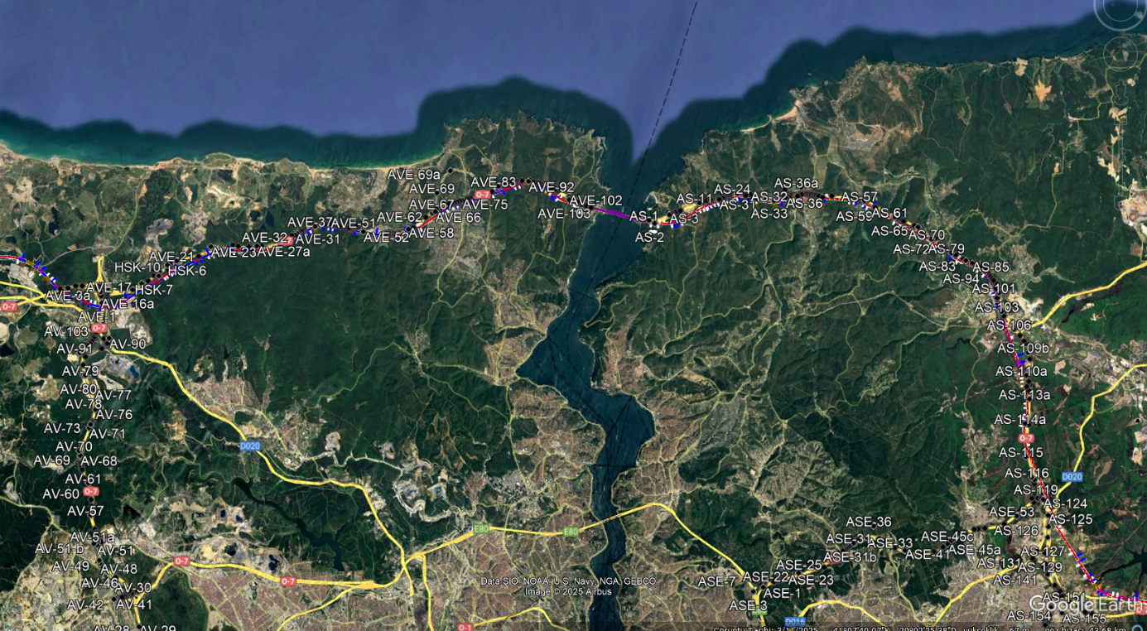
Figure 20 Existing Borohole Layout

So, the geological and geotechnical conditions are well known for the most of the alignment since the site investigation results (boreholes, in-situ tests, laboratory tests etc.) and geological and geotechnical design reports are available for the existing motorway. During the detailed design stage, additional site investigations are required where it is necessary considering the alignment, type of the structures and available data.

Seismic Hazard Evaluation:
The interaction between the alignment and the active faults was also evaluated during the design stage. According to the data given below, it is determined that the southest part of the Project is located approximately 10 km apart from the nearest active fault which is very well known as North Anatolian Fault.
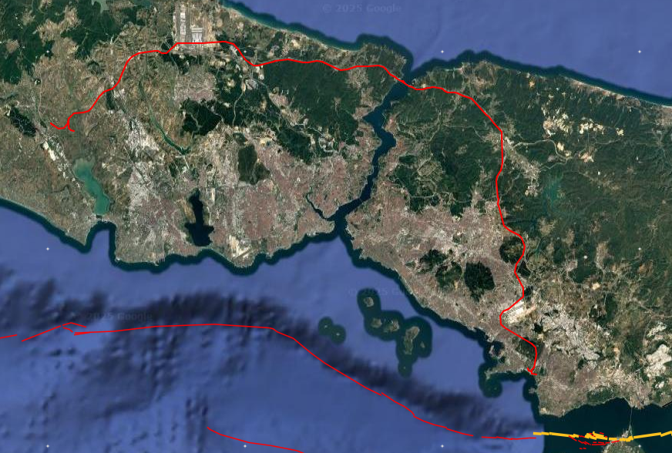
(b)
(a)
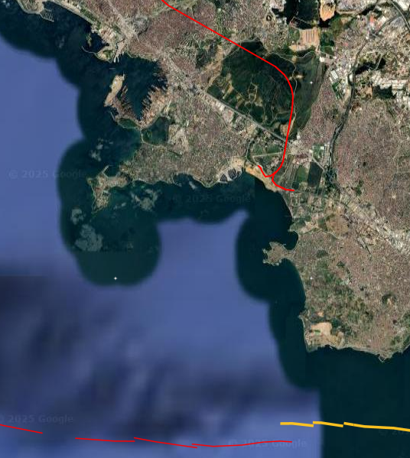
Aprx. 10 km
Figure 20 The location of active faults along route (a), the section where active faults are closest to route (b) according to MTA.

In the detailed design stage, both of the earthworks’ design (embankments, cut slopes etc.) and structural design (bridges, overpasses, underpasses etc.) will be carried out in accordance with the current seismic design code. The seismic risks will be evaluated by considering the Earthquake Hazard Map of Türkiye (2018) which is presented below:
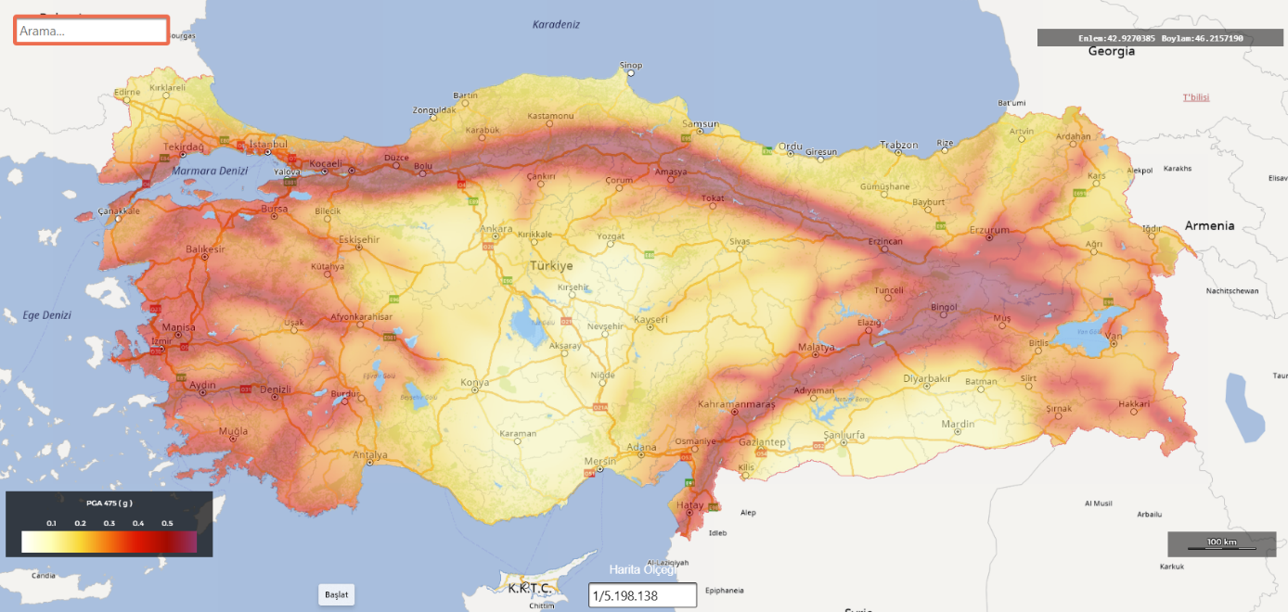
Figure 21Earthquake Hazard Map of Turkiye (2018, AFAD)

It is possible to obtain seismic design parameters for the specified region considering the local soil class properties from the interactive map which is accessible on the internet (https://tdth.afad.gov.tr/) for designers. In addition, when it is required, according to the local seismic design code (Specification of Seismic Design for Transportation Structures, 2020), a site specific seismic hazard evaluation study shall be conducted during the detailed design stage.

Yavuz Sultan Selim (YSS) Bridge Crossing for Istanbul North Railway
Istanbul North Railway corridor passes through Yavuz Sultan Selim Bridge (YSS) on which there is reserved area for railway crossing. Only the expansion joints are addressed to be changed to railway expansion joints as stated in YSS Bridge drawings. YSS bridge was designed as resistant to railway traffic loads and to seismic activity of the area. Reserve area can be seen from the section below. Railway works, slab track, rails connections, rail expansions joints, catenary system, signaling system, will be designed and constructed, in accordance with the existing bridge structural design, reserves and application points left for the railway.
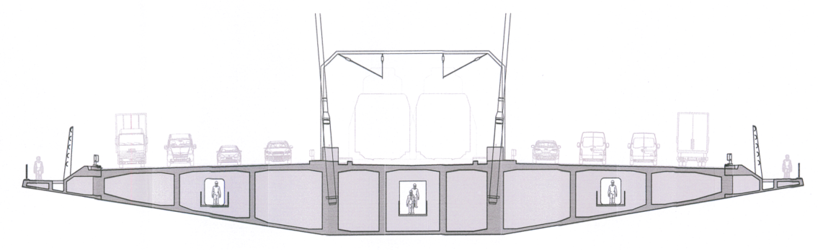
Figure 22 Typical YSS Bridge Cross Section
There is a prepared seismic hazard report for the bridge area which shows that the seismicity of the area considered in design calculations. MTA fault map presented in seismic hazard report can be seen below:

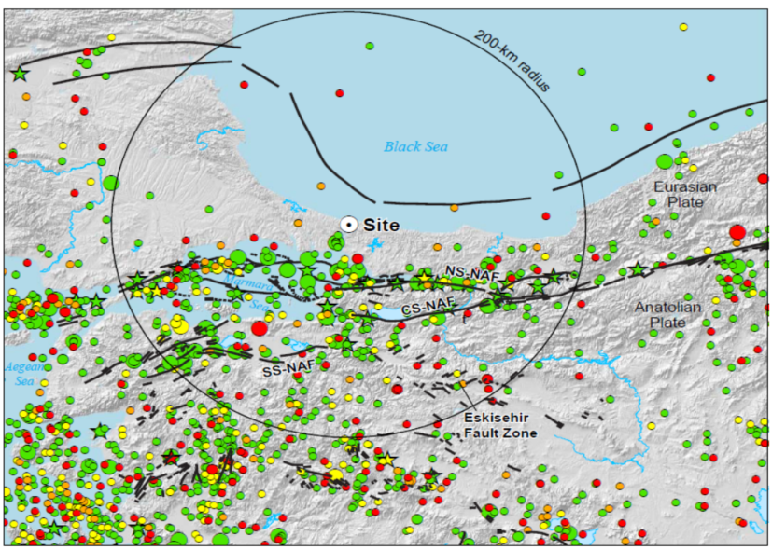
Figure 23 Seismic Map (MTA) around YSS Bridge Area
The region around the bridge was divided into eight areal source zones such as Thrace-Black Sea (Zone 101), Northern Plate Boundary (Zone 102), North Anatolian Fault-North Strand (Zone 103), Central Marmara Sea (Zone 104), North Anatolian Fault – South and Central Strand Zone (Zone 105), Anatolian – Aegean Extension (Zone 106), Anatolian Transitional (Zone 107), Anatolia Interior (Zone 108).

Summary of Areal Source Parameters used in Seismic Hazard Report is presented below;
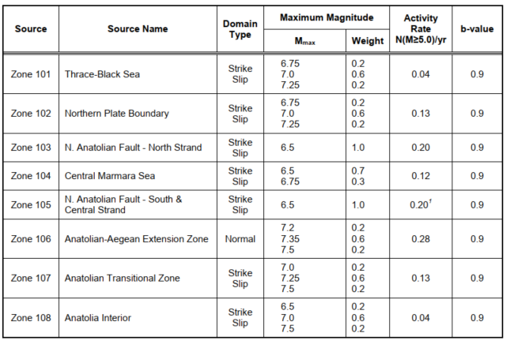
Figure 24 Summary of Areal Zone Parameters
Seismic time history motions are selected by considering the seismological conditions of the site. These are explained in detail in the seismic hazard report prepared for the YSS bridge. Selected time histories taken from the Seismic Hazard report are shown below;
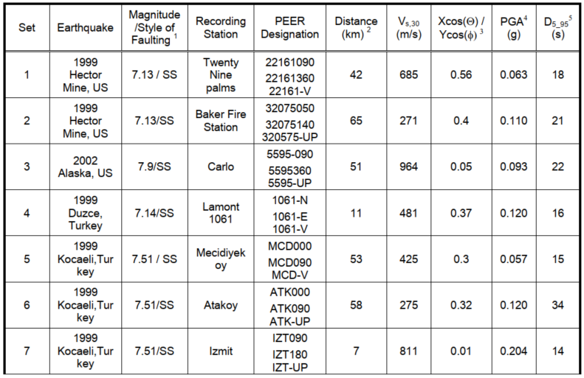
Figure 25 Selected Time History Datas for YSS Bridge

There is prepared maintenance plan for YSS Bridge and periodic maintenance is being performed accordingly. The maintenance plan table is presented below;
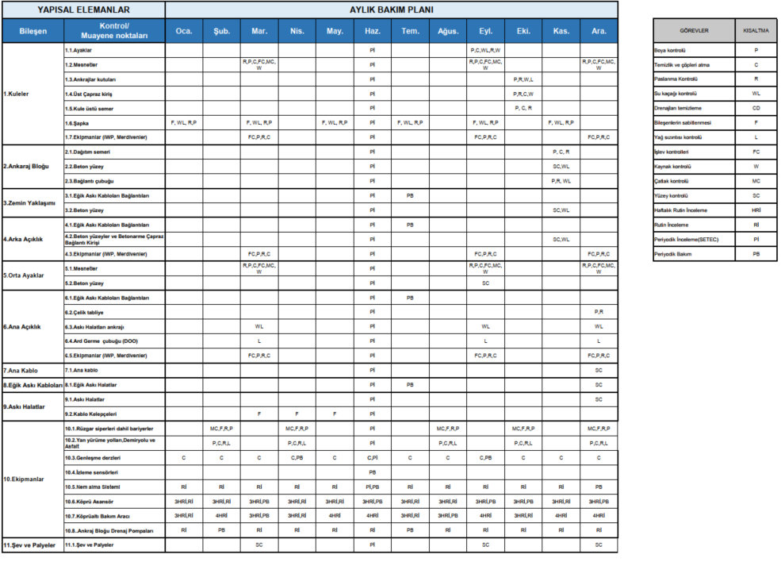
Figure 26 Maintenance Plan for YSS Bridge

Geotechnical Interpretations
As it is stated in the previous chapters, approximately 80% of the alignment is parallel to the Northern Marmara Motorway (O7) which was constructed between 2013-2017. The preliminary geological and geotechnical interpretations are based on these results but it should be noted that additional site investigations are mandatory for the detailed design stage. It can be concluded that;
- There is no a major risk in terms of landslides.

- The route does not have a direct interaction with the active faults. Istanbul is a risky project area in terms of seismicity considering the past earthquakes and current information regarding the active faults, expected ground accelerations etc. On the other hand, local seismic design specifications are a part of the state of the art for designing the transportation structures against strong ground motions. In addition, it is well known that the 49 km of the alignment is consist of tunnels which are less sensitive structures in terms of seismic conditions. Seismic activity is much more critical at southern region of the Project. At northern parts the risk is reduced. Active faults presented by MTA Local Authority was evaluated during the preliminary design stage. There are no faults crossing the alignment. Therefore, major risks regarding earthquake are not defined at this stage. However, Turkish earthquake code shall be followed during the detail design stage.

- Most of the route consists of tunnels which are not have a direct interaction with the existing structures. In a limited area (especially in the Asian side) there is a possible risk in terms of behaviour of existing structures due to tunneling. It is necessary to perform realistic soil-structure interaction analysis with considering the data obtained from the building condition survey which is suggested to carry out during the detailed design stage. Besides, an intensive monitoring programme shall be done for both tunnel construction and existing structures which are in the interaction zone.

- In the scope of the Project, temporary and permanent cut slopes with significant height (20-30 m) will be constructed. Such slopes require special attention in terms of both design and construction. A detailed site investigation programme is mandotary for the detailed design stage including the site investigation studies considering landslide hazard potential. On the other hand, since the most of the Project alignment is parallel with the existing motorway, local experience obtained from that project is valuable which will be served as an assistance for detailed design. During the preliminary design stage, a desk study conducted and it is determined that the alignment does not have a direct interaction with possible landslide mechanisms. It is expected to have both supported (with soil nails etc) and un-supported (free) cut slopes along the route.

- Considering the geological/geotechnical conditions along the route it is expected to have most of the bridges along the route will be piled foundations.

- In a limited region, the route will be constructed as embankment. In these regions shallow (weak soil replacement) or deep (deep soil mixing, unreinforced bored piles etc.) soil improvement methods may be necessary in order to mitigate bearing capacity and/or settlement problems.

Climate Change and Climate Resilience (Flooding, wind, extreme temperatures) Considerations:

General Climate Conditions and Preliminary Assessment
During the preliminary design, general examination works are performed in order to evaluate potential climate-related hazards along the corridor. Historical data was gathered from General Directorate of Meteorology as shown below;
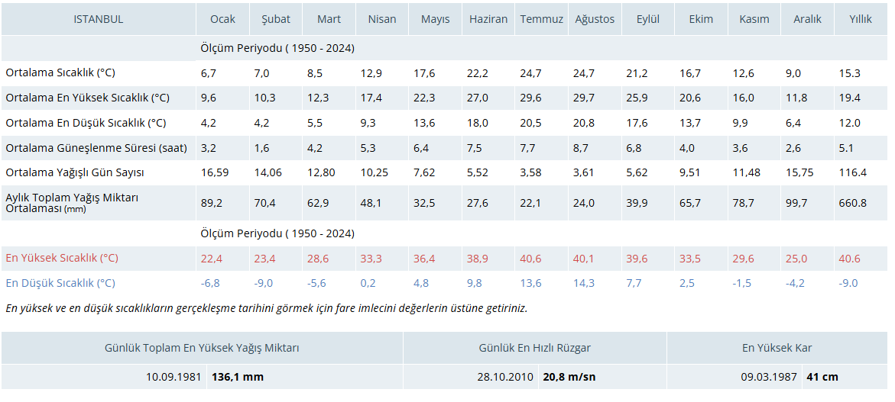
Figure 27 General Climatical Values for Istanbul
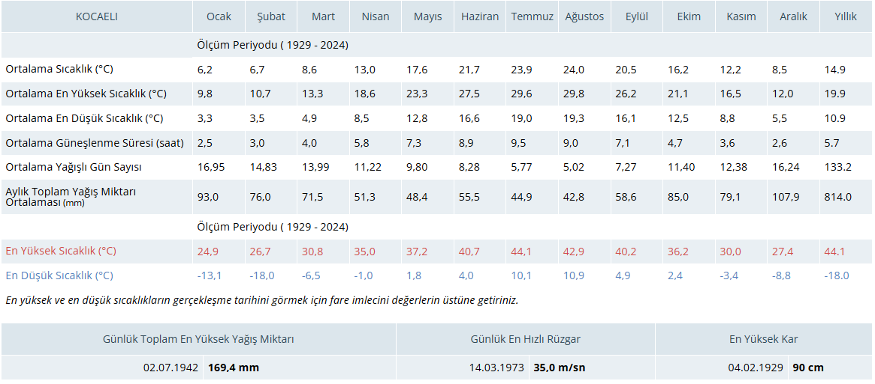
Figure 28 General Climatical Values for Kocaeli

As can be seen from the tables presented above, temperature differences and wind speeds can be considered in the acceptable design limits both for Kocaeli and Istanbul. During the detail design, wind loads and temperature difference loads shall be calculated by considering current version of the above presented data. Temperature variation is important for railway bridges serviceability conditions mainly. In European standards +/- 35oC temperature variation is applied on superstructure elements of bridge for checking the additional stress on rail for the bridges in which rail expansion joints are not used. In case of rail expansion devices, +/- 50oC temperature difference is applied on rail together with the temperature difference of 35oC on bridge superstructure and additional stress on rail is checked accordingly. As can be seen from this explanation above and by checking the average/maximum/minimum temperature values of the region, It can be concluded that the climate considerations regarding temperature is considered during preliminary design as acceptable.

After examining the climate data, the corridor was also checked whether there are potential areas for landslides or not. Explanations regarding landslides are presented in Section 3.2 in detail.
The first part of the route until seating near motorway corridor is constituted of tunnels mainly. There are mainly viaducts and culverts for valley and stream crossings same as the neighbor highways. Streams are also passed with viaducts at Çatalca region.

In Türkiye, hydrologic and hydraulic reports for the alignments of all the railway, highway projects; should get an approval from national water works organization before construction. Due to climate changes; national water works (DSİ) to increase the safety of hydraulic structures along the railway for flooding; has changed (in the year 2020) the design flow rates from hundred-year flood period to five hundred years. For the preliminary design phase, same dimensions of hydraulic structures (culverts) near existing motorway were used. During detailed design, hydrologic and hydraulic report will be prepared for the INRAIL and get approval from national water works (DSI) and the dimensions of the hydraulic structures will be in accordance with this report.

Climate Resilience Considerations for Detailed Design and Construction
While the general climatological assessment presented above is considered adequate for the preliminary design stage, a more detailed climate resilience approach shall be adopted during the detailed design and construction phases to address the potential impacts of climate change.

In this context, potential climate-related hazards shall be identified, and appropriate design parameters, safety margins, and mitigation measures shall be defined or referenced by the Design & Build (D&B) Contractor. These assessments shall be based on updated climatological data, applicable national regulations, relevant European standards, and internationally recognized guidelines.

The climate resilience considerations are structured under the following sub-headings:

Extreme Rainfall & Flooding
Extreme rainfall and flooding events may result in adverse effects such as overflow of side channels, surface runoff leading to ballast loss, exceedance of culvert capacity, scour at bridge foundations, blockage of hydraulic structures due to debris accumulation, and triggering of landslides or slope instabilities.

During the detailed design phase, hydrologic, hydraulic, and geotechnical assessments shall be carried out to identify these hazards. Design parameters and safety margins shall be defined or referenced in DSİ-approved hydrologic and hydraulic reports, considering at least a 500-year return period flood event. Mitigation measures, including adequate sizing of hydraulic structures, scour and erosion protection, debris control measures, and slope stabilization solutions, shall be incorporated into the detailed design.
During construction, temporary and permanent drainage and erosion control measures shall be implemented in accordance with approved design documents and method statements to manage extreme rainfall events.

Extreme Temperatures

Extreme temperature conditions may cause increased rail expansion and fastening forces, higher catenary tension requirements, overheating of electrical equipment, and degradation of ballast material, potentially reducing track stiffness.

Temperature-related hazards shall be assessed during the detailed design phase using updated climatological data. Design parameters and safety margins for rail, bridge, and catenary systems shall be defined in accordance with applicable European railway and structural design standards. Bridge–track interaction, rail expansion behavior, and catenary performance shall be verified under extreme temperature scenarios.

Mitigation measures shall include the selection of appropriate materials and equipment suitable for high-temperature conditions and the verification of track and structural components under extreme thermal effects.

Extreme Wind Conditions

Extreme wind conditions may impose additional loads on elevated structures, increase catenary forces, and affect operational safety due to excessive lateral forces on trains.

Wind-related hazards shall be evaluated during the detailed design phase, and wind load parameters and safety margins shall be defined in accordance with applicable standards. Structural design checks for viaducts and elevated sections, as well as verification of catenary system performance under extreme wind loads, shall be carried out. Where necessary, operational mitigation measures shall be considered.

The identification of climate-related hazards, definition of design parameters and safety margins, and determination of appropriate mitigation measures shall be the responsibility of the D&B Contractor during the detailed design phase. All measures shall be clearly documented in the design deliverables and implemented during construction in accordance with approved specifications, method statements, and quality control procedures.

ASSESSMENTS OF THE STRUCTURES ALONG THE LINE
The Project alignment was planned, considering the topographic structure of the land, existing structures and existing land uses. Due to topography and geometric design standards of the railway, some structures are to be planned along the railway line. Tunnels, bridges, under and over passes, cut and cover structures, hydraulic culverts are planned along the line. Some places along the line are planned as land-cut and land fill without any structure on the line. To increase the feasibility of the railway; alignment is planned as to pass close to Sabiha Gökcen Airport and plan a passenger station there and pass through Istanbul Airport with a previously planned passenger station.

Structural Inventory Tables can be found below:
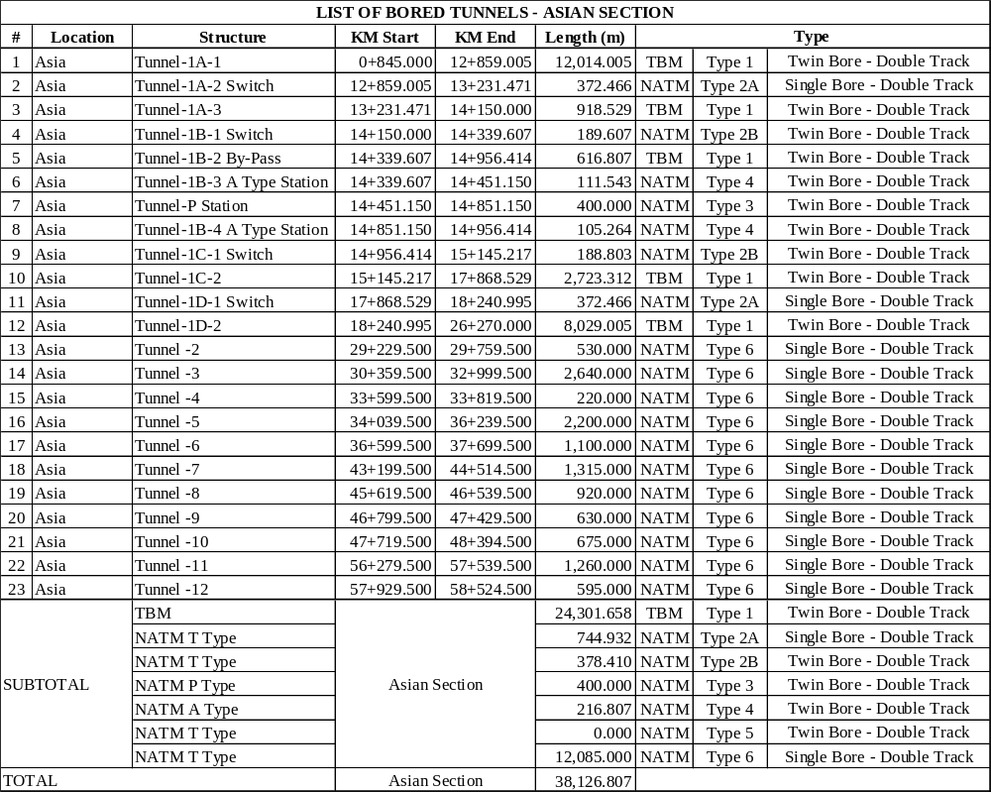
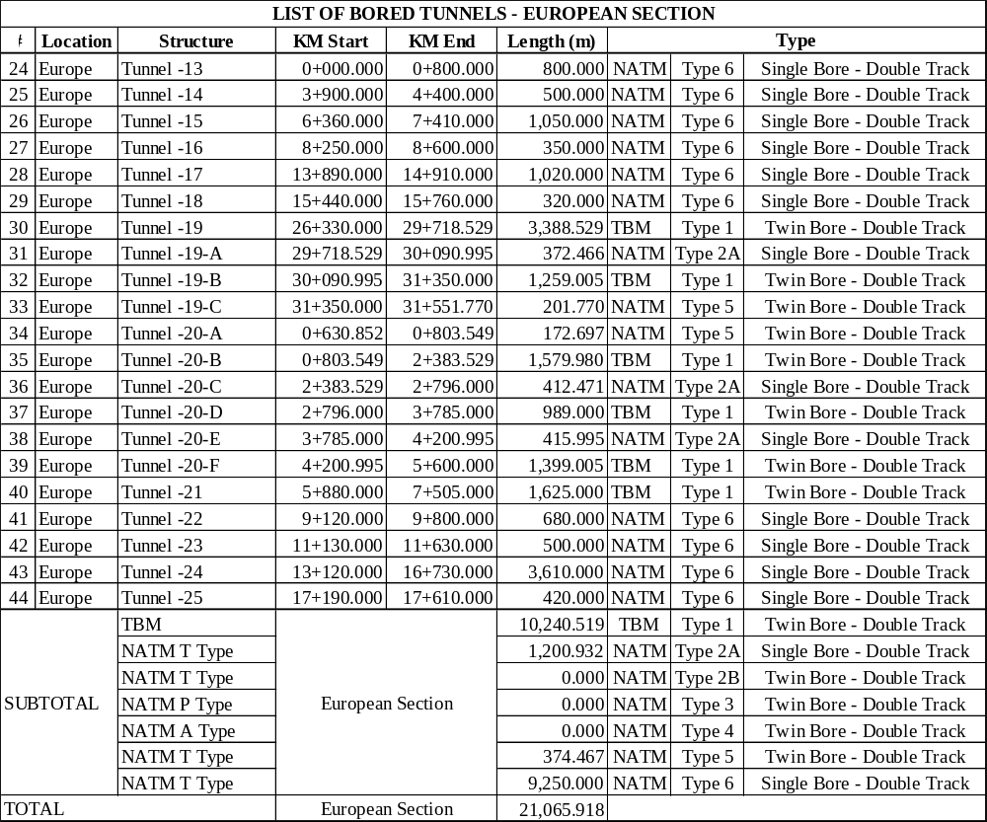
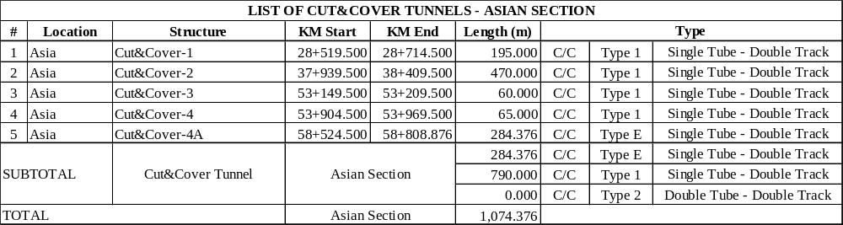
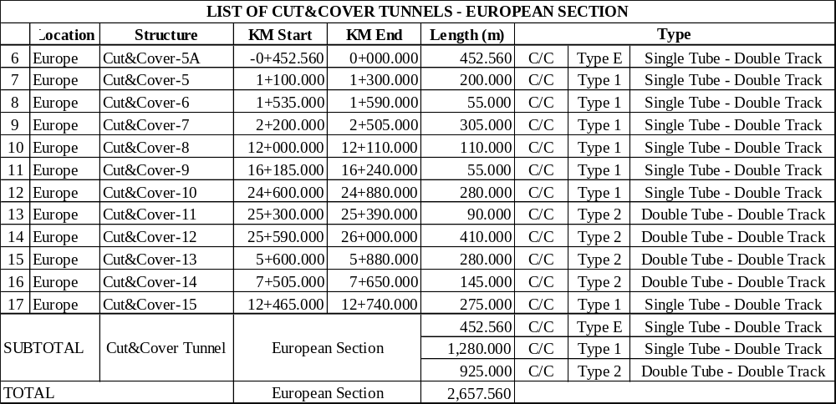
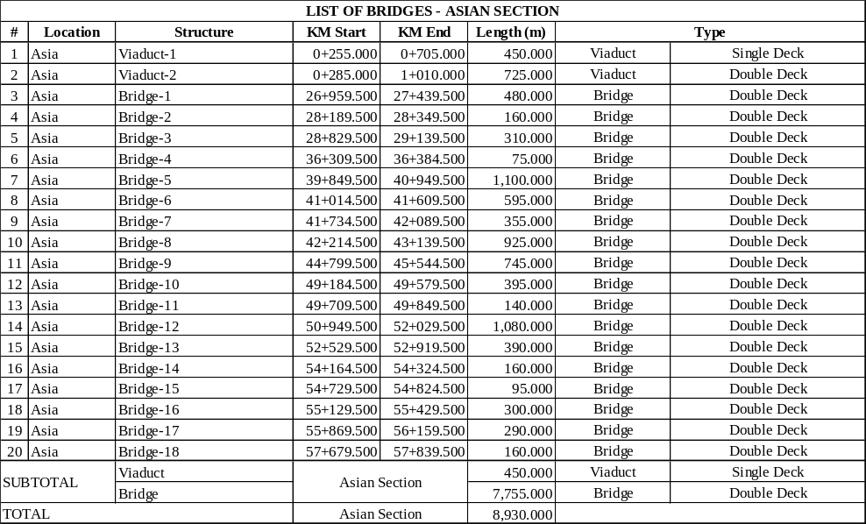
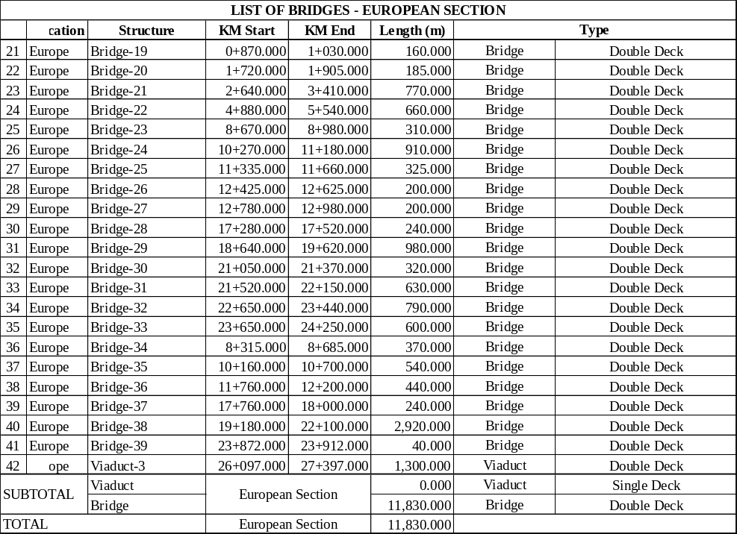
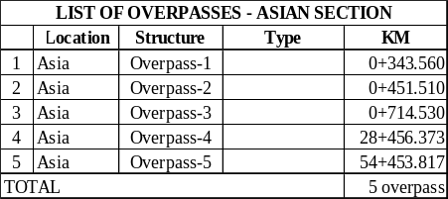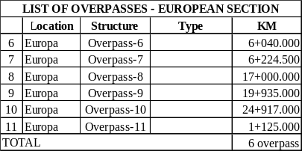
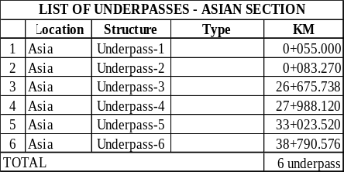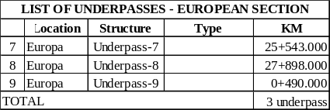
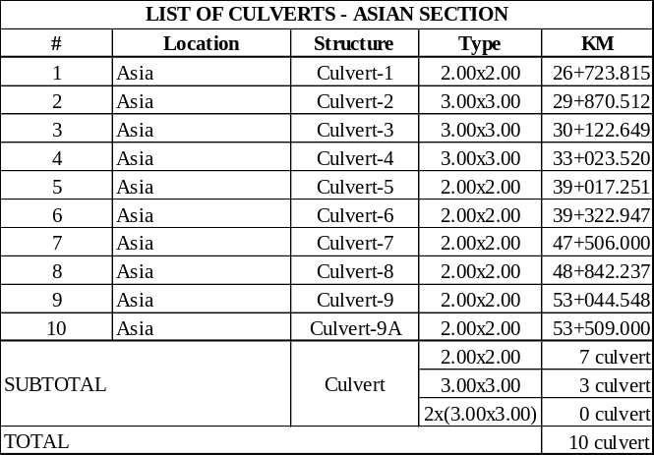
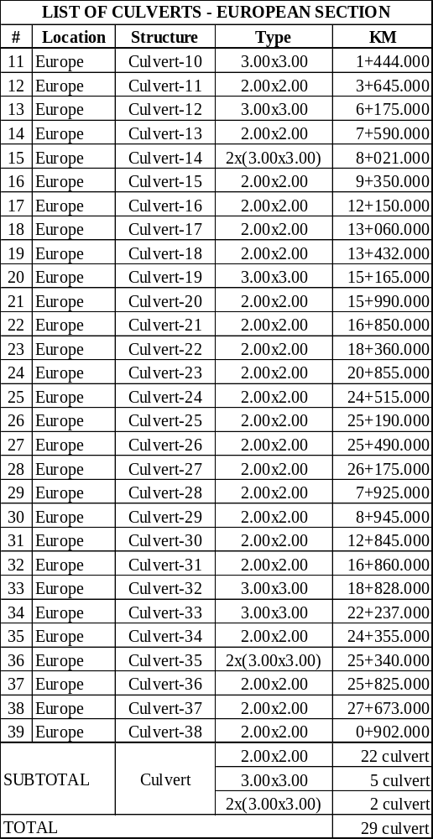

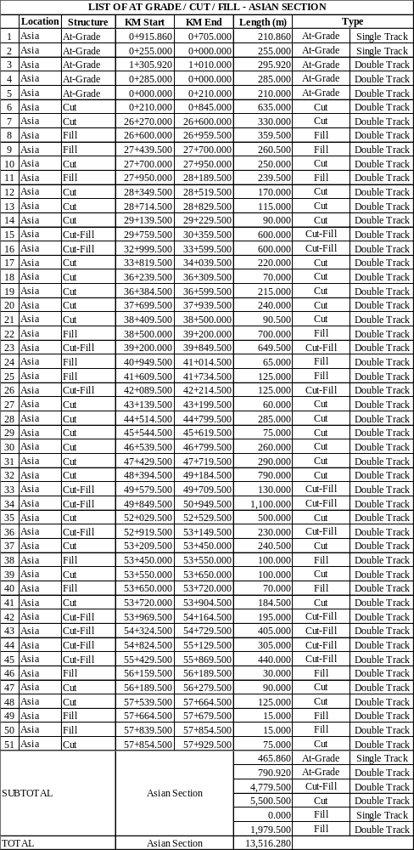
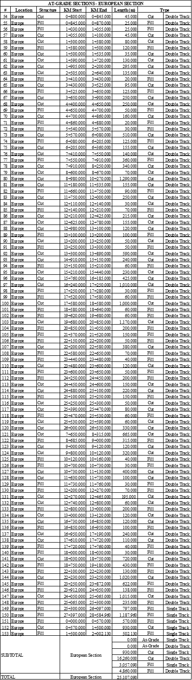
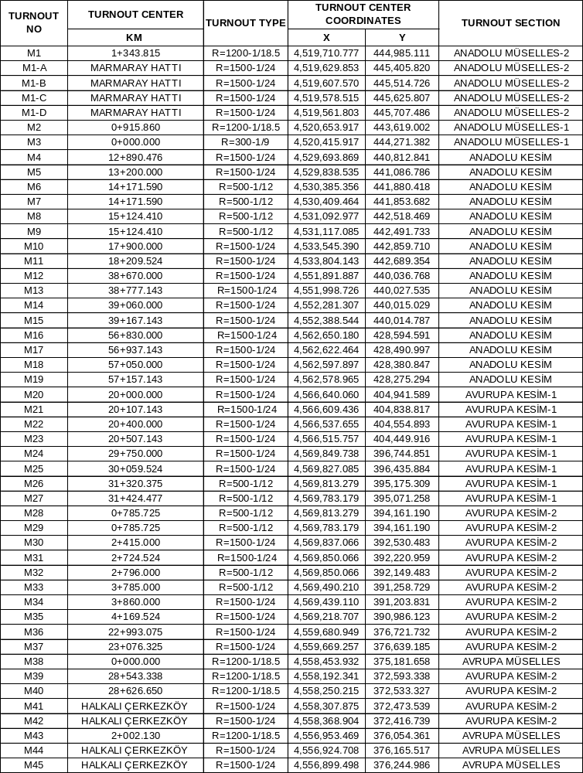
Structure inventory tables for cut-fill sections exclude cut and cover cut sections and given as a list with approximate lengths.

Along the railway line;
- 9 underpasses, 11 Overpass with different lengths (20m-90m)
- 17 cut and cover structures with different lengths (55m-470m)
- 39 culverts with different cross sections (2.0mx2.0m, 3.0mx3.0m, 2x(3,0mx3,0m); cross sectional dimensions of these hydraulic structures will be finalized after the detailed, hydrological and hydraulic studies.
Assessments of the main structures along the railway; tunnels, bridges, passenger stations are given in the following sections.

Tunnels of Istanbul North Railway
Mainly three different types of tunnels are planned along the railway line;
- Tunnels dimensioned to include one railway line are planned as TBM tunnels. These tunnels will be two parallel tunnels for two railway line; at the locations where they are planned along the line. Mostly they are used where the existing ground cover over the tunnels is not deep enough as for NATM tunnels (Type – 1)
- Tunnels dimensioned to include two railway lines are planned as NATM tunnels. (Type – 6)
- Tunnels planned to be used for railway Sabiha Gökçen passenger station. There will be different types of NATM tunnels within the station location. Switch Tunnels which will used to split transit trains and freight trains (Type – 2A-2B). Platform tunnels (includes one railway line and one passenger platform – Type 3). Tunnel along the center of the station; located along the station and in between two platform tunnels (Type – 7). Tunnel with single truck (for transit trains and freight trains which will not use platforms – Type – 1). A type tunnels before and after platform tunnels (Type 4). Tunnels (including escalators), which are to be planned, to connect concours level of the passenger station to platform level (Type 8 – 9 – 10 and 11).
Typical sections of two track NATM tunnel and one track TBM tunnel are given on the following drawings and they will be in the (TYPICAL SECTIONS) as drawings.
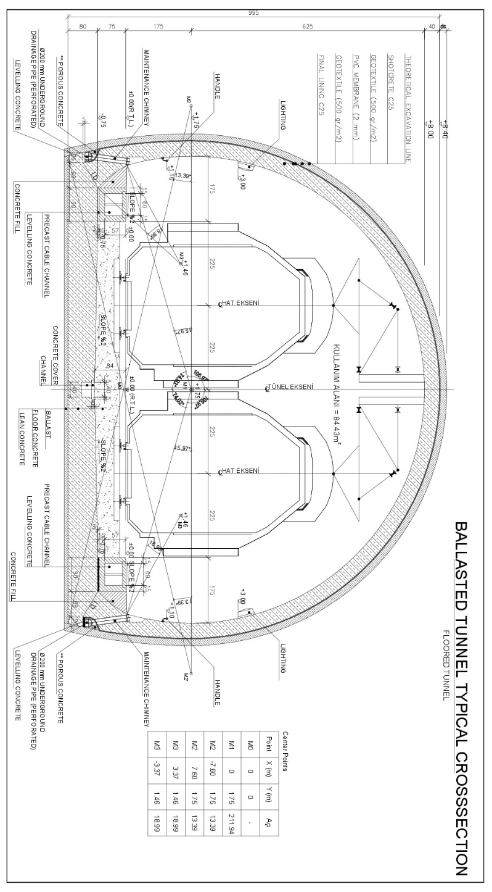
Figure 29 Double track tunnel cross-section (NATM)
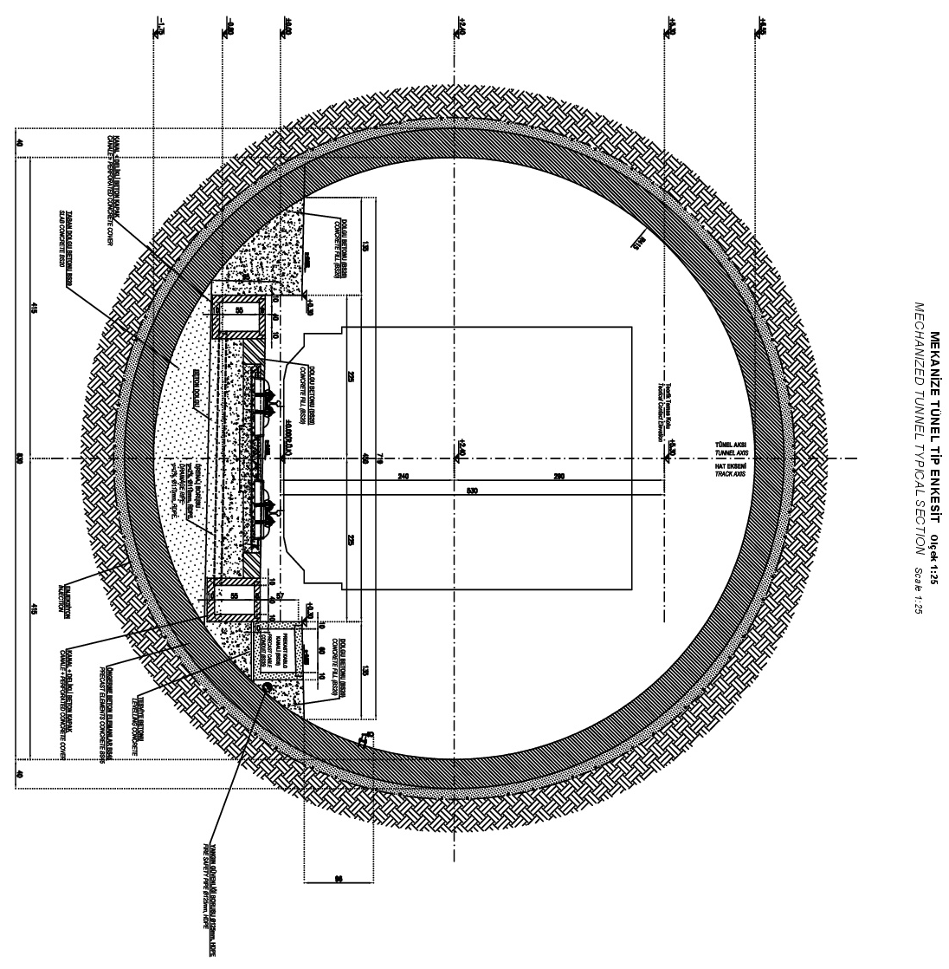
Figure 30 Single track tunnel cross-section (TBM)

Bridges of Istanbul North Railway
Main principles for bridges are summarized below;
- Bridges has 40 m typical span lengths with 2.4 m prestressed concrete beams.
- Support configurations and expansion joints are placed in a way used in railway bridges in Türkiye which provides best performance regarding serviceability and passenger comfort conditions.
- Detailed earthquake analysis shall be performed during the detail design process by following the conditions stated in National Bridge Earthquake Standard.

Typical sections of bridges are given on the following drawings;
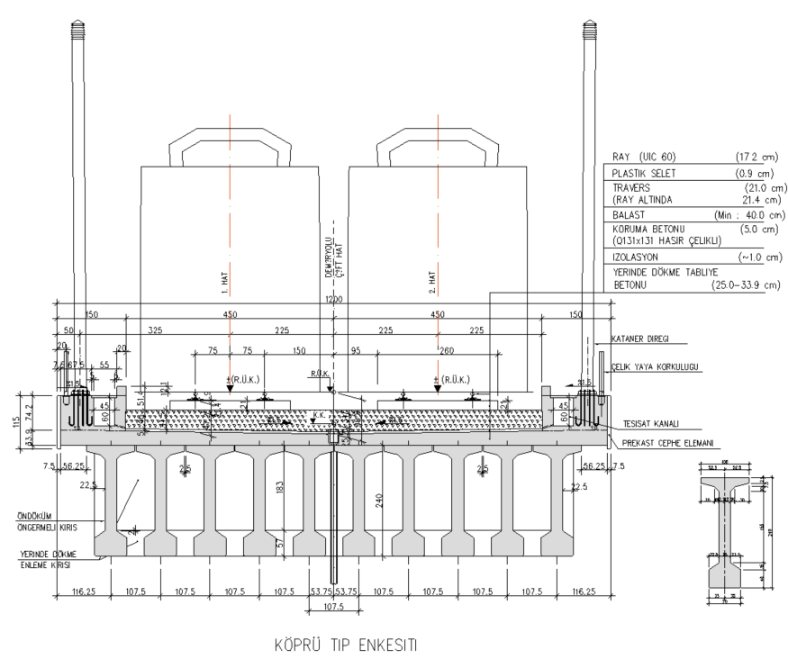
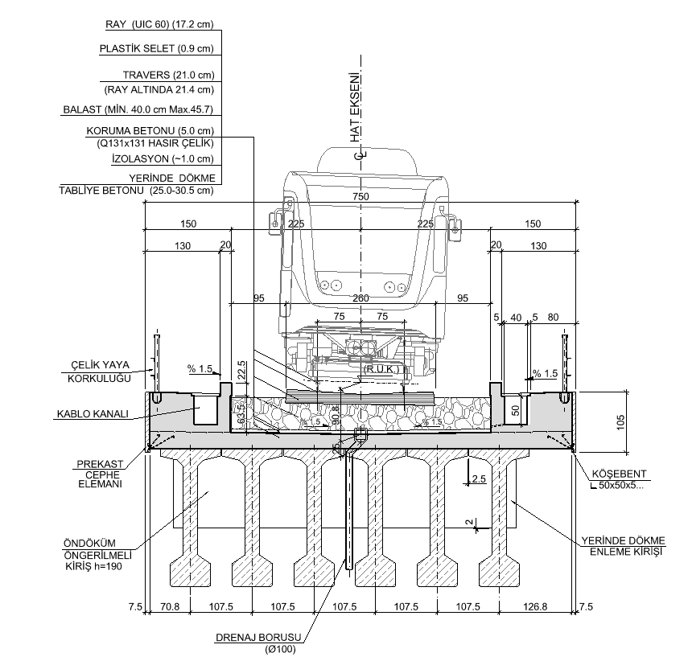
Figure 31 Typical Bridge Cross Section (Double Track-Single Track)
For the safety of pedestrians, guard rails will be used on the bridges and overpasses. Details of guard rails will be finalized during final design stage by the contractors.

RAILWAY ASSET MANAGEMENT PLAN
TCDD Track Maintenance Manual is addressed for Railway Asset Management Plan for the railway lines in Türkiye. The TCDD Track Maintenance Manual is a comprehensive technical guide developed by the Turkish State Railways (TCDD) in collaboration with Newcastle University and international railway experts. Its primary purpose is to standardize, systematize, and modernize maintenance practices across Turkey’s conventional, high-speed (HT), and high-speed train (YHT) lines. The manual establishes uniform procedures, performance criteria, and safety standards to ensure the efficient, safe, and cost-effective operation of the national railway network in compliance with European (EN) and UIC standards. It also references TSI Infrastructure Directive ensuring compatibility with European interoperability requirements.
The manual serves as the official Track Maintenance Plan of TCDD, providing detailed technical procedures for the maintenance, inspection, and repair of railway superstructure and substructure components. It aims to:
- Guarantee the safe and reliable operation of railway lines by maintaining infrastructure within defined geometric and material tolerances.
- Optimize maintenance interventions through planned inspections, preventive and corrective maintenance, and renewal strategies.
- Ensure compliance with international safety and quality standards while minimizing lifecycle costs.
- Enhance staff performance, measurement accuracy, and documentation consistency through standardized methods.
This manual is divided into two main sections as Superstructure and Infrastructure. Superstructure part is constituted of rails, sleepers, fastening systems, ballast, turnouts, rail welding and grinding, inspection methods, and track machines. Infrastructure parts covers formation, platforms, drainage systems, tunnels, bridges, culverts and level crossings if exist. For each section, there are component descriptions, technical specifications and standards, inspection intervals and control methods, limit values (Warning, Intervention and Emergency thresholds), repair, replacement and renewal procedures, personnel responsibilities and documentation templates.

The manual adopts a systematic asset management approach integrating Preventive maintenance, Corrective Maintenance and Renewal works. Preventive maintenance can be defined as regular, condition-based interventions derived from measurement and predictive data to avoid failures. Corrective maintenance includes repairs performed following identified defects or performance deterioration. Renewal works is replacement of components that have reached technical or economic end of life.

Maintenance limits can be classified in three categories;
- AL (Alert Limit) : Initiates detailed monitoring
- IL (Intervention Limit) : Triggers corrective maintenance
- IAL (Immediate Action Limit) : Requires emergency intervention and potential service restrictions.
Continuous monitoring of track and geometry and material condition using certified instruments and calibrates machinery is mandatory. Key parameters include alignment, level, gauge, rail wear, ballast condition and structural stability. Advanced technologies such as ultrasonic testing, eddy current inspections and geometry measurement systems are employed to internal and surface defects. Regular documentation and traceable reporting ensure consistent data management and safety verification.

Regarding the personnel competence and safety, there are clear roles and responsibilities defined for maintenance staff (maintenance managers, supervisors, field technicians). Training, calibration and certification requirements for measurement tools are defined. Safety procedures for field operations, including risk zones for various speed regimes and compliance with occupational health and safety directives are also defined in manual.

ELECTROMECHANICAL SYSTEMS

Signaling and Communication

General
The Project line between Gebze-Çayırova and Çatalca; will be designed and constructed; with a maximum train operating speed of 200 km/h (E-M systems are supposed to be planned in accordance with this operational speed). Signaling, telecommunication system and sub systems which are needed to meet; a safe, reliable and sustainable operational requirements of this high-speed line section will be established.

The automatic train protection and control systems to be installed on the mentioned railway line section will be ERTMS/ETCS Level 1 and ERTMS/ETCS Level 2.

Signaling and telecommunication systems shall carry at least the standards and norms specified in Section 7.

To meet the operational requirements of this line; a short description of the signaling, communication systems and sub systems are made within this document.
Switch Locations & orientations of INRAIL for the connections of existing lines at both end of the project:
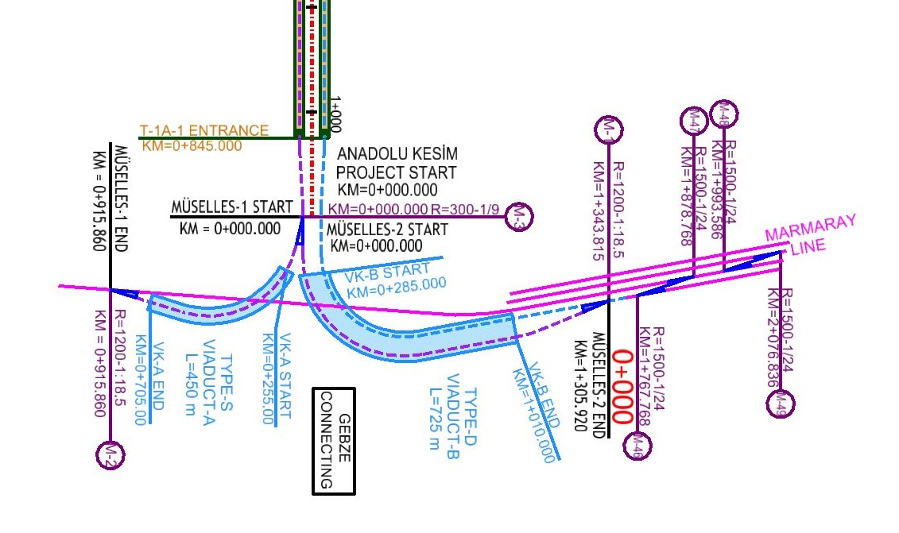
Figure 32 Schematic Turnout layout plan at Anatolian side (Gebze) connection

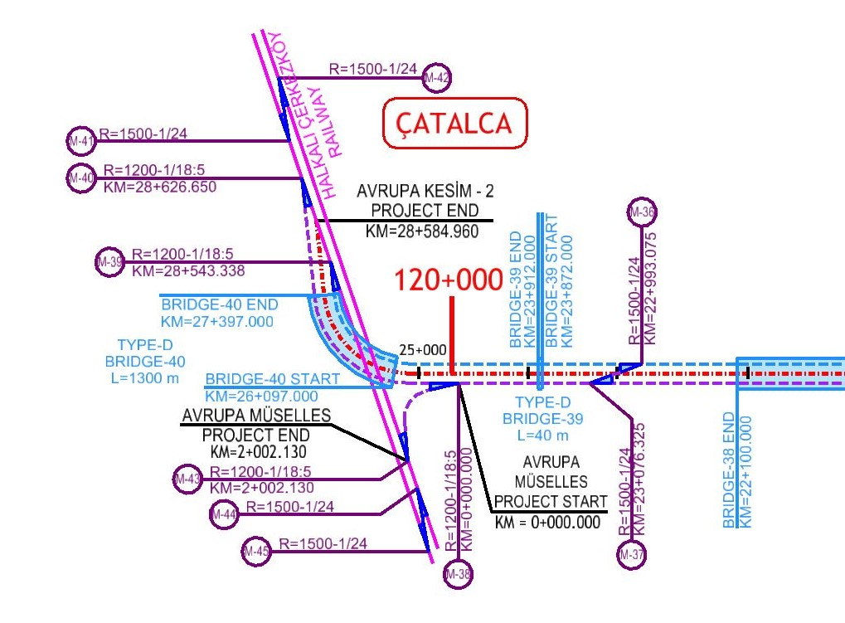
Figure 33 Schematic Turnout layout plan at Europian Side (Çatalca) connection
Other switches planned on the alignment:
Switch No- | Km: | Function
M5 ((1/24) | 12+890,476 | Operation, maintenance
M4 (1/24) | 13+200 | Operation, maintenance
M6 (1/12) | 14+171 | Operation, freight trains
M7 (1/12) | 14+171 | Operation, freight trains
M8 (1/12) | 15+124,41 | Operation, freight trains
M9 (1/12) | 15+124,41 | Operation, freight trains
M10 (1/24) | 17+900 | Operation, maintenance
M11(1/24) | 18+209 | Operation, maintenance
M12 (1/24) | 38+670 | Operation, maintenance
M13 (1/24) | 38+777 | Operation, maintenance
M14 (1/24) | 39+060 | Operation, maintenance
M15(1/24) | 39+167 | Operation, maintenance
M16 (1/24) | 56+630 | Operation, maintenance
M17(1/24) | 56+937 | Operation, maintenance
M18 (1/24) | 57+050 | Operation, maintenance
M19(1/24) | 57+157 | Operation, maintenance
M20(1/24) | 20+000 | Operation, maintenance
M21(1/24) | 20+107,143 | Operation, maintenance
M22(1/24) | 20+400 | Operation, maintenance
M23(1/24) | 20+507,143 | Operation, maintenance
M24(1/24) | 29+750 | Operation, maintenance
M25(1/24) | 30+059,524 | Operation, maintenance
M26 (1/12) | 31+320 | Operation, station line
M27(1/12) | 31+424,477 | Operation, station line
M28(1/12) | 0+785,725 | Operation, station line
M29 (1/12) | 0+785,725 | Operation, station line
M30 (1/24) | 2+415 | Operation, maintenance
M31 (1/24) | 2+724,524 | Operation, maintenance
M32 (1/12) | 2+796 | Connection Line
M33 (1/12) | 3+785 | Connection Line
M34 (1/24) | 3+860 | Operation, maintenance
M35 (1/24) | 4+169,524 | Operation, maintenance
M36 (1/24) | 22+993,075 | Halkalı connection
M37 (1/24) | 23+075,326 | Halkalı connection

System description of Inrail Signaling system specifically for INRAIL including sub-systems are defined in technical specification for the construction of signaling and communication technical specification.
System description of Communication system specifically for INRAIL including sub-systems and control center are defined in the technical specification for the construction of signaling and communication technical specification.

System description of SCADA & Control system specifically for INRAIL including sub-systems and safe train operations are defined in the technical specification for SCADA system and Technical Specification for the construction of signaling and communication.

Integrity With The Existing Systems
CTC Center, (including SCADA, signal, communication) of Istanbul Northern high-speed Railway line (INRAIL) will be near to the existing CTC center in Maltepe.

In order for the Northern Railway project to operate as a whole, the necessary connections, interfaces, software (programs) for electrification, signaling, communication (continuity of connection to the CTC center), SCADA, etc., and all facilities, equipment, materials, will be provided within the scope of the Project.

Signaling And Communication Main And Sub Systems
- CTC control center and subsystems,
- Electronic interlocking and subsystems,
- Two directional signaling along the railway line
- Point drive, locking, and verification systems,
- Electric point heaters,
- Line vacancy detection systems
- Power Supply Systems
- Automatic train control and protection systems (ERTMS/ETCS Level 1 and ERTMS/ETCS Level 2) and their subsystems
- Trackside Automatic Train Stop Systems (ATS)
- Diagnostic and maintenance support systems
- Signal, energy, and fiber optic cables
- GSM-R, telephone, and network communication systems
- Construction work related to cable laying
- Technical equipment buildings and other buildings for maintenance and operation
- Interfaces with existing electromechanical systems
- Auxiliary systems (alarm and monitoring system, camera security and monitoring system, early earthquake warning system, wheel detector systems)

General Requirements
All signaling systems, including ERTMS/ETCS Level 1/2 systems, and all telecommunications systems, including GSM-R systems, will be compatible with a train speed of 200 km/h. Low-speed trains will also be able to operate safely and efficiently on this line.

Signals, along the railway sides; will meet SIL-4 safety level requirements in accordance with EN 50129 and EN 50126 standards.

Trains can be dispatched consecutively in the same direction between two stations, within a block distance. In train operations with the ERTMS/ETCS Level 2 system, multiple trains can be dispatched consecutively in the same direction, within the same block.
The software, hardware, equipment and systems to be used in signaling systems for the interface will be vital and fail safe.

The signaling and telecommunication systems within the scope of this project, will operate in a compatible and safe manner with the signaling and telecommunication systems of existing conventional line sections, and the systems will not have any negative or destructive effects, including interference, on each other.

Truck side (way- side) typical signaling schematic plan is given in the attachment of this report.
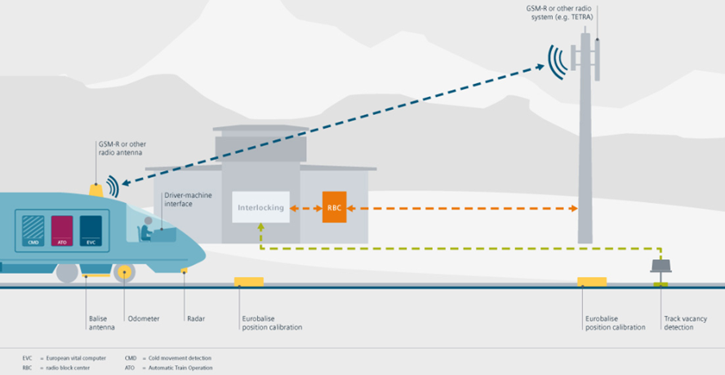
Figure 34 ETCS

Automatic Train Protection and Control Systems
The automatic train protection and control systems to be installed will be ERTMS/ETCS Level 1 and ERTMS/ETCS Level 2. ERTMS/ETCS Level 2 will be the main system, while ERTMS/ETCS Level 1 will be the fallback system, but both systems will be active at the same time.

ERTMS/ETCS Level 1 and ERTMS/ETCS Level 2 systems shall meet all mandatory conditions and requirements set out in the technical specifications for interoperability, together with the following European Council Commission decisions and directives: Technical Specification for Interoperability (TSI) No. 2012/88/EU.

The information exchange between the ERTMS/ETCS Level 1/2 system and the interlocking will be direct and the movement authority for the ERTMS/ETCS Level 1/2 system will not be affected by any failure in the track side signal colour notifications.

GSM-R System
Within the scope of the project, a GSM-R system will be installed to establish the communication infrastructure for ERTMS/ETCS (European Train Control System) Level 1-2 signaling systems on the train route, and to provide uninterrupted communication needs for dispatchers, engineers, station attendants, maintenance personnel, train personnel, line workers, railway administrators, and managers. The GSM-R system to be installed will comply with the requirements set forth in national/international legislation and the standards specified in the technical specifications.
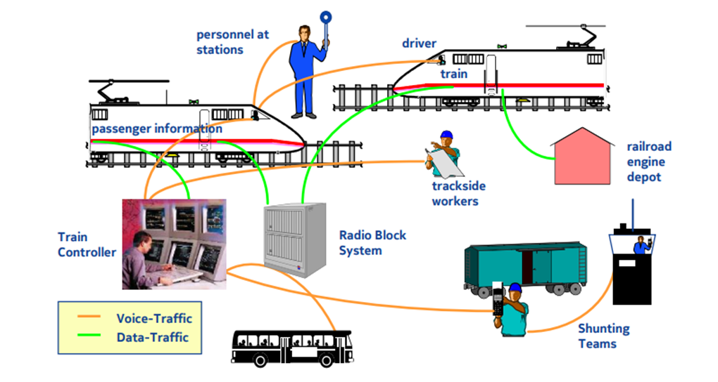
Figure 34 GSMR traffic structure

Traction Power and Electrification
Railway line between Gebze-Çayırova and Çatalca will be operated with over head catenary system. Three traction transformer center with 154/25 kV along the line will provide energy needs of the passenger and freight trains. Two of the transformer centers will be located approximately 20 km away from both ends of the railway. Third one will be located near to center of the alignment. Energy needs will be provided from nearby 154 kV lines of Türkiye Electricity Transmission Inc. With the train operation simulation studies, numbers, capacities and locations of traction transformers will be finalized.

System description of Traction Power & Electrification system specifically for INRAIL including sub-systems are explained within the Technical Specification of Transformers Center and Technical specifications for catenary systems.

Structural gauges (clearances) will be provided along the railway line, at the underground passenger stations, at the NATM and TBM tunnels, at under passes and similar structures.
Schematic typical power distribution plan is given in the attachment of this report

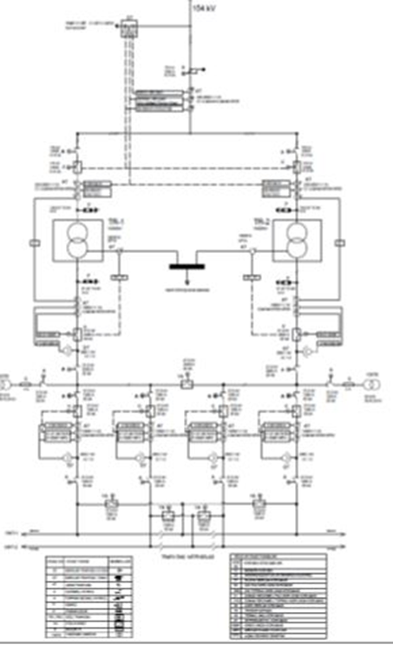

Figure 35 Transformer Center- Single Line Diagram (With 2 Lines)

Electrical-Mechanical Systems- Emergency strategy and fire fighting
UIC and European Committee have regulations for the safety of railway passengers traveling within the tunnels longer than 1000m. For the tunnels with two trucks; whether a parallel escape tunnel will be constructed, which will have connection escape tunnels at every 500m. or without parallel tunnel; there should be an escape tunnel at every 1000m directly connected to main tunnel and reaching a safe area at the surface. For the single track two parallel tunnels, there should be passenger escape connections at every 500m between two tunnels, for the escape of passengers during fire within one tunnel to escape the other tunnel.

With providing escape tunnels, longitudinal mechanical ventilation for the tunnels longer than 1000m are required. Additionally, fire extinguishing will be established. Fire detection and ventilation systems will be remote controlled.

Firefighting and detection systems will be established within the passenger stations. NFPA standards will be used for the stations.

Tunnel cross sections for two tracks single NATM tunnels and single track TBM tunnels planned to be used along Inrail railway; have similar dimensions which have been used on different high speed railway projects in Türkiye. (Ankara- Sivas, Bandırma- Bursa, Ankara İzmir). Axial tunnel ventilation systems are to be used along the line. Necessary electrical, communicational (including SCADA), connections will be provided, additionally firefighting systems will be provided for the tunnels mentioned. With the international accepted tunnel ventilation simulation programs, ventilation systems of the tunnels will be planned.

On the passenger stations; platform level, there will be two scenarios; fire in the tunnel and fire at the platform. When a fire occurs on the tunnel, funs at the stations will be activated (if the fire in the tunnel is close to station, otherwise smoke will be pushed towards the other end of tunnel via jet funs). If the fire is at the platform inside the station area, then another fire ventilation system which will be planned to take smoke at the platform level will be activated. Fire detection systems and extinguishing systems will be planned in the tunnels and at the stations.

Electrical supply (AC) of two stations will be from the local energy supplier (TEDAŞ, BEDAŞ), electrical power needs for the tunnels (AC) (fans, lighting, pumps, alarm etc.) will be supplied from the passenger stations and/or nearby local suppliers. Transformers in the Passenger stations will supply all the electrical needs to be used in the stations; ventilation systems (exhaust and fresh air), escalators, elevators, lighting, alarm, CCTV, announcement, pumps etc.).
Mechanical systems for the mainline of INRAIL; will consist of tunnel ventilation systems, firefighting systems (fire pumps, water tanks).

Simulation programs (CFD, and similar) will required to be used from the contractors for the emergency ventilation calculations at the stations and at the tunnels. In accordance with the fire loads in the tunnels and at the stations. Piston effects will be required to be considered for the extraction of the exhausted air from the stations and from the tunnels. Accordingly, the capacities of the funs to be used will be determined. Technical specifications of tunnel electromechanics are to be considered for the fire detection and alarm systems and ventilation systems.

Announce system and CCTV systems will be required from the contractors of the passenger stations. Announcements should be louder than ambient noise (train, crowd, ventilation). The reverberation time should be kept short. NFPA 130 – Rail stations (especially emergency announcements) criteria’s will be required.

CCTV coverage simulations will be required to ensure post-installation system performance, reduce costs, and minimize security risks. Through these studies, the system is optimized to meet both operational needs and relevant standards.

APPLICABLE DOCUMENTS

Codes, Standards and Regulations
National Standards;
- Türkiye Deprem Yönetmeliği, 2020, Deprem Etkisi Altında Karayolu ve Demiryolu Bridge ve Viyadükleri Tasarımı için Esaslar (Turkish Seismic Code, 2020, Principles for the Design of Highway and Railway Bridges and Viaducts Under Seismic Effect)
- Türkiye Deprem Yönetmeliği, 2020, Deprem Etkisi Altında Karayolu ve Demiryolu Tunnelleri ile Diğer Zemin Yapılarının Tasarımı için Esaslar (Turkish Seismic Code, 2020, Principles for the Design of Highway and Railway Tunnels and Other Buried Structures Under Seismic Effect)
- Türkiye Bina Deprem Yönetmeliği, 2018
- TS 498, Yapı Elemanlarının Boyutlandırmasında Alınacak Yükler, 1997
- TS 500, Betonarme Binaların Hesap ve Yapım Kuralları,2000
- Çelik Yapıların Tasarım, Hesap ve Yapım Esaslarına Dair Yönetmelik,
- TS 708 Çelik ve Betonarme için Donatı Çeliği
- TS 910 Çelik I Profilleri-Sıcak Haddelenmiş
- TS 911 Sıcak Haddelenmiş Yuvarlak Köşeli Çelik T Profiller-Boyutlar, Şekil ve Boyut Toleransları
- TS 912Çelik U-Profilleri-Sıcak Haddelenmiş Yuvarlak Köşeli
- TS 913Çelik Z-Profilleri-Sıcak Haddelenmiş, Yuvarlak Köşeli
- TS EN 10025-1 Sıcak Haddelenmiş Yapı Çelikleri–Bölüm 1: Genel Teknik Teslim Şartları
- TS EN 10056-1 Yapı çelikleri–L Profiller Ve Köşebentler–Bölüm 1: Boyutlar
- TS 3233 Öngerilmeli Beton Yapıların Hesap ve Yapım Kuralları
- T.C. Ulaştırma Bakanlığı Demiryolları, Limanlar, Hava meydanları İnşaatı Genel
- Müdürlüğü, Demiryolları Eki, Bridge Tasarım Esasları Sonuç Raporu
- T.C. Bayındırlık ve İskân Bakanlığı Karayolları Genel Müdürlüğü, Karayolu Bridgeleri Teknik Şartnamesi
- Türkiye Deprem Yönetmeliği, 2020, Geoteknik Konular
- TS 1500 İnşaat Mühendisliğinde Zeminlerin Sınıflandırılması
- Karayolları Genel Müdürlüğü, Karayolu Teknik Şartnamesi, 2023
- Kazı Destek Yapıları Tasarım ve Uygulama Esasları, 2022

International Standards;
- IBC 2003 International Building Code
- NEHRP 2003 Recommended Provisions for New Buildings and Other Structures, FEMA-450
- ACI 318 Building Code Requirements for Structural Concrete
- EN 1990 Eurocode–Basis of Structural Design
- EN 1991 Eurocode 1: Actions on Structures
- EN 1992 Eurocode 2: Design of Concrete Structures
- EN 1993 Eurocode 3: Design of Steel Structures
- EN 1994 Eurocode 4: Design of composite steel and concrete structures
- UIC 702 Static loading diagrams to be taken into consideration for the design of rail carrying structures on lines used by international services
- UIC 772-1 Standard principles for the use of bearings made from various materials for railway bridges
- UIC 774-2 Distribution of axle-loads on ballasted railway bridges
- UIC 774-3 Code For Track Rail Interaction
- UIC 776-1 Loads to be considered in railway bridge design
- UIC 776-3 Deformation of bridges
- UIC-719-R Earthworks and track bed for railway lines
- BS 8002: 1994 British Standard Code of Practice for Earth Retaining Structures
- BS 8004: British Standard Code of Practice for Foundations
- AASHTO Bridge design specification
- AISC-ASD 89 Specification for Structural Steel Buildings
- ANSI-AWS D1.5 Bridge Welding Code
- SCDOT 2019, Geotechnical Design Manual
- FHWA0-IF-03-017 Geotechnical Engineering Circular No7_Soil Nail Walls Manual (2003)
- FHWA-IF-99-015 Geotechnical Engineering Circular No4_Ground Anchors and Anchored Systems (1999)
- FHWA-HRT-13-046 Deep Mixing for Embankment and Foundation Support, 2013
- EN 1997 Eurocode 7: Geotechnical Design
- BS 6031:2009 British Standard Code of Practice for Earthworks
- BS 8081:2015 British Standard Code of Practice for Grouted Anchors
- BS EN 1538:2010 Execution of Special Geotechnical Works. Diaphragm Walls
- Canadian Foundation Engineering Manual, 4. Edition (2006), Canadian Geotechnical Society, Montreal
- BS 8002: 1994 British Standard Code of Practice for Earth Retaining Structures
- BS 8004: British Standard Code of Practice for Foundations
- NAVFAC DM 7.02 Foundations and Earth Structures, 1986
- BTS Specification for tunneling, British Tunneling Society, 2000
- FHWA-NHI-10-034, Technical Manual for Design and Construction of Road Tunnels — Civil Elements, 2009
- EN 13803-1:2017 Track alignment design parameters
- EN 15273-1:2013 Railway applications - Gauges - Part 1: General - Common rules for infrastructure and rolling stock
- EN 15273-2:2013 Railway applications - Gauges - Part 2: Rolling stock gauge
- EN 15273-3:2013 Railway applications - Gauges - Part 3: Structure gauges
- AREMA Manual for Railway Engineering,, 2019
- EN 13232-4 Railway Applications, Track, Switches and crossings
- EN 50121-1 to 5 Railway applications, Electromagnetic compatibility
- EN 50122-1 Railway applications, Fixed installations, Protective provisions relative to electrical safety and earthing
- EN 50124-1 to 2 Railway applications, Insulation coordination
- EN 50125-1 to 3 Railway applications, Environmental conditions for equipment
- EN 50126 Railway applications, The specification and demonstration of reliability, availability, maintainability and safety (RAMS)
- EN 50128 Railway applications, communications, signalling and processing systems Software for railway control and protection system
- EN 50129 Railway applications, Communications, signalling and processing systems, Safety related electronic systems for signalling
- EN 50155 Railway applications, Electronic equipment used on rolling stock
- EN 50159-1 to 2 Railway applications, Communications, signalling and processing systems, Safety related communications (closed or open transmission systems)
- EN 50238 Railway applications, Compatibility between rolling stock and train detection systems
- EN 50261 Railway applications, Mounting of electronic equipment
- EN 60529 Degrees of protection provided by enclosures (IP code) (For electrical equipments)
- EN 60721-3-4 Classifications of environmental conditions
- EN 61373 Railway applications, Rolling stock equipment, Shock and vibration tests
- EN 61508-1 to 3 Functional safety of electrical / electronic / programmable electronic safety related systems
- EN 61000-4-2 Electromagnetic Compatibility (EMC)-Part 4-2: Testing and measurement techniques-Electrostatic discharge immunity test
- EN 61000-4-4 Electromagnetic Compatibility (EMC)-Part 4: Testing and measurement techniques-Section 4: Electrical fast transient/ burst immunity test-basic EMV publication
- EN 61000-4-5 Electromagnetic Compatibility (EMC)-Part 4-5: Testing and measurement techniques surge immunity test
- EN 61000-6-1 Electromagnetic compatibility (EMC)-Part 6-1:Generic standards-immunity for residential, commercial and light-industrial environments
- EN 61000-6-2 Electromagnetic compatibility (EMC)-Part 6-2:Generic standards-Immunity for industrial environments
- EN 61000-6-4 Electromagnetic compatibility (EMC) - Part 6-4: Generic standards; Emission standard for industrial environments
- DIN 934 Hexagon nuts with metric coarse and fine pitch thread - Product classes A and B
- ISO 9241 Ergonomic requirements for office work with Visual Display Terminals
- ISO 7250 Basic human body measurements for technologic design
- IEC 61508 Functional Safety of Electrical/Electronic/Programmable Electronic Safety-related Systems
- 89/336/EEC Electromagnetic Compatibility Directive
- UIC 734 Adaptation of safety installations to high-speed requirements
- UIC 753-1 Technical regulations concerning international railway telephone circuits
- UIC 753-2 General technical regulations governing establishment and development of communication capacity over the railway telecommunication network
- UIC 753-3 General procedures governing maintenance, operating and performance criteria for the UIC member railways telecommunication network
- Recommendation UIT-T G.703 (2001) Physical/electrical characteristics of hierarchical digital interfaces
- Recommendation UIT-T G.732 (1988) Characteristics of primary PCM multiplex equipment operating at 2048 kbit/s
- UIT-T G.707/Y.1 322 (2000) Recommendation Network node interface for the synchronous digital hierarchy (SDH)Corrigendum 1 (2001), Corrigendum 2 (2001) et Amendment 1 (2001)
- Recommendation UIT-T G.782 Types and general characteristics of synchronous digital hierarchy (SDH) equipment
- Recommendation UIT-T G.708 Sub STM-0 network node interface for the synchronous digital hierarchy (SDH)
- Recommendation UIT-T G.704 (1998) 1 544, 6 312, 2 Synchronous frame structures used at primary and secondary hierarchical levels 2048, 8 448 et 44 736 kbit/s
- Recommendation UIT-T G.709 Management aspects of the optical transport network element
- Recommendation UIT-T G781 Synchronization layer functions
- Recommendation UIT-T G.784 Management aspects of the synchronous digital hierarchy (SDH) transport network element
- Recommendation UIT-T G.957 Optical interfaces for equipments and systems relating to the synchronous digital hierarchy
- Recommendation UIT-T G.958 Digital line systems based on the synchronous digital hierarchy for use on optical fibre cables
- Recommendation UIT-T G.783 (2000) Characteristics of synchronous digital hierarchy (SDH) equipment functional blocks Corrigendum 1 (2001)
- Recommendation UIT-T G812 Timing requirements of slave clocks suitable for use as node clocks in synchronization networks
- Recommendation UIT-T I.321 (1991) B-ISDN protocol reference model and its application
- Recommendation UIT-T G803 Architecture of transport networks based on the synchronous digital hierarchy (SDH)
- Recommendation UIT-T G811 Timing characteristics of primary reference clocks
- Recommendation UIT-T I.610 (1999) Measurement of round trip delay using loopback cell Corrigendum 1 (2000)
- Recommendation UIT-T G813 Timing characteristics of SDH equipment slave clocks (SEC)

Technical Specifications
- AYGM Railways Geotechnical Design Technical Specification
- AYGM Railways Bridge Design Technical Specification
- AYGM Railways Design Technical Specification
- AYGM Infrastructure Works Technical Specification
- AYGM Superstructure Works Construction Specification
- AYGM Superstructure Projects Drawing Technical Specification
- AYGM Measurement Technical Specification
- AYGM Subballast Technical Specification
- AYGM Under-Ballast Mat Technical Specification
- AYGM Ballast Technical Specification
- AYGM Under-Sleeper Pad Technical Specification
- AYGM Pre-Tensioning - Pre-Drawn Concrete Sleeper Technical Specification
- AYGM Rail Technical Specification
- AYGM Elastic Fastenings W14 for Ballasted Track Technical Specification
- AYGM Ballastless Track Fastenings Technical Specification
- AYGM Elastic Fastenings W21 for Ballasted Track Technical Specification
- AYGM Ballastless Railway Construction Technical Specification
- AYGM Mass Spring System Technical Specification
- AYGM Turnout Technical Specification
- AYGM Turnout Rails Technical Specification
- AYGM Turnout Fastenings Technical Specification
- AYGM Prefabricated Concrete Road Mat Technical Specification
- AYGM Machine Technical Specification
- AYGM Rail Welding Technical Specification
- AYGM Stress Relief Technical Specification
- AYGM Insulated Rail Seal (IRS) Technical Specification
- AYGM Rail Grinding Technical Specification
- AYGM Ultrasonic Inspection of Rail Welds Technical Specification
- AYGM Ultrasonic Inspection of Newly Built Lines Technical Specification
- AYGM Perimeter Wall Technical Specification
- AYGM Superstructure Works Acceptance Conditions
- AYGM Rail Expansion Gasket (REG) Technical Specification
- AYGM Finishing Works Technical Specification
- AYGM Electrical and Electronical Systems Technical Specification
- AYGM Mechanical and Fire Protection Systems Technical Specification
- Technical Specification for Catenary Facilities
- Transformer Substation Technical Specification
- Technical Specifications For Tunnel Electromechanical Works
- Remote Control System (Scada) Technical Specifications
- Technical Specifications For Signaling, Telecommunications And Support Systems
- AYGM Safety & RAMS Technical Specification
- AYGM Building Automation Systems Technical Specification
- AYGM Testing & Commissioning Technical Specification
- AYGM Quality, HSE & Environment Technical Specification
The list below is a reference list of the standards mentioned above and specifications that are required to be complied with as part of this Plan.
Table 2 – Applicable Standards and Specifications
Document | Description
EN 50126: 2017/TS EN 50126-1:2018 | Railway applications – The Specification and Demonstration of Reliability, Availability, Maintainability and Safety (RAMS).
EN 50128: 2011/TS EN 61508-1:2010 | Railway applications – The Specification and Software for railway control and protection systems.
EN 50129: 2003/TS EN 50129:2020 | Railway applications – Communication, signaling and processing systems – Safety-related electronic systems for signaling.
EN 61508 2010/TS EN 61508-1:2010 | Functional Safety of Electrical / Electronic / Programmable Electronic Safety-Related Systems, 2010.
IEC 61025 2006 | Fault Tree Analysis (FTA).
CSM 2015/1136 | EU directive for Common Safety Methods.
EU 2016/919 | Technical Specification for Interoperability relating to the Command – Control and signaling subsystems of the rail system in the European Union.
EU 1301/2014 | Technical Specification for Interoperability relating to energy subsystem of the rail system in the European Union.
EU 1299/2014 | Technical Specification for Interoperability relating to the Infrastructure subsystem of the rail system in the European Union.
EU 2019/772 | Technical Specification for Interoperability relating to the Operation and Traffic Management subsystem of the rail system in the European Union.
EU 1300/2014 | Technical Specification for Interoperability relating to accessibility of the Union’s rail system for persons with disabilities and persons with restricted movement.
EU 1303/2014 | Technical Specification for Interoperability relating to safety in tunnels of the rail system in the European Union.
19th November 2015, Official Gazette: 29537 | Regulation on Railway Safety (prepared based on the EU Directive and states the compliance with TSIs)
6th July 2015, Official Gazette: 29418 | Regulation on Railway Transport of Dangerous Goods (prepared in parallel with COTIF C-RID)

Definitions and Abbreviations
Definitions and abbreviations applicable to this Plan are outlined in the table below.

Table 3: Definitions and abbreviations
Abbreviation | Definition
Accident | An unintended event or series of events resulting in loss of human health or life, damage to property or environmental damage.
ADB | Asian Development Bank
AIIB | Asian Infrastructure Investment Bank
AIS | Acceptance Into Service. All those approvals required before the railway is allowed to enter into service.
ALARP | As Low as Reasonably Practicable.  Point at which the cost of further improving safety is grossly disproportionate to the achieved safety benefit.
AsBo | Assessment Body
ASSC | Application Specific Safety Condition
Assessment | The undertaking of an investigation in order to arrive at a judgment, based on evidence, of the suitability of a product.
AYGM | Directorate of Infrastructure Investments (English Translation)
Broadly Acceptable | A hazard is Broadly Acceptable when the risk arising from it is sufficiently small that it is not reasonable to implement any additional safety measure.
CCA | Common Cause Analysis
Contractor | Organization which has a contract with AYGM to perform Deliver the whole project.
CSM-RA | European Common Safety Method for Risk Assessment
CRSM | Contractor’s Railway Safety Manager
Critical items | Items whose failure can significantly affect safety, operating success and/or repair or replacement costs.  Critical items include:  - Reliability of sensitive parts (i.e. high failure rates from historical experience)  - Single failure points (failures which cause total loss of operating capabilities)  - Limited life items  - New technologies  - New process  - Single sources.
Detection | Process which discovers the existence of faults.
EBRD | European Bank of Reconstruction and Development
ERTMS | European Railway Traffic Management System
ETA | Event Tree Analysis
EU | European Union
Euro Norm | European Standard
Fail-safe | Concept incorporated into the design of a product that, in the event of a failure, enters or remains in a safe state.
Failure rate | Total number of failures within an item population, divided by the total time expended by that population, during a particular measurement interval under stated conditions.
FAT | Factory Acceptance Test
FMEA | Failure Mode Effects Analysis. The method for identifying potential or known process failure conditions.
FMECA | Failure Mode Effect and Criticality Analysis. Reliability evaluation and design review technique which examines the potential failure modes within a system or lower indenture level to determine the effects of failures of equipment or system performance.
FRACAS | Failure Reporting Analysis and Corrective Action System. FRACAS is a closed loop failure reporting system which includes procedures for the analysis of failures, determination of root causes, and documentation for recording any corrective action taken.
FTA | Analysis to determine which fault modes of the system, subsystem or external events, or combinations thereof, may result in a stated fault mode of the product. Results are presented in the form of fault tree.
GASC | General Application Safety Case
GSM-R | Global System for Mobile Communications - Railway
Hazard | Physical situation with a potential for human injury and/or damage to environment.
Hazard analysis | Process of identifying hazards and analyzing their causes and deriving requirements to limit the likelihood and consequences of hazards to a tolerable level.
Hazard Record | Document in which all safety management activities, hazards identified, decisions made, and solutions adopted are recorded or referenced.
HAZOP | Hazard and Operability Study
Human errors | Human action (mistake) which can result in unintended system behavior/failure.
Human factors | Human factors define the impact of human characteristics, expectations and behaviors on  the Red Line.
IHA | Interface Hazard Analysis
Intolerable | A hazard is intolerable if the risk arising from it is higher than the limit of tolerability for individual or societal risk.
IsDB | Islamic Development Bank
Maintainer | Contractor performing maintenance including rolling stock maintainer, SDAG maintainer and O&M Contractor.
MoTI | Ministry of Transport and Infrastructure
NATM | New Austrian Tunneling Method
NoBo | Notified Body
O&M | Operation and Maintenance
OSHA | Operation and Support Hazard Analysis
PPP | Public Private Partnership
Proof Test | Test on one or a sample of items which shows that the item will withstand the expected structural loads.
RAMS | Reliability, Availability, Maintainability and Safety
Redundancy | Duplication (or triplication) of critical component of a system with the intention of increasing reliability, usually in the case of a backup or fail-safe.
Reliability | Probability that an item can perform a required function under given conditions for a given time interval.
Risk | An uncertain event [or circumstance(s)] that may occur during the Program/Project and hence impact the chances of the Project meeting one or more of its objectives: [i] Schedule; [ii] Cost; [iii] Scope/Quality/Performance.
Safety | Freedom from unacceptable risk of harm.
SASC | Specific Application Safety Case
SIL | Safety Integrity Level (as defined in EN50126).  One of a number of defined discrete levels for specifying the safety integrity requirements of the safety functions to be allocated to the safety-related systems.
SOPT | Sector Operational Programme
SRAC | Safety Related Application Condition
Subcontractor | A person, group or organization which has a contract with “the Contractor” to perform Works or provide services. This shall include but not be limited to supply, design, build or design/build and maintenance contracts.
Subsystem | Self-contained system within a larger system.
Supplier | The company who has entered into a contract to supply goods or services to the Project.
System | A set of things working together as parts of a mechanism or an interconnecting network or complex whole (e.g. a Railway system).
T&C | Testing and Commissioning
TCDD | Turkish State Railways
TEN-T | Trans European Transport Network
Tolerable | A hazard is Tolerable if its risk is such that it is lower than “Intolerable” but higher than “Broadly Acceptable”. Tolerable Hazards shall be shown to be ALARP.
Top-level | Term referring to "at the highest level", e.g. the composite of all equipment, procedures and people in the Red Line Project that are integrated to perform an operational task or function within a specific environment.
Type Test | Test on one or a small number of production or prototype items to show that the production items will be fit for their intended purpose and meet the requirements.
TRACECA | Transport Corridor Europe – Caucasus - Asia
TSI | Technical Specification for Interoperability
Validation | Confirmation by examination and provision of objective evidence that the particular requirements for a specific intended use have been fulfilled.
Verification | Confirmation by examination and provision of objective evidence that the specified requirements have been fulfilled.
WB | World Bank
YSS | Yavuz Sultan Selim Bridge
ZHA | Zonal Hazard Analysis

10.SAFETY STRATEGY

  - Introduction
Safety for the INRAIL will be achieved through:
- Compliance with the requirements of Turkish legislation regarding safety; and
- Compliance with worldwide best practices for safety management of railway projects, such as the CSM-RA (Common Safety Method for Risk Assessment), EN 61508/TS EN 61508-1, EN 50126/TS EN 50126-1, EN 50128/TS EN 50128/AC, EN 50129/TS EN 50129 and compliance with TSIs (Technical Specifications for Interoperability).
To accomplish this, a safety management system will be set up which ensures proper management of all safety aspects of the project. This safety management system will include technical safety analysis, documentation of all safety aspects of the project and regular safety audits to ensure that the management of safety is being applied as described in this Railway System Safety Plan.
This plan sets out the basic framework of safety management for the project. It also identifies the key legal requirements and standards to be followed.
  - Project Safety Objectives & Requirements

Legislation & Guıdelıne
The following Turkish legislation is relevant to this project:
- Labour Law No: 4857;
- The Occupational Health and Safety Law (No. 6331) (28339/2012)
- Regulation on Railway Safety, 19th November 2015, Official Gazette: 29537
- Regulation on Railway Transport of Dangerous Goods, 6th July 2015, Official Gazette: 29418
- CSM-RA Guideline, V01, July 2017 by MoTI

Customer’s Specifications - Safety Targets and Tolerability of Risk
The following, which are in line with European practice as identified in the EU directive for Common Safety Methods (CSM) and EU law, shall be implemented.
Where these principles fully address the risk, it is assumed that this will meet the Safety Targets and no other analysis is required.
The target for individual risk to employees is a risk of Equivalent Fatality of 1 in 100,000 years per employee and 1 in 1,000,000 years per member of the public. The Intolerable level of risk is 1 in 10,000 years for both employees and members of the public. The risk arising from an individual hazard would not be expected to be more than 10% of the total risk to which an individual is subjected.
Any individual hazard will be deemed to be Broadly Acceptable if the probability of a fatal accident arising from it is less than 1 in 10⁹ hours for the whole railway.
Any individual hazard will be deemed to be Broadly Acceptable if the probability of an accident resulting in major injury arising from it is less than 1 in 10⁷ hours for the whole railway.
Where the risk from hazards cannot be reduced to Broadly Acceptable, the risk shall be reduced as Low as Reasonably Practicable (ALARP). This concept has been accepted and successfully applied as good international practice for railway safety in a number of countries.

Risk Matrix
The Risk Matrix below will be used by the project. It may be used for initial screening of hazards (e.g. during a HAZID) and as a methodology to rank the importance of hazards in terms of action. It may also be used for risk acceptability purposes. The risk matrix below applies to a single hazard across the whole of the Project.
Table 4 Risk Matrix
Frequency | Consequence
Frequency | 1 | 2 | 3 | 4
1 | N | N | N | T
2 | N | N | T | T
3 | N | T | T | I
4 | T | T | I | I
5 | T | I | I | I
6 | I | I | I | I

Table 5 Risk Categories
Term | Acronym | Definition
I | Intolerable | Risk is unacceptable and measures must be taken to reduce or eliminate
T | Tolerable | Risk is acceptable providing it can be shown that all reasonably practicable measures have been taken to reduce or eliminate risk
N | Negligible | Risk is so low as to be acceptable

Table 6 Consequence Category
Consequence Category | Classification Term | Description
1 | Minor | Minor injury to single person
2 | Major | Single major injury or up to 20 minor injuries
3 | Fatal | Single fatality or more than 10 major injuries
4 | Catastrophic | Multiple Fatality
Table 7 Frequency Category
Frequency | Classification Term | Frequency Estimate for Whole System | Description
6 | Frequent | More often than once per month | The event is likely to occur more often than once per month
5 | Probable | Between once per month and once per year | The event is likely to occur often
4 | Occasional | Between once per year and once every ten years | The event is likely to occur several times in the system lifecycle
3 | Remote | Between once in ten years and once in 100 years | The event is likely to occur once in the system lifecycle
2 | Unlikely | Between once per hundred years and once per thousand years | The event is unlikely to occur in the system lifecycle
1 | Improbable | Less often than once per thousand years | The event is very unlikely to occur

- SAFETY MANAGEMENT METHODOLOGY

Safety Management Plan
This current plan is the overall Railway Safety Plan for the project and will be owned by AYGM. It covers the full lifecycle but would require updating following comments from the AsBo or other stakeholders or substantive changes to the project organization. The Contractor shall produce a Railway Safety Management Plan which will be aligned to this plan, fulfil the objectives of EN50126/TS EN 50126 and the CSM-RA and will show how the Contractor and any subcontractors will implement the railway safety process. Major subcontractors (such as for signaling) shall produce their own railway Safety Management Plans. Each plan shall define the Management Framework, Hazard Management process, and Assurance and Analysis Methods that will be applied by each organization. All Subcontractor plans shall be subject to review by the Safety Expert, the ISA/AsBo and acceptance by the Contractor or its appointed representative.
- PROJECT ORGANISATION

Overview of Project Safety Organisation
The project organisation for safety is shown below. It shows all the main actors and their safety roles within the Project.

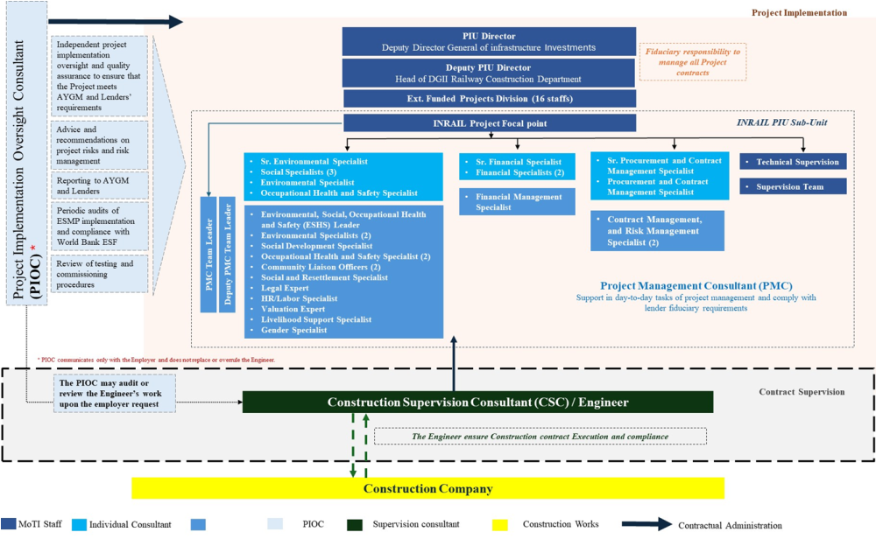

Ministry of Transport and Infrastructure
The role of MoTI is to grant permission to place the railway into service on completion of the project. To assist them in making this decision an Overall Technical Safety Case will be prepared by the Contractor and an Operational Safety Case by TCDD. These safety cases will be reviewed by an Independent Safety Assessor/Assessment Body (ISA/AsBo) and the Safety Expert who will both document the results of their reviews. In addition, the Notified Body will assess compliance with the TSIs and produce a certificate of compliance.

AYGM Railway Delivery Organisation
AYGM is the Directorate General of Transport and Infrastructure to deliver the project as a whole. They are responsible for ensuring the Railway safety Process is followed and co-ordinating the Safety deliverables. AYGM will employ a Contractor to deliver the project but will remain responsible for and co-ordinate all of the deliverables for the project. They may delegate some of their system safety and safety case responsibilities but will remain accountable.
AYGM will specifically be required to facilitate integration between the various parties involved such as:
- The Rolling Stock owners and suppliers and the signalling contractor whose equipment will need fitting to the rolling stock
- The Scheme plan designers and the signaling contractor
- TCDD as operator and owner of the railway with the Contractor

Contractor(s) for Design and Build
The Contractor(s) (not yet appointed) will be appointed by AYGM to deliver the design and build of the complete project. This Contractor may employ Subcontractors to deliver specified parts of the scope and associated requirements. The Contractor will be responsible to AYGM for producing the Design, Construction, Testing and Commissioning Overall Technical Safety Case at the appropriate points in the delivery cycle. The Contractor may delegate some of these responsibilities to a Subcontractor(s), but will remain accountable to AYGM for the scope. At the design stage the Contractor will involve TCDD in the safety process to ensure that the design adequately reflects operational and maintenance concerns.
The Contractor(s) shall establish an organization that meets the requirements for independence of Designer, Verifier and Validator as per EN 50126 and EN 50129 as applicable.

Contractors Railway Safety Manager
The Contractor will employ a Contractors Railway Safety Manager (CRSM) who will have responsibility for producing and delivering all of the required Contractor safety documentation as set out in this plan.

Subcontractors
Subcontractors (none yet appointed) may be appointed by the Contractor to deliver specific parts of the project scope (including Safety) and requirements. The Subcontractor scope and deliverables will be defined and contracted between the Contractor and the Subcontractors. However, these arrangements do not affect the Contractors overall accountability for the successful delivery of their safety responsibilities.

Lenders
The WB, EBRD, IsDB, OPEC Fund, ADB and AIIB are potential key financing partners of the project and as such will have their own advisor monitoring, albeit with a relatively light touch, the technical and safety delivery of the project.

Supervising Engineer
AYGM will contract an independent organisation (the Supervising Engineer) to check the design and build of the project against the requirements of the contract. The Supervising Engineer will make recommendations to AYGM regarding any areas of deficiency.

Safety Expert
AYGM or the Supervising Engineer will contract an independent Safety Expert. The Safety Expert role will be to supervise and check the safety deliverables of the Contractor and any Subcontractors.

TCDD
TCDD are the Turkish railway operator and they will be responsible for the operations and maintenance of the railway, including its safety, on completion of the design, construction, testing and commissioning of the project. Through AYGM they will actively engage with the contractor in the design stage to ensure that the design reflects their concerns.

Independent safety Assessor/Assessment Body (ISA/AsBo)
The ISA/AsBo shall be appointed by the Contractor shall fulfil the roles of an Independent Safety Assessor as defined in EN50126/TS EN 50126-1 and EN50129/TS EN 50129 and also an Assessment Body as Defined in the CSM-RA.
This shall be done by:
- Audits of those involved in the safety process including AYGM, Contractors and Subcontractors to ensure that the process is complete and robust;
- Specific checks on documentation such as safety management plans, hazard records and safety cases to ensure that interfaces are adequately managed and that there are not gaps in the coverage or areas where different parties make incompatible assumptions;
- Change is managed adequately throughout the project life cycle; and
- Representation of the project to the Turkish Railway Authorities (if required).

Notified Body (NoBo)
The Notified Body will assess the projects compliance with TSIs and produce a technical report detailing the results at the end of the Testing and Commissioning phase of the project before service.
This shall be done by:
- Assessment of the adequacy of the TSIs and attendant standards proposed for the project;
- A clause by clause assessment of compliance based on information/evidence supplied by the Contractor, Subcontractors etc as appropriate;
- Preparation and issue of a technical file and declarations of compliance; and
- Representation of the project to the Turkish Railway Authorities (if required).

STAKEHOLDERS
There may be a large number of stakeholders involved in obtaining the Acceptance Into Service (AIS). These may include, but are not limited to:
- Utilities providers/owners;
- Turkish Railway Authorities;
- Police;
- Fire Authorities;
- Rescue services;
- Private enterprises on or near the railway;
- Other railway lines; and
- Local government.
These stakeholders will have a variety of different interests, such as:
- Providing utilities for railway operation
- Preserving services and infrastructure that might be disrupted by introduction of the railway
- Providing emergency services and therefore needing to understand access arrangements, issues of safety on railway and overhead line etc.
- Integrating the new line into existing systems
- Giving permission for changes to infrastructure caused by the Project
- Being made aware of specific operational and safety risks that might arise due to the project
AYGM will implement a project Stakeholder Engagement Plan that defines all stakeholders and
- ensures that they are consulted
- ensures their requirements are captured and met by the project as far as possible
- ensures that they are informed about the project and its impact upon them
  - COMPETENCE AND TRAINING
AYGM will appoint competent organisations to the roles of Supervising Engineer and Safety Expert.
The Contractor shall appoint ISA/AsBo, NoBo and competent people or organisations to the other roles that meet the requirements of the table below.
Table 8 Requirements of Competent Persons
Role | Qualifications and Experience
AYGM Project Lead | Chartered Engineer with over 20 years’ experience in railway and metro projects
Contractor Project/Design Lead | Chartered Engineer with over 20 years’ experience in railway and metro projects
Subcontractor Project/Design Lead | Chartered Engineer with over 10 years’ experience in railway and metro projects
Supervising Engineer | Organisation that has supervised at least 5 major railway projects in Europe in the last 5 years and has proven expertise in Railway Project contract management and experience of application of the TSIs and European standards.
Safety Expert | Chartered Engineer with over 10 years’ experience in managing railway project safety under CSM regulations
Contractors Railway Safety Manager | Chartered Engineer with at least 10 years’ experience in railway projects with respect to delivering safety cases under CSM regulations
PMC | Qualified AsBo registered with the EU
PIOC | Qualified NoBo registered with the EU
  - CONTRACTOR MANAGEMENT
A key part of the safety management strategy is that, as far as possible AYGM will:
- Devolve the responsibility for system safety and the management of designated interfaces with others down to the Contractor; and
- Provide appropriate surveillance of the Contractor's safety programs and interface management so that timely management action can be taken as the need arises so that program progress is maintained.
It is currently planned that individual Subcontractors will not be managed by AYGM directly but will be managed by the Contractor who will be overseen by the Supervising Engineer and Safety Expert.
Independent Assessment
The Contractor shall employ an organization to work as the Independent Safety Assessor/Assessment Body (ISA/AsBo) at the earliest opportunity at the start of the project. The ISA/AsBo will be registered with the European Union and be properly qualified both as an organization and as the individuals involved. The ISA/AsBo shall assess the safety deliverables of the project at discrete points within the project lifecycle against requirements of CSM-RA: As a minimum these discrete points shall be:
- System definition;
- Preliminary design;
- Detailed design;
- Testing and commissioning; and
- Operations.
The ISA/AsBo will produce Safety Assessment Reports (SAR) at each point. These reports will provide an assessment of the state of the safety deliverables (System Definition, Hazard Record, Compliance with Safety Requirements) and recommendation as to the suitability of the project moving forward to the next stage.
The Contractor shall also employ a Notified Body (NoBo). Who is fully qualified and notified with the EU to validate the projects compliance with Technical Specifications for Interoperability (TSIs). This will be an ongoing process where a clause by clause record will be kept of each TSI and any evidence of compliance. This can then be produced at the same discrete milestones in the project to support continuation. At the end of the Testing and Commissioning phase the NoBo will produce a technical file that details compliance ready for service.
The Contractor will write remits for the ISA/AsBo and NoBo in line with the requirements of EN50126/TS EN 50126, EN50129/TS EN 50129, the CSM- RA and TSI regulations.
As a minimum the ISA/AsBo will review the:
- The System Definition;
- The Hazard Analysis and the Hazard Record including but not limited to, Preliminary Hazard Analysis (PHA), System Hazard Analysis (SHA), Interface Hazard Analysis (IHA), Subsystem Hazard Analysis (SSHA), Testing and Commissioning Hazard Analysis (T&CHA) and Operation and Support Hazard Analysis (OSHA);
- The Safety Requirements;
- Hazard and Safety Requirements close out evidence; and
- The Overall Technical Safety cases for preliminary design, detailed design, Testing and Commissioning, Trial Running, Entry into Service including any contributing safety cases not already reviewed by an ISA/AsBo.
- The Operational Safety Case
The ISA/AsBo will make observations and those observations will be classified as follows:
- Category 1: The issue represents a significant risk to safety or breakdown in the safety process that needs urgent action or would prevent a system moving from one project stage to the next;
- Category 2: The issue represents a significant risk to safety or breakdown in the safety process that is less serious or urgent than Category 1 and would allow progress from one project stage to the next providing that it was remedied in reasonable time and/or controls were put in place to mitigate risk in the interim; and
- Category 3: The issue is highlighted for incorporation into the Safety Case at the next periodic review, but no action is required separately.
  - Structural Safety
The safety of structures will largely be determined by compliance with Turkish building codes which will be supervised in part by the Supervising Engineer and in part by the local authorities who issue appropriate permits and approvals under Turkish regulations.
The ISA/AsBo role will be to oversee that this process is happening, and that residual risk is adequately identified, owned and controlled.
  - Acceptance Into Service (AIS)
A major objective of the Safety Plan is to achieve Acceptance into Service (AIS) from the Turkish approval authorities. In every primary contract there will be generic requirements regarding the AIS process.
The basis of the AIS process is that the Contractor will produce a Safety Case as detailed elsewhere and AYGM shall take responsibility for oversight of the Safety Case and for the presentation of that Safety Case to the MoTI at each stage of the project through the Safety Expert, based on the recommendations from the AsBo and NoBo. Once the railway has been built and handed over for operation the responsibility for producing an operational safety case and obtaining approval for passenger operation falls on TCDD as operator and maintainer. The MoTI will approve the AIS milestones based on the recommendations provided. More details on the AIS will be provided when known.
  - Safety Migration Plan
AYGM is acting as the proposer (as defined in the CSM-RA) for the design and construction scope of the project. TCDD will act as the maintainer and operator once the design and build parts of the scope have been delivered and approved.
  - Design Management
The Contractor shall have a Design Management Plan that all design organizations shall follow. Primary requirements of this Design Management Plan will be:
- Contractors and Subcontractors have total responsibility for the quality, safety and fitness for purpose of their design; and
- All design shall be checked by somebody independent of the designer. The level of independence of the checker for safety related electronic/electrical design shall be in accordance with CSM-RA, EN 61508, 50128 and 50129 as appropriate.
  - Quality Management
The Contractor and all major Subcontractors shall have a Quality Management System including a Quality Plan for the project in accordance with ISO 9001 or equivalent. Quality records shall be kept such that the construction quality of any safety related items can be verified by the ISA/AsBo.
  - Security
Security is a major factor which needs to be considered in relation to safety. In general, achievement of security is essential to safety and the requirements complement each other. However, in some cases, specific security requirements might be in contradiction to safety requirements. For this reason, AYGM’s safety team will have regular meetings with the Turkish Authorities’ security team to ensure that any such issues are resolved.
13. Hazard Management
13.1. Introduction
Safety will be managed by a process of hazard identification, followed by a process of either eliminating hazard causes or controlling the risks arising from hazard causes to an acceptable level as described below. The Contractor shall develop a Hazard Management Process in accordance with the process defined below. This Hazard Management Process shall ensure that close out of hazards is reviewed and approved by personnel independent of the designers with sufficient level of authority to ensure that adequate safety is achieved.

The overall process will be overseen by ISA/AsBo who will be responsible for ensuring that the process itself is adequate and that it is correctly applied and followed.

The hazard Close-out process will use the identified CSM Risk Acceptance Principles as detailed below. For each hazard, the close-out actions effectively become Safety Requirements and therefore need to be listed as such in the Hazard Log and subject to the full requirements capture, verification and validation process.

13.2. Hazard Identification
Hazards will be identified and managed through the following activities:
Preliminary Hazard Analysis (PHA);
Interface Hazard Analysis (IHA);
System and Subsystem Hazard Analysis (SHA & SSHA);
Operating and Support Hazard Analysis (OSHA);
Zonal Hazard Analysis.
Hazard identification may use predefined hazard lists, empirical methods, or creative methods as defined in EN 50126. In addition, any personnel who perceive a new hazard during their work should raise it directly with the Contractor RSM.
13.2.1 Preliminary Hazard Analysis (PHA)
The PHA has already been completed and is attached in Appendix A. This shall be further developed, added to and completed by the Contractor.

13.2.2 Interface Hazard Analysis (IHA)

The IHA will identify the hazards arising at the interfaces between different subsystems and systems and also external systems.
The Contractor (and his subcontractors) shall complete an IHA for the hazards arising at the interfaces between the different systems/subsystems within their own scope and for external systems. IHA will be undertaken by using a structured brainstorming or other technique as appropriate.

System & Subsystem Hazard Analysis (SHA & SSHA)
The SHA and SSHA will be undertaken to identify the hazards arising within particular systems or subsystems. This may use a structured brainstorming technique or a more rigorous approach such as HAZOP. In some cases, FMEA or FTA may also be used to identify hazards, particularly hazards arising from failures of systems or incorrect operation or maintenance.
The Contractor shall undertake SHA & SSHA for their scope of supply.
Zonal Hazard Analysis (ZHA) (Site & Environmental Study)
The primary objective of ZHA is to identify elements of the system design and implementation which may lead to application or site-specific hazards not considered within the generic system but introduced because of the physical proximity of the system to other systems. The Contractor shall complete Zonal hazard Analysis for their scope of supply.
This is the analysis of the physical disposition of the system and the components in its installed or operating domain to determine:
- The consequences of effects of failures in adjacent systems or damage from external forces;
- The safety of the installation and its compliance with relevant standards and guidelines;
- Areas where maintenance errors affecting the installation may cause or contribute to a hazard.
The analysis may be based on representative drawings and design documentation, and inspections of mock-ups as well as the first representative system installation.
An independent inspection of the system on site may be considered necessary upon completion of the theoretical Zonal Hazard Analysis. The objective of the site inspection is to ensure conformance with respect to the theoretical Zonal Hazard Analysis.

Operating & Support Hazard Analysis (OSHA)
The OSHA shall be undertaken by the Contractor to identify the hazards relating to operation and maintenance of all the systems. The Contractor shall involve TCDD, as the Operator/Maintainer in this analysis. In addition to structured brainstorming methodologies and HAZOP, OSHA will use Human Factors methodologies such as Task Analysis to systematically identify operational hazards. Maintenance Hazards will be identified by structured brainstorming as well as by maintenance walkthroughs.

Safety Measures, Requirements and Risk Acceptance principles
The first stage of managing a Hazard is to identify measures that might be taken in order to eliminate, reduce or mitigate the hazard and then to decide which of these measures to actually apply. The applied measures then become Safety Requirements.
During the early design stages, wherever practicable, hazards and their causes should be eliminated or reduced. Evidence should be produced that this has been completed.
For any one hazard, where it cannot practicably be eliminated, the hazard must be managed using one or more of the following risk acceptance principles and the Risk Acceptance Principle recorded in the Hazard Log:
- Use of a Code of Practice;
- Use of a Similar System as a reference;
- Use of Explicit Risk Estimation.

Risk Acceptance Principles
The risk acceptability of the safety measures selected for each hazard shall be evaluated by using one or more of the following risk acceptance principles (RAP) as defined in the CSM REA:
- Use of a Code of Practice (CoP);
- Use of a Similar System as a reference;
- Use of Explicit Risk Estimation (ERE).
The risk acceptance principles selected to control the risk associated with each hazard will be recorded in the hazard record.

Code of Practice
A Code of Practice (Cop) is a well-known and acknowledged set of rules which, when correctly applied, can be used to control one or more specific hazards. Typically, this includes national and international standards.
The Code of Practice shall satisfy as a minimum the following requirements:
- Be widely acknowledged in the railway domain. If this is not the case, the Code of Practice will have to be justified and be deemed acceptable by the Supervising Engineer
- Be relevant for the control of the considered hazards in the system under assessment;
- Be publicly available.
The rules of the Code of Practice become the safety requirements for the hazards they control.

Similar System Used as a Reference
An existing comparable system (or subsystem) which is accepted as safe and state-of-the-art will be used as a reference for the new system or subsystem. The safety requirements for the new system will be derived from the reference system, through reuse of existing safety requirements, either featuring mitigations or specifying additional mitigations.
A reference system shall satisfy at least the following requirements to fulfil similarity:
- It has already been proven in-use to have an acceptable safety level for current usage;
- It has at least similar or comparable functions and interfaces as the system under assessment;
- It is used under similar operational conditions as the system under assessment;
- It is used under similar environmental conditions as the system under assessment.
Note: If the same safety level as the reference system cannot be demonstrated, additional safety requirements shall be identified for the deviations, applying one of the two other risk acceptance principles.
Where relevant the requirements of EN 61508 shall apply in respect of “proven in use”. For items that have a defined life characteristic (e.g. are subject to fatigue) they may only be proven in use if a significant population of the items have reached at least half the required life without failure.

Explicit Risk Estimation
Explicit Risk Estimation (ERE) aims to evaluate risks against risk acceptance criteria, either derived from or based upon legal or other requirements (such as prevailing legal requirements, existing technical standards, existing safe systems or processes), agreed upon by the Approval Authority.
The estimation can be done quantitatively and/or qualitatively, and may directly use targets for tolerability of risk, such as the target for Technical Systems from the CSM of 1x10-9, or may indirectly use these targets through means such as a Risk Matrix.
Quantitative analysis would normally use Event Trees, Fault Trees, FMECA or other quantified risk assessment techniques as appropriate to derive a quantitative estimate of the risk.
Any mitigations, design features, maintenance or operating requirements required to ensure the safety of the system will be recorded as safety requirements.

Hazard Status and Close-Out
Once a hazard has been identified, it will be assigned to a hazard owner who will be responsible for closing it out. The hazard owner will normally be the Subcontractor responsible for the system which causes the hazard.
The Hazard will be moved towards a process of close out through the project stages using the risk acceptance principles as follows:

- Where a Code of Practice is used as the means of closing out a particular hazard, the process of hazard close-out is simply to show compliance with that Code of Practice. No additional safety analysis other than that called for by the Code of Practice, is required.

- Where use of a similar system as a reference is employed, either a quantitative or a qualitative argument may be used to justify that the proposed new system is at least as safe as the existing one. In either case, it must first be established that the proposed existing system is adequately safe by analysis of existing safety data. To show that the new system is at least as safe a coherent argument must be made. This may include analysis such as Failure Modes Effects and Criticality Analysis FMECA to show that single faults will not have serious safety effects, or Fault Tree Analysis to show that combinations of faults are not likely to result in catastrophic events. Other techniques such as Event Trees, Cause/Consequence Analysis, or similar methodologies may also be used. Where safety is assured by the use of electrical, electronic and programmable electronic equipment the systematic failure of these items must be controlled by the allocation of Safety Integrity Levels (SILs), and following the requirements of EN 50126, 61508, 50128 or 50129 as appropriate.

- Where explicit risk estimation is used, qualitative or quantitative risk assessment is required, employing FMECA, FTA, Event Trees, Event Sequence Analysis, etc. as appropriate. SIL allocation should also be employed where appropriate.
Hazard status changes and eventual close out will be approved by personnel independent of the designers. This process shall be auditable and visible. Each hazard will be managed for the Concept Stage, Design and Implementation stage, Manufacturing and Installation stage, System Validation stage and Acceptance stage and the status updated in the Hazard Log.

The following Hazard Statuses shall be used:
Table 9 Hazard Status
Status | Meaning
Open | The initial status assigned immediately after a hazard has been identified.
Resolved | The risk evaluation process has been completed and safety requirements have been established which are sufficient to control risk to an acceptable level.
Managed for Stage X | All of the safety requirements have been implemented appropriate to Stage X and evidenced. (As an example, for design this means that any design safety requirements can be seen to have been implemented in the current design. A hazard where all safety requirements relate to maintenance and operations would automatically be managed for design)
Cancelled | The potential hazards have been determined not to be an actual hazard or to be wholly contained within another hazard so no further action is necessary.
Transferred | The hazard has been transferred to another actor who now takes the lead in delivering the associated safety requirements for controlling the risk of the hazard. The proposer retains responsibility for managing the hazard.  Status “To be Transferred” can be used for the hazards that are in the process of being transferred to another actor.
Closed | Compliance with all safety requirements related to the hazard has been demonstrated and any other actions associated with the hazard have been satisfactorily completed and so no further action is required. The residual risk of each hazard shall be acceptable however no further evidence is required if one of the three risk acceptance principles has been used.

Hazard Log
The Hazard Log format will be that employed in the Preliminary Hazard Log ( Appendix A) but will be subject to approval the ISA/AsBo. The Hazard Log will be owned and managed by the CRSM.

The Hazard Log has a number of purposes (which includes, but is not limited to):
- To note those hazards classed as “Broadly Acceptable” (using the CSM-RA definition);
- Recording the significant findings of risk assessments undertaken by the project (hazards, causes, consequences);
- Identify the Risk Acceptance Principle(s) adopted;
- Record all reasonably practicable safety measures;
- Identify safety requirements from the recorded safety measures; and
- Provide the link to the evidence that shows the safety requirements are/will be adequately controlled.
Management of Hazards will be by the Contractor up until handover of the project to the Operator /Maintainer (TCDD) who will then take ownership of the Hazard Log.

Safety Audits
It is the responsibility of the Safety Expert provide appropriate surveillance of the Contractor safety program and advise AYGM so that timely management action can be taken as the need arises and program progress is not adversely affected.
The Safety Expert will undertake regular safety audits of the safety management of the Contractor, to ensure that the safety management plans and policies are being followed. As a minimum this shall include review of monthly safety reports by the contractor and 3 monthly Safety Reviews but may also include additional audits if the Safety Expert believes that they are required to provide confidence of the Contractor performance.

Safety Approvals Strategy
AYGM shall be responsible for obtaining the AIS process as defined by the Turkish Railway Authorities. AYGM shall facilitate this process by working with the Turkish Railway Authorities both prior to and after the appointment of the Contractor and also through the AsBo and NoBo who shall endorse the safety process.
The Contractor shall produce an Overall Technical Safety Case at key stages to prove that the Safety Strategy has been adequately implemented to permit safe operation at that stage. Examples of key stages are Design, Testing and Commissioning, Testing with Running Trains; Operation and Emergency Testing, Test Run to demonstrate RAMS minimum requirements and AIS. The AsBo will review the Overall Technical Safety Case and prepare an assessment report which shall make it clear whether the Overall Technical Safety Case is considered adequate at the key project stages. The NoBo will assess the design against TSIs. The AsBo and the NoBo shall make a recommendation as to its acceptability for the Turkish Railway Authorities.
TCDD shall produce an Operating Safety Case at the same key stages, except for the Design Stage where an Operating Safety Case is not required. External expertise is likely to be needed to assist TCDD.
The Overall Technical Safety Case produced at each stage of the Project by the Contractor will be supported by all other Subcontractors’ safety cases, as appropriate, and assessed by the AsBo and NoBo through the production of assessment reports. All category 1 and category 2 observations must be closed out although this may be by means of temporary operation restrictions or conditions during early operations but only where this is expressly authorized by the Operator and Turkish Railway Authorities. Although AYGM will lead the approval process, the Contractor may be required to present their safety case to the Turkish Railway Authorities.
Products used by Subcontractors shall undergo a formal safety acceptance process and a Product Technical Safety Case shall be prepared by the Subcontractors for each product that has safety-related functions. This may be based on cross-acceptance, where the product has gone through a formal acceptance process in accordance with EN50126/TS EN 50126 or similar standard on another railway that has standards of safety similar to major European Railways, or by a proven in use argument where it can be shown that the product has a substantial history of safe operation on another railway. If a cross-acceptance or proven in use process is not possible, then the Product Technical Safety Case will need to be produced for the product based on a detailed process of hazard identification, close-out and logical argument to support its approval.
Within each Safety Case, the Technical Safety Argument shall set out the technical reasons why the system is safe to operate. This will include the Operational and Maintenance measures that are taken to ensure safety in operation. The Overall Technical Safety Case will be produced by the Contractor with input from each of the Subcontractors, as required, to include:
- Evidence of Hazard Identification and Close-Out;
- Theoretical evidence supporting Close-Out (Verification); and
- Practical evidence supporting Close-Out (Validation).

Safety Case Structure

Structure
The complete Safety Case structure will be broadly as follows:
- An Overall Safety Case composed of two documents; the Overall Technical Safety Case and the Operational Safety Case.;
- An Overall Technical Safety Case: managed and produced by the Contractor, which is composed of a number of Product or System-specific Technical Safety Cases, each of which shall be produced by the Subcontractors responsible for that product or system; and
- An Operational Safety Case: managed and produced by the Operator/Maintainer.
Each Technical Safety Case shall provide a complete reasoned argument and evidence as to why the Product or System will be safe. This includes the specification of any operational rules or restrictions required to ensure safety of the product or system and all requirements for maintenance.
The Overall Technical Safety case will specifically include argument and evidence that all technical systems are adequately integrated to give a safe operational railway. This will include, for example, rolling stock and existing operational systems. It is expected that any existing systems and rolling stock can be regarded as already proven to be safe in their own right and therefore the Contractor only needs to address compatibility and integration issues. Any new rolling stock is outside the scope of the immediate project and would need to be proven to be safe in its own right by the procurer/supplier but the Contractor would need to demonstrate compatibility and integration in the Overall Technical Safety Case.
The Operational Safety Case shall provide a complete reasoned argument and evidence as to why the operational railway will be safe. This includes evidence of processes to ensure that any operational rules or restrictions are complied with and all required maintenance will be completed. It also includes all other aspects of operational safety management such as:
- Control of working hours and employee competence;
- Ongoing management of safety during the operational phase, including FRACAS and control of changes and modifications;
- Control and update of the operating rulebook;
- Training; and
- Emergency Plans.

Safety Case Flow
Figure below shows an example of how the safety case structure works. The Signalling Supplier will produce a Technical Safety Case for the signalling product. This safety case will demonstrate that the signaling system ensures safety, provided that a set of Safety-Related Application Conditions (SRACs) are adhered to.
Some of these SRACs affect the design of the Rolling Stock and the Scheme Plan. Others may relate to maintenance and operation. The technical safety case for the rolling stock, for example, will need to show that the SRACs for the signalling system have been met, and the Signalling Scheme Plan Technical Safety Case will need to show that the SRACs have been met. Hence, with respect to the signaling system, the Overall Technical Safety Case is assembled to show that the Technical Safety Cases for the Signaling, the Rolling Stock and the Scheme Plan between them demonstrate full safety compliance.
Similarly, the Operational Safety case will have to show that the signalling equipment is being maintained and operated in accordance with the SRACs.
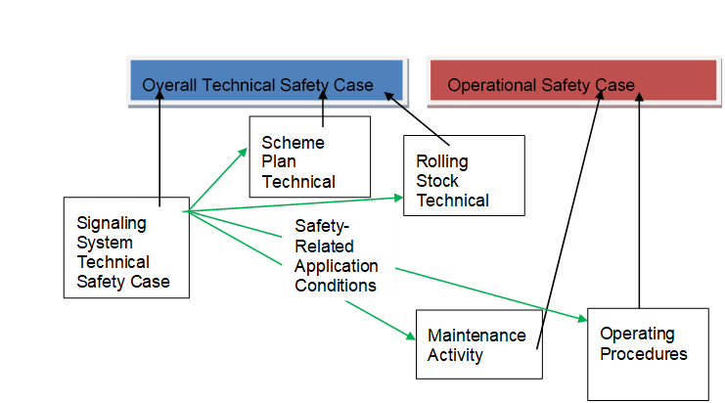
Figure 36 Example of Part of a Safety Case Structure

SAFETY LIFECYCLE AND ANALYSS

Safety Tasks
The project will broadly follow the lifecycle outlined in EN 50126. The safety tasks that the contractor shall follow for each part of the lifecycle are detailed in Table 8.1 below. It should be noted that since this is a mixture of new railway and existing railway, some of the tasks may not be relevant at all times or will be slightly different for different parts of the railway from the standard tasks in EN 50126. All of the tasks are for the Contractor to implement unless stated otherwise. The Contractor shall cascade these requirements to their sub-contractors as applicable through the contractual agreements.
Table 10 Safety Tasks by Lifecyle Phase
Lifecycle Phase | EN 50126 Safety Tasks | Project Safety Tasks
1. Concept | Investigate the general safety implications of the system.  Investigate previous safety requirements and past safety performance of similar/related systems.  Investigate current safety policy and targets of the relevant railway duty holders.  Investigate safety legislation. | Safety issues and legislation and targets to be investigated and incorporated into Railway Safety Plan at later stage by AYGM
2. System Definition and Operational Context | Establish the safety policy.  Establish the safety plan. | Review, update and agree Railway Safety Plan (Overall) this document. (AYGM)
3. Risk Analysis and Evaluation | Perform risk analysis.  Establish hazard log.  Update Safety Plan.  Establish Independent Safety Assessment Plan | Preliminary Hazard Analysis and Hazard Log produced (AYGM)  Railway Safety Plan Updated (AYGM)  Independent Safety Assessor to be appointed by Contractor and produce assessment plan
4. Specification of System Requirements | Establish safety requirements specification.  Establish safety-related application conditions.  Update hazard log.  Update the safety plan.  Establish validation plan for safety requirements | Establish safety requirements specification.  Establish safety-related application conditions where applicable  Perform Detailed Hazard Identification and update hazard log.  Produce Contractors safety plan.  Establish verification and validation plans for safety requirements
5. Architecture and Apportionment of System Requirements | Perform hazard analysis.  Allocate safety requirements to subsystems/components.  Update safety-related application conditions.  Update hazard log.  Update the safety plan.  Update validation plan for safety requirements. | Perform further hazard identification and analysis  Allocate safety requirements to subsystems/components.  Update safety-related application conditions.  Update hazard log.  Update the safety plan.  Update verification and validation plans for safety requirements.
6. Design and Implementation | Plan safety tasks of further phases.  Perform hazard analysis.  Update safety-related application conditions.  Update hazard log.  Update the safety plan.  Update validation plan for safety requirements.  Prepare safety case. | Plan safety tasks of further phases.  Hazard Analysis and Risk Assessment including IHA, ZHA, FTA, CCA, FMECA, ETA, OSHA and SIL allocation  Update safety-related application conditions.  Update hazard log.  Update the safety plan.  Update verification and validation plan for safety requirements.  Prepare Overall Technical Safety Case  Prepare Operational Safety Case (TCDD)
7. Manufacture | Establish safety assurance arrangements.  Update safety-related application conditions.  Update hazard log.  Update the safety plan.  Update validation plan for safety requirements.  Update safety case | Establish safety assurance arrangements.  Update safety-related application conditions.  Update hazard log.  Update the safety plan.  Update validation plan for safety requirements.  Update Overall Technical Safety Case  Update Operational Safety Case (TCDD)
8. Integration | Establish integration report for safety requirements.  Update safety-related application conditions.  Update hazard log.  Update the safety plan.  Update validation plan for safety requirements.  Update safety case | Update Safety Requirements Specification  Update safety-related application conditions.  Update hazard log.  Update the safety plan.  Update verification and validation plan for safety requirements.  Update Overall Technical Safety Case  Update Operational Safety Case (TCDD)
9. System Validation | Establish safety validation report.  Update safety-related application conditions.  Update hazard log.  Update the safety plan.  Update validation plan for safety requirements.  Update safety case. | Update Safety Requirements Specification  Update safety-related application conditions.  Update hazard log.  Update the safety plan.  Update verification and validation plan for safety requirements.  Update Overall Technical Safety Case  Update Operational Safety Case (TCDD)
10. System Acceptance | Establish Independent Safety Assessment Report.  Assure endorsement of safety-related application conditions. | ISA/AsBo Assess Technical and Operational Safety Cases
11. Operation, Maintenance and Performance Monitoring | Implement and maintain process for the acquisition and recording of safety performance data.  Perform an impact analysis in case of changes and reapply process if needed.  Records to trace the safety tasks undertaken.  Establish reports of safety performance analysis and evaluation. | Contractor collect, analyse, evaluate and use performance & safety statistics during initial operation period  TCDD Perform Ongoing Safety Performance Monitoring, FRACAS and Hazard Record Maintenance including producing safety reports  TCDD implement process for managing change
12. Decommissioning | Identify the safety impact of decommissioning and disposal | TCDD identify the safety impact of decommissioning and disposal

Notes:
- Change Control and Configuration Management activity applies to all project phases.
- Verification and Validation activities apply within most lifecycle phases.
- Note that the scope is limited to safety and does not address all assurance activities. However, it is necessary to ensure the synchronization between Safety and other program-related phases, and to agree on the conditions for passing from one phase to another from a safety point of view.

Document Schedule
The schedule below lists the documents that shall be produced by the Contractor. The Contractors documentation shall include all Railway Systems and the civil elements. For some systems, such as Signalling, it is expected that a specialist Subcontractor will be employed and they will produce a document for their own scope which will then be integrated into the Contractors overall documentation.
Table 11 Contractor Document Schedule
Document | Due Time
Safety Plan | Within 1 month of Contract Award
Safety Reports | Monthly
Preliminary Hazard Analysis | Existing PHA to be reviewed within 3 months of Contract Award
System and Subsystem Hazard Analysis | Progressive during design stage with initial version within 2 months of start of detailed design
Interface Hazard Analysis | Progressive during design stage with initial version within 2 months of start of detailed design
Operating and Support Hazard Analysis | Progressive during design stage with initial version within 3 months of start of detailed design
Zonal Hazard Analysis | Progressive during design stage with initial version within 3 months of start of detailed design
Hazard Log | Progressive during design stage with initial version within 3 months of Contract Award
Quantified Risk Assessment (includes FMECA, FTA, SIL allocation, Common mode failure analysis, etc.) | As required to support Hazard Management and safety case
Human Factors Analysis | As required to support Hazard Management and safety case but no later than 2 months before end of detailed design
Verification Plan | Within 3 months of contract award
Verification Report | As required to support Hazard Management and safety case
Validation Plan | Within 3 months of contract award
Validation Report | As required to support Hazard Management and safety case
Safety Audit | At least every 3 months
Maintainability Analysis | Progressive during design stage with initial version within 3 months of start of detailed design
Maintainability Demonstration | As part of Testing and Commissioning activity (during Factory Acceptance Tests and Site Acceptance Tests)
Overall Technical Safety case | As required to support acceptance process. As a minimum:-  - approximately 2 months before end of Preliminary design;  - approximately 2 months before end of detailed design;  - At end of Testing and commissioning before trial running  - At end of trial running before entry into service

It shall be the responsibility of the contractor to ensure that all documents are submitted to the ISA/AsBo for assessment as required and to obtain approval from the ISA/AsBo and the NoBo for the project up until handover to TCDD. Approval shall be obtained at the following milestones:
- At end of preliminary design before start of detailed design
- At end of detailed design before commencement of construction
- At end of testing and commissioning before trial running
- At end of trial running before entry into service

Safety Reporting
The Safety Expert shall hold meetings with the Contractor at no more than 3 monthly intervals to discuss progress. The Contractor shall produce a safety report detailing progress 1 week before each such progress meeting. At key stages of the project (specifically during detailed design and during testing and commissioning) more frequent meetings may be held.
A program for the control and monitoring of the Contractors and Subcontractors will be established by the Safety Expert to help ensure that the safety requirements will be completed with success. This will include audits.
The Safety Expert will engage with both the AsBo and the NoBo at project start up and meet regularly with them to discuss the status of the project and outstanding issues regarding safety and standards compliance.

Safety Activities
The Contractor shall complete the following safety activities as required in order to support the Hazard Management process and the Safety Case.

Fault Tree Analysis
Fault Tree Analysis (FTA) is the most widely known and accepted top-down or deductive system failure analysis technique. IEC 61025 provides a standard for the application of FTA.
FTA is a deductive, top-down analytical technique which focuses on a single undesired event and provides a method for determining all the possible causes of that event. A correctly constructed Fault Tree is a graphical and logical model of the various parallel and sequential combinations of faults and failures which will result in the occurrence of the Top Event. The faults can be events that are associated with hardware failures, software errors, human errors, external influences, or any other pertinent events which can lead to the undesired event.
Fault Tree Analysis shall be used by the Contractor and the Subcontractors to determine the safety of systems that incorporate redundancy to protect against the adverse safety effects of single failures. The fault tree models shall be developed using an agreed software.
Fault Tree model files shall be passed on to the Contractor for incorporation into their analysis as appropriate.
Common Cause Failure Analysis
Systems which contain redundant paths may fail due to the simultaneous failure of all the redundant paths as a result of a single cause or event that affects all paths. Such system failures are termed "Common Cause Failures". Common Cause Failure of systems resulting from the random (primary) failure of common hardware components in the redundant paths are best analysed by the correct application of FTA. However, FTA may miss other causes such as systematic failure of the paths due to common design errors or common external influences or events.
Common Cause Failure Analysis is applied following initial FTA minimal cut set determination in order to identify any dependencies between any of the constituent base events of each cut set. Use is then made of engineering assessment, checklist and brainstorming techniques to assess the possibility of a common failure mechanism existing, and a qualitative assessment of the likelihood of such a failure occurring.
The engineering assessment and brainstorming of common cause failure by the analysis team is to be based on suitable checklists to provide some element of control to the process.
Fault tree estimates of Common Cause Failure effects may be modelled using the beta factor model.
The Contractor and Subcontractors shall apply Common Cause Failure Analysis in all cases where high levels of safety are required (e.g. SIL 3 or 4 systems)

Event Tree Analysis
Event Trees are used to model accidents where multiple safeguards are in place as protective features. Event Tree Analysis is highly effective in determining how various initiating events can result in accidents of interest. Event Trees are:
  - Models of the range of possible accidents resulting from an initiating event or category of initiating events;
  - A risk assessment technique which effectively accounts for timing, dependence, and domino effects among various accident contributors that are cumbersome to model in fault trees;
  - Performed primarily by an individual working with subject matter experts through interviews and field inspections;
An analysis technique which generates the following:
  - Qualitative descriptions of potential problems as combinations of events producing various types of problems (range of outcomes) from initiating events;
  - Quantitative estimates of event frequencies or likelihoods and relative importance of various failure sequences and contributing events;
  - Lists of recommendations for reducing risks; and
  - Quantitative evaluations of recommendation effectiveness.
Event Trees shall be utilized by the Contractor and the Subcontractors in cases where this is required in order to quantify the way in which faults propagate through to accidents.

Safety Integrity level (SIL) Allocation and Achievement
Where safety is assured by the use of electrical, electronic, and programmable electronic equipment, the systematic failure of these items must be controlled by the allocation of Safety Integrity Levels (SILs). Methodologies to do this are explained in EN 50126, EN 61508 and EN 50129 for signalling. For all systems where a SIL is allocated, the allocation shall be agreed with the Safety Expert before proceeding with design.
Once a SIL has been allocated, the Contractor or Subcontractor shall follow the procedures in the relevant standards to meet that SIL. All safety-related software shall be allocated a SIL and shall meet the requirements of EN 50128.
Evidence of achievement of a SIL may be through proven in use argument, third party accreditation (for fire safety systems UL/FM accreditation would be taken as equivalent to SIL 2) or through the Contractor providing evidence of compliance with the requirements of compliance with the relevant SIL requirements including completion of the checklists included in Appendix A of EN 50128, Table E of EN 50129 and Appendices A & B of EN 61508 part 2 and Appendices A, B & C of EN 61508 part 3 as appropriate.

Failure Mode Effects and Criticality Analysis
The purpose of a Failure Mode Effects and Criticality Analysis (FMECA) is to examine the higher level (e.g. system) effects of postulated lower level, single-point failure modes. In performing an FMECA, it is very important to establish a complete set of credible failure modes of the lowest level items in the analysis (for instance, functional failure modes) and to determine the functional structure of the equipment under analysis.
This analysis is carried out in tabular form, with the analyst being required to take each component failure mode in turn and assess its effects at the appropriate higher levels, then record the results on the worksheet. The FMECA is complete when all of the functional failure modes have been systematically assessed and their effects recorded.
As with most safety and reliability analyses, the sooner in the project lifecycle FMECA is applied, the earlier failures or discrepancies are identified and the cheaper any necessary modifications turn out to be. Therefore, FMECAs will be embarked upon as soon as the necessary design information is available.
The uses of FMECA include:
  - identifying single point failures (including operator tasks) which have undesirable or significant effects;
  - indicating the need for modifications to the design;
  - providing an input into the reliability predictions;
  - providing an input to top-down safety and reliability analyses for the purposes of service reliability prediction and system safety justification; and
  - providing a basis for measuring and specifying the testing requirements for the item being analyzed.
FMECA shall be applied by the Contractor and Subcontractors to all subsystems where there is redundancy for safety purposes in order to show that single-point failures do not cause undesirable effects.

Human Factors Analysis
Human factors are an integral part of the project's safety, reliability and maintainability aims. Special consideration will be given to all aspects of the design which interface with system users, operators or maintainers. Safety-related/critical human factors will be addressed in the Operation and Support Hazard Analysis, Interface Hazard Analysis, and FMECA aspects of the project. Recognized techniques of ergonomics, human error, ethnographic, and task analysis will be applied as appropriate.
In the design stage, human factors assessment will be concerned with:
  - the design of human-machine interfaces (e.g. the layout and accessibility of subsystems);
  - alarm presentation and management;
  - control panel design;
  - the design of job aids (e.g. carrying handles);
  - the design of operating, maintenance and training procedures and methods; and
  - environmental conditions, including the need to avoid hazards such as high temperature or live electrical components.
Human Factors analysis shall be applied to all safety-related systems by the Contractor and the Subcontractors.

Requirements Management
The Contractor shall have a Project Requirements Management Plan to ensure traceability from the System Requirements specification to the subsystem requirement specifications and then through to Verification and Validation. All Safety Requirements shall be subjected to this formal requirements management process.
Safety requirements include:
  - Requirements from standards;
  - Specific requirements identified in order to close-out hazards;
  - Requirements identified by safety analysis; and
  - Requirements needed in order to comply with Application Specific Safety Conditions (ASSCs) or Safety-Related Application Conditions (SRACS) for the use of systems or subsystems.
Any requirement cited in the Hazard Record as part of the reason to close out a hazard will become a Safety Requirement that then becomes subject to requirements management. The adequacy of close-out arguments will be assessed by the Contractor and audited by the ISA/AsBo. The Safety Expert will then apply a “Risk Based” approach to auditing and checking for adherence to the requirements management process.
Requirements directly controlled by the Contractor will be reviewed to ensure that they are definitive, succinct, verifiable, consistent, unambiguous and measurable. The requirements specifications should include all functional requirements, all non-functional requirements and all necessary references to railway and client standards.
For those requirements that apply to a Subcontractor it shall be the responsibility of the Subcontractor to have a rigorous Requirements Management system in line with the Contractor Requirements Management process and the Safety Expert will conduct audits of compliance with this process on a risk based approach.

Verification and Validation
The objective of system verification is to demonstrate the compliance and consistency of the proposed design solution and its implementation and application with the systems requirements. Specifically, it will involve:
  - checking, by means of checks of drawings and appropriate calculations and analysis, that the hazard mitigations identified in the Hazard Record have been correctly implemented and will be effective;
  - checking the analysis, modelling and/or simulation results to confirm the correctness of the proposed design solution;
  - checking drawings and calculations to show that all specific safety requirements have been met;
  - testing to show that all of the systems requirements and specifically safety requirements have been met. This will include Proof Tests, Type Tests, Quality Tests, Factory Acceptance Tests, Commissioning Tests and operational trials;
  - checking that maintenance is specified and will be implemented so as to maintain conformance with requirements; and
  - checking that operating procedures will be implemented so as to maintain conformance with requirements.
The verification status of a requirement shall be recorded in the requirements management system. All verifications will be subject to audit and control by the RCSM and the Contractor.
Validation is undertaken to ensure that the implemented system not only complies with all the requirements but is fit for its intended usage and that in practice all the hazard mitigations operate as expected. During the Design Phase this will include theoretical checks that the system requirements will meet the intended usage requirements for the system. The more significant part of validation will be tests on actual equipment to show that its operation is safe under normal and failure conditions and that all safety features of the design operate as expected. This testing will include Proof Tests, Type tests, Quality Tests, Factory Acceptance Tests, Commissioning Tests, and operational trials. The validation process shall include assessment that maintenance and operations will preserve safety. In some cases, validation will provide evidence to support analysis rather than directly showing that fitness for purpose has been achieved. The validation status of a requirement will be recorded in the Requirements Management System. All validations will be subject to audit and control by the CSM and appropriate Contractor/Subcontractor design manager.
Verification and Validation shall be completed for all safety-related equipment by the Contractor and the Subcontractors at each stage of the project lifecycle as appropriate. In particular, progression from one stage of the project to the next would normally only be permitted on the basis that the verification and validation of the previous stage has been completed or that outstanding issues are clearly recorded and are assessed as low risk.

Integration and Interface Management
The system integration process shall largely be assigned to the Subcontractors through the Contractors Interface Management process which shall be written and then monitored and audited by the Contractor. The Contractor’s Interface Management plan is required to address interfaces with safety related implications both in design and construction. The Subcontractors must hold regular cross discipline reviews of their Interface Database and Hazard Records.

Maintenance Walkthroughs
Maintenance walkthroughs shall be conducted at all stages of product development by the Subcontractors for their scope of supply, to ensure that equipment is maintainable, including the identification of safety issues. Walkthroughs shall consist of imagining or actually doing maintenance procedures (depending on the stage of design) on real equipment, visualizations or mock-ups and identifying each of the tasks which may have safety consequences if done incorrectly, and then ensuring that adequate design or procedural safeguards are put in place to minimize the risk. The Contractor shall be invited to participate in these walkthroughs.

Maintainability Testing – Fault Injection
Maintainability testing shall be carried out on a selection of equipment once they have been installed and the systems are operational. Using fault injection, these tests will be used to verify the equipment maintainability (i.e., accessibility, fault detection, fault isolation, MTTT, MTTR, labelling, procedures, equipment removal and installation times) within the actual working environments.
The results of the maintainability testing will be used to validate the maintainability predictions, FMECA and FTA analysis. Fault Injection testing may also be used to validate that the equipment does fail safely as designed.

Design Reviews
Railway Safety shall be reviewed as an agenda item at all Contractor and Subcontractor design reviews. The effectiveness of the proposed or implemented Systems Safety features of the design are to be critically reviewed to ensure that the design will be capable of achieving the specified Systems Safety requirements. The Safety Expert shall attend, or be represented, at all design reviews.

Document Reviews
The CSPCM will review all documents for the project which have a significant impact on safety. Attendance at Contractor/Subcontractor document reviews is at the discretion of the CSPCM. Evidence that the CSPCM or a nominated representative has participated in a Document Review should be found in the document review records stored in the Project Files.

Configuration Control
The Contractor and Subcontractors shall have a system of controlling the configuration of the design, hardware and software under their control. This system shall ensure that it is always possible to identify the latest version of the design and to link the hardware and software implementation to a specific version of the design such that it is possible at any time to understand:
  - The version of the hardware and software at each location;
  - What the changes are from one version of the design or hardware or software to the next version;
  - What the approval status is of the major hardware and software components; and
  - That any proposed changes are compatible with the versions of hardware and software.

