AYGM-YAP-2023-WB 02/ Pre-Bid Meeting
Distinguished participants, welcome to the clarification meeting for the tender of the RLIP Last-Mile Rail and Road Infrastructure Connectivity to/from Çukurova Region and İskenderun Bay Project.
The tender for the project is conducted by the AYGM Railway Construction Department.
11th Development Plan (2019-2023) by the Republic of Turkey Presidential Directorate of Strategy and Budget underscores that rail lines ought to be engaged among Turkey's transportation investments.
To supply enhanced trade routes between the harbors and inner regions and develop organization structure of TCDD defined as follows.
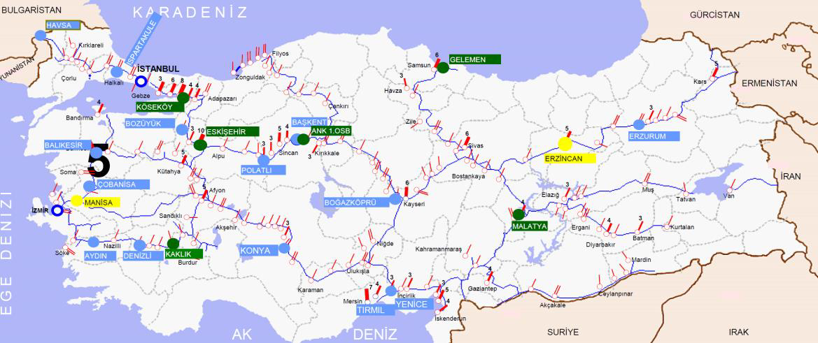
Project Location
Figure 1 Freight Transport Railway Network
We are now going to procure approximately 30 km long railway line. The Project has two major connection lines, which are between Erzin and Tayseb Station and Osmaniye OIZ and Port.

Çukurova Region and İskenderun Bay Railway Connection Project is located within the boundaries of Yumurtalık District in Adana Province, Toprakkale District of Osmaniye Province and Erzin Disrtict of Hatay Province, in the South of Turkey. The project is consisting of two main lines with a total length of approximately 44.1 km (single line) and includes four stations. Only one station (Erzin) will be used additionally as it exists, the rest of them will be constructed. In Erzin Station, there will be no works in the station buildings, only the platforms may be enlarged.
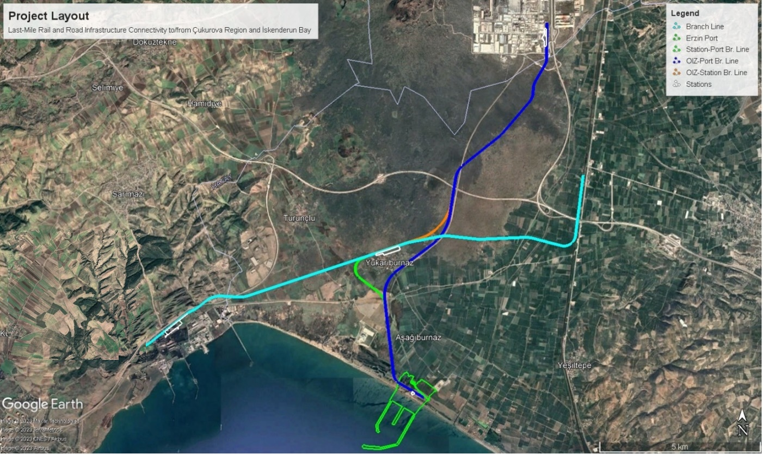
Figure 2 Project Location
RLIP Çukurova project consists of the following sections:
There are 4 lines within the scope of the project. These are summarized in three items:
1.Connection Line: The planned line starts from existing Erzin Station (Km: 0+000), continues parallel to the Toprakkale-Iskenderun Railway Line about 1,900 m to the South, and leaving to continue to the West. Between Km: 7+000 and Km: 9+000, it passes through west of Yukarıburnaz and arrives to Toros Adana Yumurtalık Free Zone (TAYSEB). This line will be located within the borders of Adana-Hatay Provinces. Two station locations are planned in this line. These are:
    - Station-1 between Km: 7+900 and Km: 8+800 in the North of Yukarıburnaz
    - Station-2 between Km: 15+355 and Km: 16+788 (Free Zone)
The existing Erzin station will be expanded. At this station, the connection between existing Osmaniye OIZ, Yumurtalık Free Zone and planned Ceyhan OIZ, and connection between existing Toprakkale-İskenderun railway line will be provided.

2. OIZ-Port Line: It is the line that will provide the connection between Osmaniye Organized Industrial Zone (OIZ) and the new port located in the Yukarıburnaz Neighborhood. In this context, the line will be located in the borders of Osmaniye and Hatay Provinces. The line starting from Osmaniye OIZ and proceeding in the south-southwest direction, starting from Km: 5+600, reaches to the port, which has not came into service, by continuing parallel to the OIZ-Port Connection Highway. The total length of the line is nearly 13.05 km. Two station locations are planned in this line. These are:
    - Station-4 between Km: 0+000 and Km: 1+000 (OIZ)
- Station-5 between Km: 12+150 and Km: 12+850 (Port)

3. Other Connection Lines: There will be two connection lines in this scope. These lines are the 2 connection lines planned to be established to provide the connection between the above-mentioned 1st Line and 2nd Line, OIZ-Port Connection Line, through Station-1. Of them:
    - OIZ-Station Connection Line is about 8,197 m,
- Station-Port Connection Line is about 6,101 m.
The total length of all lines to be built in this project is approximately 44.1 km (single line) and will have electrification, signalization and telecommunication. Most of the lines planned in this project are within the boundaries of Hatay Province, a few are in the boundaries of Adana Province. Only nearly 1.5 km of the line is in Osmaniye Province. The Project is designed mainly for the freight trains and the design speed will be 80 km/h. The Contractor will be responsible of the certification of the line.
Design parameters of the Project are as follows:
Design speed is 80 km/h,
Rail gauge will be 1435 mm,
Rail type is 60 E2 (UIC 60),
Concrete sleeper type is B70, and
The axle load is 22.5 tons.
Projects, Technical Specifications and Bill of Quantities have been prepared for the main components of construction works such as earthworks, bridges, underpasses, overpasses, box culverts, and railway track works, Signalization, Electrification, and Telecommunication.
Electricity of the overhead line system will be provided by transformers designed and located within the railway corridor. Detailed design of transformers including the locations of them will be under the responsibility of the Contractor. The designs will be in accordance with the 'EN 50329' and 'Technical Specifications for the Construction of Substations'.
The Contractor will be responsible for liaising with the Turkish Electricity Generation and Transmission Corporation (TEAŞ) for connecting the transformer centers to the transformers by overhead lines.
The overhead line system will be connected to the traction system that is a part of the train. All the necessary connection works related the existing line is in the scope of this project.
The traction Supervisory Control and Data Acquisition (SCADA) System will be a central control and monitoring system for electrification systems (overhead line system and traction power system). Control Center will be developed as part of the railway project.
The Project's Signalization System will be designed to be compatible with (TSIs Interoperability Technical Specifications (European Railways Agency)) and equipped with an ERTMS Level 1 signaling system. Signaling systems will ensure the safe separation of train movements at train speeds of 80 km / h (included). The Contractor will apply a risk analysis for the signaling systems and minimize potential risks and hazards in accordance with the TS EN 50126 standard.
The signaling system installed for the project will be equipped with national signaling systems with Automatic Train Stop (ATS) train protection systems.
As the Control System, the Global System for Mobile Communications - Railway (GSM-R) will enable voice communication between passenger and freight trains and with the wider railway communication systems.
The telecommunications system will provide telephone communication and data communication between the overhead line system, SCADA system, signalization system and the GSM-R system.
There are currently 1 active stations on the project route, which is Erzin Station. There will be no changes in the buildings in the station. However, at the station, it will be necessary to carry out various works at the platforms and for access arrangements in compliance with the project requirements and TSI Interoperability Technical Specifications, related to freight train operations on the conventional railway line.
As known; the construction of the RLIP Çukurova railway line will be carried out with the financing of IBRD. Since the financing for the construction works of the Project will be provided by IBRD, our tender is carried out in accordance with the WB’s procurement rules relying on the exception in the Public Procurement Law. The construction tender is an open tender and consists of one-stage tender with two-envelopes. Our tender is open to all domestic and foreign companies. Since our tender will be with two envelopes, first technical proposal. Then, technical scores of the bidders will be announced and financial proposals will be opened. The bidder with the highest combined score will be awarded. We plan to conclude this entire tender process in June/July of this year.
If you have any questions about what we have just explained or about the tender documents, you can send your questions in writing until tonight after this meeting.

Thank you all for your participation. I wish you success in your work.

